Transport across membranes
Strand: Structures and Processes of Life
Learning Outcomes: 2.6.1, 2.6.2

A semi-permeable or selectively permeable membrane allows some but not all substances to pass through it.
These membranes do not allow some substances such proteins, sodium and urea to pass through easily, so channel proteins and transporter proteins facilitate the movement of these molecules in and out cells.
The different in concentration of molecules in two areas is known as the concentration gradient.
Oxygen will diffuse into the cell, and the carbon dioxide will diffuse out of the cell
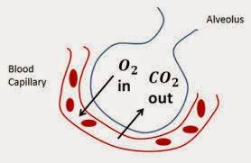
Diffusion will take place along a concentration gradient. It is a passive process, so it does not require energy.
Diffusion is the movement of molecules from a region where the molecules are in high concentration to a region of where the molecules are in low concentration
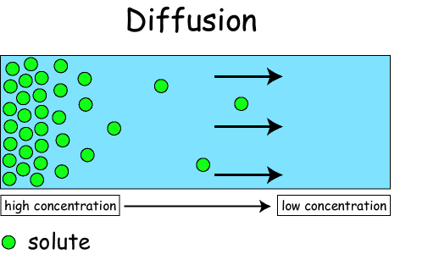
Diffusion occurs in leaves, when carbon dioxide diffuses into a leaf, and oxygen diffuses out of a leaf
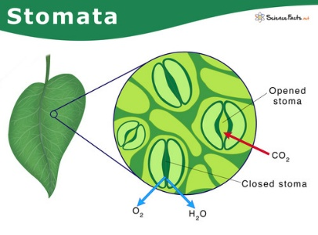

Osmosis is a special type of diffusion.
Osmosis does not require energy, as it involves movement molecules along the concentration gradient, so it is a passive process.
Osmosis is the movement of water molecules from a region where the water molecules are in high concentration to a region of where the water molecules are in low concentration
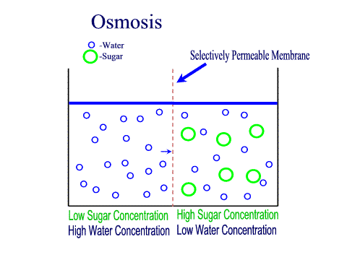
The role of osmosis in plant health and food preservation
- Plant Health
Condition | Effects
If a plant cell is placed in a solution with the same concentration as their cytoplasm | Water will move in and out of the cell via the cell membrane at the same rate
If a plant cell is placed in a solution less concentrated than their cytoplasm | Excess water will move into the cell via osmosis and into the vacuole which swells and pushes the cytoplasm against the cell wall. The cell is said to be turgid – it does not burst as plant cells have a cell wall
If a plant cell is placed in a solution more concentrated than their cytoplasm | Water passes out of the cell, turgor pressure is the lost, the cell becomes flaccid – this is called plasmolysis and it causes wilting in plants
A turgid cell is a cell in which the cytoplasm and cell membrane are pushed against the cell wall.

The role of osmosis in plant health are summarised
Concentration of cytoplasm of plant cell | Concentration of surrounding environment | Direction of osmosis | Effect | Role in plant health
2% concentration of sugar/salt | 5% concentration of sugar/salt | Water moves into the plant cell | Plant cell becomes turgid | Give structure and support to the plant
6% concentration of sugar/salt | 4% concentration of sugar/salt | Water moves out of the plant cell | Plant cell undergoes plasmolysis | Plant wilts
3% concentration of sugar/salt | 3% concentration of sugar/salt | Water moves in and out of the plant cell | No change in mass or volume of the plant cell | Plant cell does not change shape

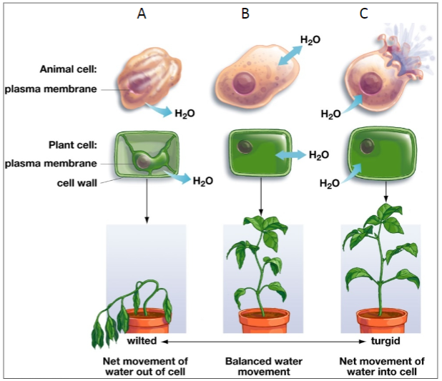
- Food preservation
The growth of micro-organisms on food causes the food to spoil. Micro-organisms such as bacteria and fungi need water to survive.
In jam making, a high level of sugar is added to the fruit to make the jam. When micro-organisms land on the jam, they lose water by osmosis and thus die. This extends the shelf-life of the jam, thereby preserving it.
Similarly, foods such as meat and fish are soaked in a very salty solution. Micro-organisms on the food will lose water and thus die due to osmosis

Active Transport
Many cells need to take in substances which are already in high concentration within the cell. Active transport is the process where substances are taken into the cell, using energy, against the concentration gradient.
Active transport is the movement of molecules from a region where the molecules are in low concentration to a region of where the molecules are in high concentration.
For example, the cells in the small intestine (the ileum) absorb glucose molecules by active transport.

Investigate factors affecting rates of osmosis across semi-permeable membranes
The rate of osmosis is the speed at which water molecules move from a region of high-water concentration to a region of low water concentration.
Factors affecting osmosis include
The higher the temperature, the faster the rate of osmosis.
The greater the concentration gradient, the faster the rate of osmosis.
The greater the surface area, the faster the rate of osmosis.

To investigate the effect of temperature on the rate of osmosis across semi-permeable membranes
The rate of osmosis is the speed at which water molecules move from a region of high-water concentration to a region of low water concentration.

Temperature: Higher temperature causes the water molecules to move faster as they have more energy. Water molecules move slower at lower temperatures.

The independent variable is the temperature of the water baths.
The dependent variable is the change in mass of the potato
.
The controlled variables are the volume of water, the size of potato pieces, the type of potato pieces and the time in the water baths.

The rate of osmosis is measured by calculating the percentage change in mass after a set time duration.

To ensure fairness only one variable is changed – the temperature of the water baths – while all other variables are kept constant.

Comments:
- Quantitative data was collected.
- To ensure reliability, this investigation could be repeated three times and the average calculated
- To ensure accuracy, the temperature of the water bath could be kept constant by using a thermostatically controlled water bath
- To ensure precision, the potato pieces could be cut with a cork borer and scalpel
- To limit sources of error, dry the potato pieces gently before weighing to remove surface water, avoiding extra mass.

SEC Sample Paper Questions
