Enzymes

Enzymes are Biological Catalysts.
Enzymes control the rate at which metabolic reactions occur.
Enzymes are referred to as Catalysts as they alter the rate of a chemical reaction without being used in the reaction itself
Enzymes are selective catalysts
Enzymes are made of chains of amino acids (which are made in the ribosome) which are folded into a globular 3D shape.

Features of Enzyme Action
A substrate is the substance an enzyme joins with.
The product is the substance produced by the action of an enzyme
Enzymes work because they have the correct shape to fit the substrate. Anything that changes the shape of an enzyme (pH, temperature etc) will reduce the efficiency of the enzyme to speed up a reaction.
Enzyme Specificity: Enzymes will only reach with one particular substrate
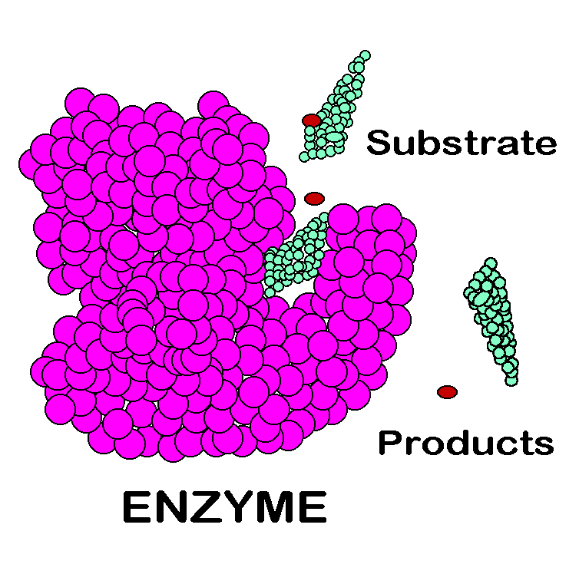
Substrate | Enzyme | Product
Starch | Amylase | Maltose
Maltose | Maltase | Glucose
Lipids | Lipase | Fatty acids & glycerol
Pepsin | Pepsin | Amino acids

The part of the enzyme that binds with the substrate is called the Active Site
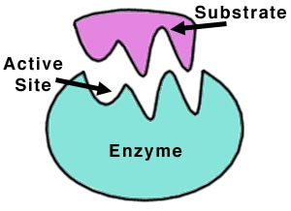
Active-Site Theory / Induced-Fit Theory
The Active site of an enzyme closely fits the shape of that enzymes’ substrate. Therefore, a certain enzyme will only work on its own specific substrate.
- Each active site is specific for a particular substrate

- The enzyme now slightly alters the shape of its active site to fit the substrate more exactly and to put the substrate under strain.

- The substrate binds to the active site, forming an enzyme-substrate complex

- The product is then released from the active site. The active site is now available to repeat the process with more of the substrate (not used up in the reaction – Catalyst).

Factors affecting Enzyme Activity
Anything that alters the shape of an active site will reduce the ability of the enzyme to work effectively.
The shape of the active site is particularly sensitive to pH and Temperature.
pH
For most enzymes, the optimum activity occurs at pH 7 (neutral). Some enzymes such as Amylase works best at pH 9 (basic) while others such as Pepsin work best at pH 2 (acidic).
Optimum pH = the pH at which the enzyme works best at.
If an enzyme is present in an unsuitable pH, then the active site of the enzyme will change shape and will no longer be able to bind to the substrate. The Enzyme is said to be Denatured.
Denaturation = the permanent loss enzyme shape and function due to extreme pH or temperature
During an experiment involving enzymes, the pH must be kept constant. To do this a buffer solution is used. E.g., to keep a constant pH of 7, the buffer 7 solution is used.
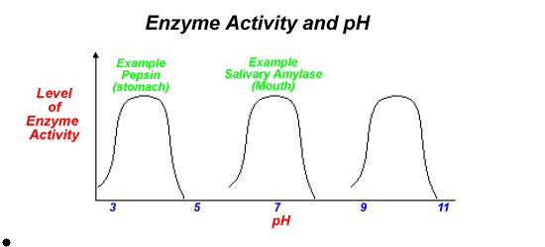
Temperature
For Human enzymes, their optimum activity occurs at 37^{O}C while plant enzymes work best at 25^{O}C
A rise in temperature causes the active site to change shape and it will no longer be able to carry out it’s function. It will be Denatured.

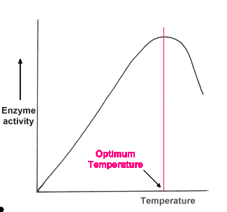
Immobilised Enzymes
Bioprocessing is the use of enzyme-controlled reactions to make a product
Bioprocessing is used by many pharmaceutical and food companies to produce high quality products very quickly and cheaply.
A bioreactor is a vessel in which these useful products are made by cells
Enzymes are now immobilised before partaking in bioprocessing.
Immobilised enzymes are enzymes that are attached to or trapped to an inert (inactive) material
Benefits of Immobilised Enzymes
- Immobilised enzymes can be reused many times
- Immobilised enzymes are protected in gel and so are more stable
Uses of Immobilised Enzymes

Food Industry
Amylase: Breaks down starch into sugars in baking (improves dough texture) and brewing (converts starch to fermentable sugars).

Biofuel Industry
Cellulase: Break down plant biomass (cellulose) into sugars for fermentation into ethanol.

Pharmaceutical Industry
Penicillinase: Used to modify antibiotics like penicillin to produce new versions.

To investigate factors affecting the rate of enzyme-catalysed reactions, use primary and secondary data to support conclusions
Factor = substrate concentration, enzyme concentration, environmental pH, temperature, subject to denaturation
Enzyme = Catalase
Source of enzyme = Celery
Substrate = Hydrogen peroxide
Products = Water and oxygen
In an investigation, only change one variable, while keeping all other variables constant – this is to ensure a fair test.
Repeat the investigation so that the results are more reliable.
The rate of enzyme activity is measured by reading the volume of foam produced per minute
To investigate the effect of temperature on the rate of enzyme activity.
- Add 20 ml of one of the selected pH buffers to a graduated cylinder.
- Using a dropper, add one drop of washing-up liquid to the graduated cylinder.
- Add 5g of finely chopped celery to the cylinder.
- Add 2 ml of hydrogen peroxide to a boiling tube.
- Stand the cylinder and the boiling tube in an ice-cold water bath until the desired temperature (4^{O}C) is reached in both.
- Pour the hydrogen peroxide into the cylinder.
- Note the volume in the cylinder immediately and record.
- Read the volume again after a measured amount of time, e.g. 2 minutes, and record.
- Subtract the initial volume from the final volume to get the volume of foam and record.
- Repeat the procedure from step 1 for at least four more temperatures, to include a sample in the 50^{O}C – 60^{O}C range.
Results:
Temperature (^{O}C)
Initial volume (ml)
Final volume (ml)
Volume of foam produced (ml)

Enzyme Graphs
- Temperature on rate of activity

- pH on rate of activity

- Substrate concentration on rate of activity

- Enzyme concentration on rate of activity

