Viruses
Viruses are considered non-living and are not included in any of the five kingdoms of living organisms.
Viruses can only be viewed under an electron microscope because they are so small
Viruses contain features both living and non-living matter
Living features | Non-living features
- They have one type of nucleic acid  - They have a protein coat  - They can replicate and pass on genetic material | - They only have one type of nucleic acid – rather than both  - They do not contain any organelles  - They cannot reproduce  - They cannot respire or feed  - They are non-cellular and do not carry out metabolic reactions on their own
Viruses are obligate parasites – they must feed on or in another living organism to survive
Structure of viruses
Viruses consist of a protein coat, inside which is a strand of nucleic acid – either DNA or RNA
Viruses affect humans, animals, plants and bacteria.
- Viruses cause human diseases such as Mumps and the Flu
- Viruses cause animal diseases such as Rabies and Foot & mouth
- Viruses cause plant diseases such as the Tobacco Mosaic disease
- Viruses called Bacteriophages control bacterial infections
Bacteriophages – viruses that affect bacteria
Viruses are classified by their shape
- Rod-shaped e.g. Tobacco Mosaic Virus
- Round shaped e.g. Flu
- Complex shaped e.g. Bacteriophage
Viral Replication
- Attachment
The virus attaches to the host cell
- Entry
The virus pushes its nucleic acid through a hole into the host cell
- Synthesis
The host DNA becomes inactive. The viral nucleic acid uses the host cells organelles to produce new viral nucleic acid and proteins
- Assembly
New viruses are made inside the host cell
- Release
The host cell bursts to release new viruses. The bursting of the host cell is called lysis.

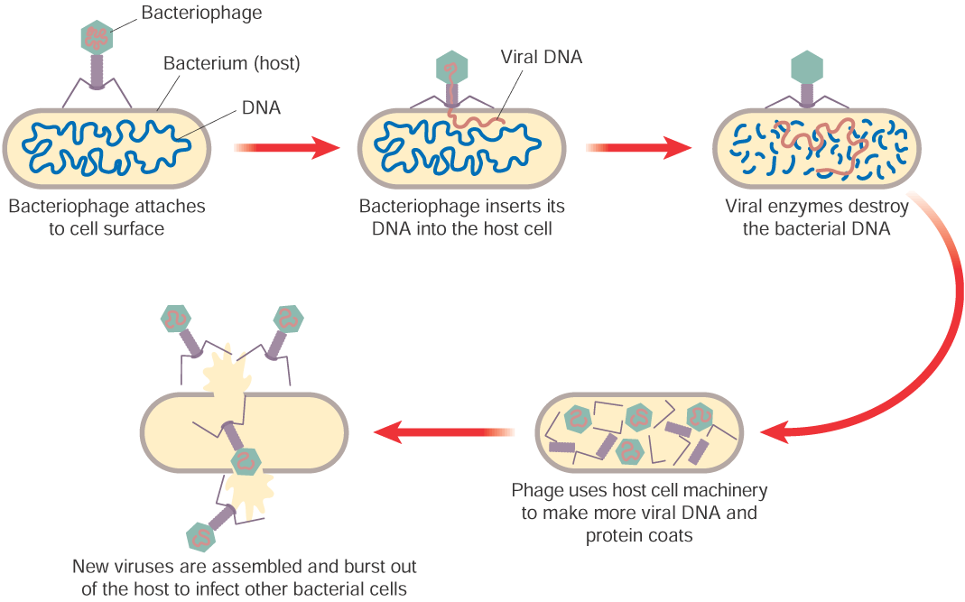
Medical and Economic Importance of Viruses
Benefits:
- Viruses called vectors are used to transfer genes from one organism to another in genetic engineering
- Bacteriophages are used to control bacterial infections

Disadvantages:
- Viruses cause human diseases such as Mumps and the Flu
- Viruses cause animal diseases such as Rabies and Foot & mouth
- Viruses cause plant diseases such as the Tobacco Mosaic disease
These diseases cause medical problems resulting in economic losses (medical costs) and time lost at work

Control of Viruses
Viruses are controlled by the body’s general defence system (skin, stomach acid) and by the specific defence system (antibodies produced by white blood cells).
Vaccinations can be used for protection against some viral disease.
Antibiotics have no effect on viruses.

