Classification Systems
Strand: Organisation of Life
Learning Outcomes: 1.1.3, 1.1.4

Review Questions
19.1
(i) What is taxonomy?
(ii) Define the term ‘species.
(iii) Write down three examples of different species.
(iv) Outline two reasons why classification is important for biologists.
(v) Classification systems have been enhanced by developments in science brining about new evidence. Write down two examples of scientific developments which have led to more evidence for classification.
19.2
(i) Name the scientist who proposed the seven levels or ‘taxa’ to classify organisms based on similar characteristics.
(ii) Identify the taxa in which groups of closely related species are grouped.
(iii) In relation to taxonomy, distinguish between a family and an order.
(iv) Organisms in the phyla are grouped into six kingdoms. Name the six kingdoms of life
(v) As a result of modern scientific technology, eight taxa were added, which grouped members of the six kingdoms into three broader groups. Name this additional taxon.
19.3
(i) List the 8 levels of biological classification in order, from the broadest group to the most specific.
(ii) Which taxonomic level comes between family and species?
(iii) In the binomial system of naming organisms, which two levels of classification are used?
(iv) Name the three domains of life and state one defining characteristic of each.
(v) Which domain of life do fungi and animals belong to?
(vi) Name the domain that includes organisms that live in extreme environments, such as high-salinity or high-temperature areas/
19.4
(i) Three organisms are named below: using the binomial nomenclature system
Canis lupus, Canis familiaris, Felis catus
Identify which organisms listed belong to the same genus. Justify your answer.
(ii) The red fox is known as Vulpes vulpes. What does each part of this name represent in taxonomic classification?
(iii) Distinguish between eukaryotic and prokaryotic cells.
19.5
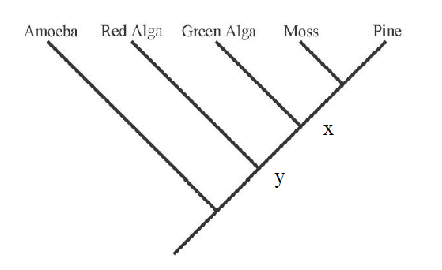
By reference to the tree above, which of the following is an accurate statement of relationships?
a) A green alga is more closely related to a red alga than to a moss
b) A green alga is more closely related to a moss than to a red alga
c) A green alga is equally related to a red alga and a moss
d) A green alga is related to a red alga, but is not related to a moss

19.6
Analyse the phylogenetic tree and answer the questions that follow.

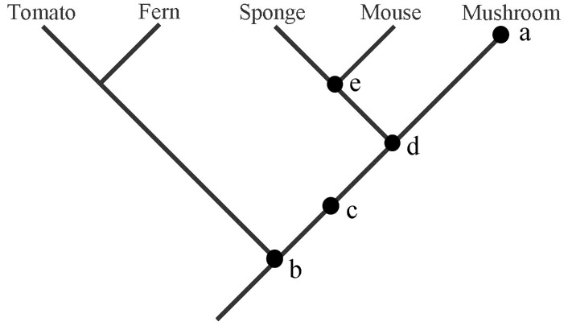
- Identify the species which is most closely related to the tomato. Give a reason for your answer.
- Which of the five lettered dots in the phylogenetic tree corresponds to the most recent common ancestor of a mushroom and a sponge?
- Identify which five lettered dot represents the common ancestor of all of the species displayed in the phylogenetic tree.
19.7
Analyse the phylogenetic tree and answer the questions that follow
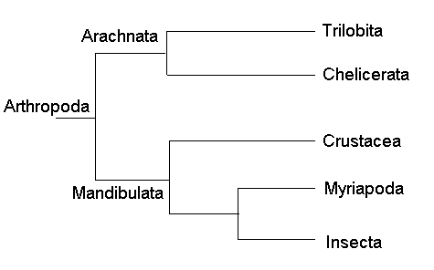
- Identify the common ancestor of all species present in the phylogenetic tree
- In relation to the species Insecta, write down the name of the species that it is most related to.
- In relation to the species crustacea, write down the name of the species that is it least related to.
19.8
- Use the taxonomic classification system classify each of the following organisms into one of six kingdoms
- Fish
- Mushrooms
- Birds
- Salmonella
- Yeast

- Write down two difference between members of the fungi kindgom and members of the plantae kingdom

- What is the purpose of the phylogenetic tree.

- Classification systems have changed over the centuries. Describe, in detail, how the way in which we classify organisms has evolved over time.

19.9
Table 19.1 outlines features of five different species. Analyse the table and answer the questions that follow
Organism | Cell Type | Number of Cells | Mode of Nutrition | Cell Wall Composition | DNA Similar to Human (%)
Homo sapiens | Eukaryotic | Multicellular | Heterotrophic | None | 100%
Pan troglodytes (Chimpanzee) | Eukaryotic | Multicellular | Heterotrophic | None | 98.8%
Saccharomyces cerevisiae (Yeast) | Eukaryotic | Unicellular | Heterotrophic | Chitin | 31%
Escherichia coli | Prokaryotic | Unicellular | Heterotrophic | Peptidoglycan | 7%
Arabidopsis thaliana (Plant) | Eukaryotic | Multicellular | Autotrophic | Cellulose | 25%

- Identify the species which belongs to the bacteria domain
- Chitin, peptidoglycan and cellulose are all components of cell walls. Identify the biomolecule to which these materials belong?
- Pan troglodytes is the binomial name for chimpanzee. Which part of this name is the species name?
- To which kingdom does Saccharomyces cerevisiae belong to?
- Plants are described as autotrophic. Explain the meaning of this term.

Exam-Style Questions on Classification
19.1
(a) Outline why classification is important for biologists.
(b) Scientific ideas are modified over time. With reference to classification, describe how scientific ideas are modified over time.
(c) What term is used to describe a group of closely related species?
(d) What term is used to describe a group of phyla?

19.2
(a) List the eight taxonomic ranks in correct order from most general to most specific.
(b) Explain what is meant by binomial nomenclature.
(c) The red squirrel is named Sciurus vulgaris. Fill in table 19.1 by identifying the genus name and the species name of the red squirrel.
Taxon | Red Squirrel
Genus
Species
Table 19.1

(d) Distinguish between eukaryotic and prokaryotic organisms by writing a sentence about each.

19.3
(a) List the three domains of life and identify one characteristic common to all organisms each domain.
(b) Which of the five kingdoms of life includes organisms that are multicellular, autotrophic, and have cell walls made of cellulose?
(c) Name two differences between the kingdoms Fungi and Plantae.

19.4
A newly discovered organism has no nucleus, a circular loop of DNA, and no membrane-bound organelles.
(a) To which domain does it most likely belong?
(b) Which kingdom might it belong to?

(c) The long-tailed field mouse, Apodemus sylvaticus, is a small mammal common in mainland England. Complete table 19.2 to show the classification of the long-tailed field mouse
Taxon | Name of taxon
 | Eukaryota
Kingdom | Animalia
 | Chordata
 | Mammalia
Order | Rodentia
Family | Muridar
 | Apodemus
 | Sylvaticus
Table 19.2

19.5
Figure 19.1 shows how some animals with hooves are classified
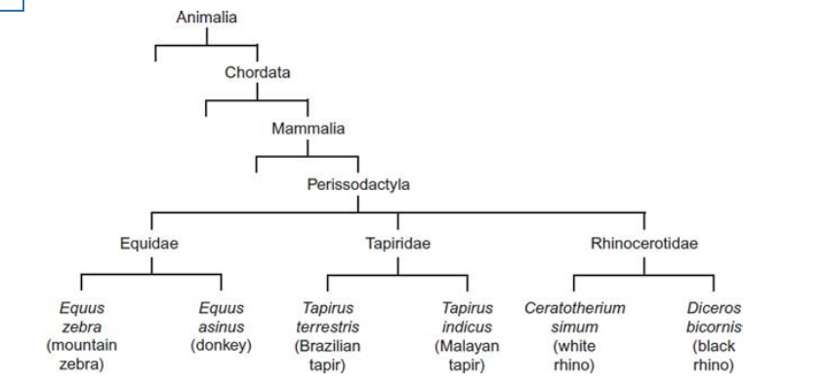

- Name the kingdom to which all organisms in figure 19.1 belong to.
- Identify the domain of life to which all organisms in figure 19.1 belong to

- How many different families are displayed in figure 19.1?

- To which phylum does the white rhino belong to?

- To which class does the order does the black rhino belong to?

19.6
(a) What is meant by the term phylogeny?
(b) A phylogenetic tree is displayed in figure 19.2. The domestic cat is highlighted in red. Analyse the phylogenetic tree and answer the questions that follow
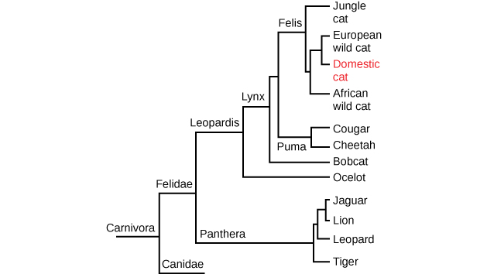
Identify the domain of life to which all organisms displayed in the phylogenetic tree belong. Justify your answer.

Is the Jungle cat closer related to the Cheetah or the tiger? Justify your answer.

Name the closest relation of the domestic cat.

19.7
Interpret the table 19.3 which presents some traits to classify each organism (A–D) into the correct kingdom of life
Organism | Cell Type | Chloroplasts | Cell Wall | Mode of Nutrition | Reproduction
A | Eukaryotic | Yes | Yes: cellulose | Autotrophic | Sexual & Asexual
B | Prokaryotic | No | Yes | Heterotrophic | Asexual (fission)
C | Eukaryotic | No | Yes: chitin | Heterotrophic | Spore formation
D | Eukaryotic | No | No | Heterotrophic | Sexual
Table 19.3
Organism A: ______________________ Organism B: _______________________
Organism C: ______________________ Organism D: ________________________

19.8
Table 19.4 below shows Discovery of new species vs the number of Bioinformatics Papers Published (1990–2020)
Year | New Species Discovered | Bioinformatics Papers Published
1990 | 25,000 | 200
1995 | 30,000 | 500
2000 | 35,000 | 1,200
2005 | 45,000 | 2,500
2010 | 60,000 | 4,000
2015 | 70,000 | 6,000
2020 | 80,000 | 9,000
Table 19.4
(i) Draw a line graph to show both variables over time on the same plot.
(ii) What is the relationship between the number of species discovered and the rise of bioinformatics research?
(iii)Suggest why bioinformatics may influence species classification and discovery.

19.9
Tick the box in table 19.5 for each statement to show which of the three domains of life they belong to:
Statement | Archea | Bacteria | Eukaryota
Have cells with a nucleus
Primitive forms of bacteria
Contains kingdoms protists, fungi, plants & animals
Contains one kingdom
Contains the kingdom bacteria
Contains the kingdom archaea
Includes extremophiles
Table 19.5

19.10
The phylogenetic tree shows the relationships between birds and some reptiles. Analyse the phylogenetic tree and answer the questions that follow.
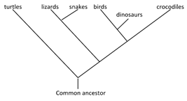

(a) Which group is the closest relative to the snakes?
(b) Are dinosaurs more closely related to crocodiles or birds?
(c) Suggest a reason why the time line for the dinosaurs ceases before those for the other groups.

19.11
Put a tick under the correct column in table 19.6 to categorise each statement as either true or false, and justify your choice.
Statement | True | False | Reason for choice
Taxonomy is the study of classifying organisms based on their characteristics.
A species is defined as a group of organisms that can interbreed and produce fertile offspring.
Carl Linnaeus developed the three-domain system of classification.
The binomial name for humans is Homo sapiens.
Domains are the highest level in the modern classification system.
Prokaryotic cells contain membrane-bound organelles.
Archaea and Bacteria are both made up of unicellular prokaryotic organisms.
Eukaryotic organisms include fungi, protists, plants, and animals.
All organisms in the kingdom Animalia have cell walls.
Phylogenetic trees show evolutionary relationships between species.
Binomial names use a capital letter for the species name and lowercase for the genus.
The fewer the nodes between two organisms in a phylogenetic tree, the more closely related they are.
Table 19.6

19.12
The table below shows part of the nucleotide sequence in a gene in populations of tigers living in different parts of the world.

Siberian tiger | G C A C C G T
South China tiger | A C G C C G C
Sumatran tiger | A C G C C G C

Explain what the information in the table suggests about the phylogenetic relationships between these tigers.

19.13
Put the taxonomic levels in the correct order from most general (1) to most specific (8) in table 19.8
Taxonomic Level | Order (1–8)
Genus
Phylum
Domain
Species
Kingdom
Family
Class
Order
Table 19.8

