The Characteristics of Life
Life is a very difficult concept to define.
Life is incredibly diverse.
Living organisms come in all shapes and sizes, so it is difficult to find traits which they all have in common.
Life describes an organism which shows metabolism and continuity of life.
Metabolism = The sum of all the chemical reactions that place in the body. Metabolism is controlled by enzymes.
Continuity of life = cells arise from cells of the same type and organisms arise from other organisms of the same type.
Metabolism is closely associated with energy conversions as during metabolism energy is released or absorbed.
There are two types of metabolic reactions;
- Anabolic Reactions (Anabolism) use energy to convert smaller molecules into larger molecules e..g Photosynthesis & Protein Synthesis
- Catabolic Reactions (Catabolism) release energy to convert molecules into smaller molecules e.g. Respiration & Digestion
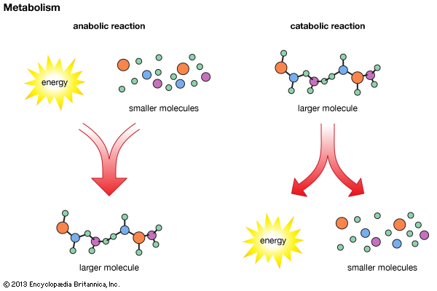

The five Characteristics of Life
‘NERRO’
‘Nutrition, Excretion, Response, Reproduction, Organisation’
- Nutrition
Nutrition is the way organisms obtain and use food.
Organisms primary source of energy on Earth is from the Sun.
Plants and some bacteria use light energy to produce their own food.
There are 2 types of Nutrition
- Autotrophic Nutrition – Organisms that make their own food e.g. plants and some bacteria (photosynthetic bacteria)
- Heterotrophic bacteria – Organisms that cannot make their own food

- Excretion
Excretion is the removal of waste products of metabolism from the body. For example, carbon dioxide is a waste product of the process of respiration – it is excreted by the lungs.
If these waste products build up in the body, they can become toxic. Organisms therefore need to maintain a constant internal environment (Homeostasis)
In animals, organs of excretion are the lungs (carbon dioxide and water), the kidneys (urine) and the skin (sweat).
Plants excrete oxygen through pores in their leaves called stomata, and through pores in their stems called lenticels.

- Response

Response is the way in which living organism react to their environment.
Most living organisms respond to changes in their environment (called stimulus) by some form of movement e.g. plants growing towards sunlight, animals move around for food.

- Reproduction

Reproduction is the formation of new living organisms.

Sexual Reproduction occurs by fusing gametes (sex cells) such as the fusion of the sperm and egg in humans, and the fusion of the pollen and egg in plants. Sexual reproduction involves 2 parents and thus produces variation.

Asexual reproduction involves only one parent and is common in single-celled organisms such as bacteria. They reproduce simply by cell division producing offspring that are identical to the parent (no variation)

- Organisation

Organisation is the way living things are arranged into cells. Some contain only one cell (single-cellular), while others contain many cells (multi-cellular).

A group of cells working together with a similar function forms a tissue.
A group of tissues working together with a similar function forms an organ.
A group of organs with a similar function forms a system.
A group of systems forms an individual.
A number of individuals make up a population.

Call -> Tissue -> Organ -> System -> Individual -> Population

