Vegetative Propagation
Vegatative Propagation involves asexual reproduction in plants.
It does not involve seeds or fertilisation, but rather part of the plant’s stem, root or leaves becoming new plants.
There is no variation in vegetative propagation as only one parent is involved.
Natural Vegetative Propagation
- Stems
Horizontal Stems called Runners grow over the surface of the sol and adventitious shoots grow out of it e.g. strawberries
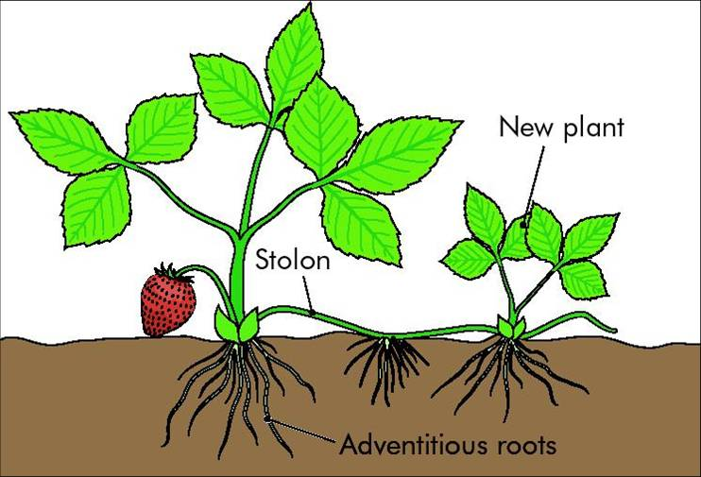
- Roots
Swollen underground roots called Root Tubers swell with stored food and a bud grows near the top of the tubers e.g. dahilas
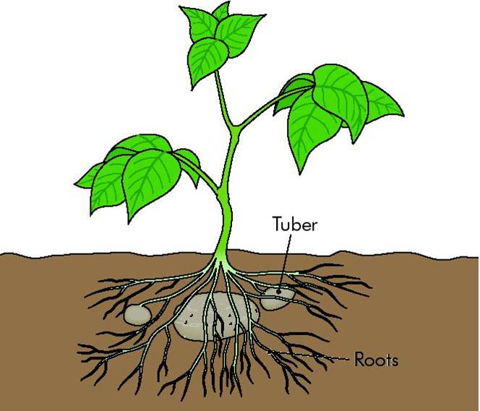
- Leaves
Plantlets are formed along the edges of some leaves which drop off and grow into new plants e.g. Cacti
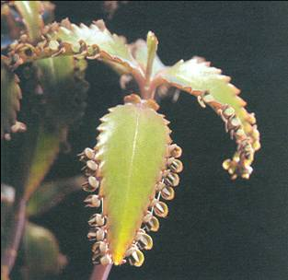

- Bulbs
Underground buds called Bulbs has a reduced stem and roots with a main bud in the centre surrounded by fleshy leaves which grows into a new plant e.g Onions
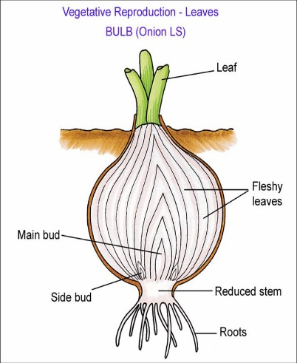

Artificial Vegetative Propagation
These methods are used by gardeners to propagate plants
- Cuttings
Parts of a plant (usually shoots) removed from plant allowed to form new roots and leaves. It is rooted in water, well-watered compost, or rooting powder e.g. busy lizzie, geranium

- Grafting
Part of one plant (scion) is removed and attached to a healthy, rooted part of a second plant (stock). Useful qualities from both plants combined into one e.g. rose flower and thorn-less stem e.g. apple trees
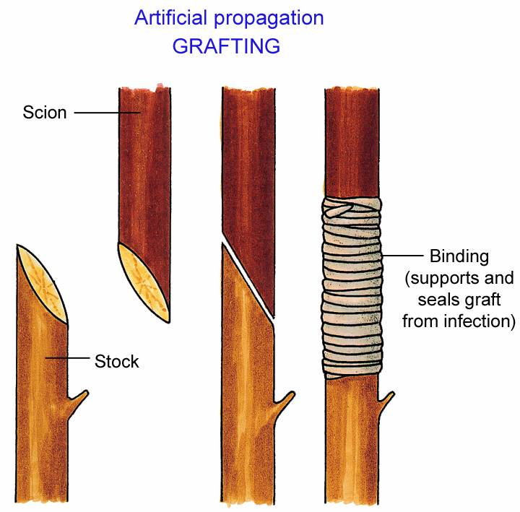

- Layering
A branch of a plant is bent over and pinned to the earth at a node. When roots develop the branch is separated from the parent plant. Useful for the propagation of woody plants e.g. blackberry, gooseberry.
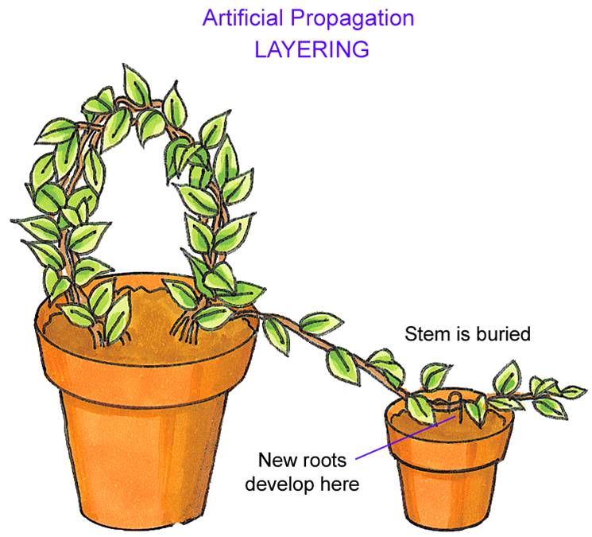

- Tissue Culturing – Micropropagation
Cells removed from plant and grown as a tissue culture in a special medium. Growth regulators and nutrients added so that growing cells form a group of similar cells called a callus

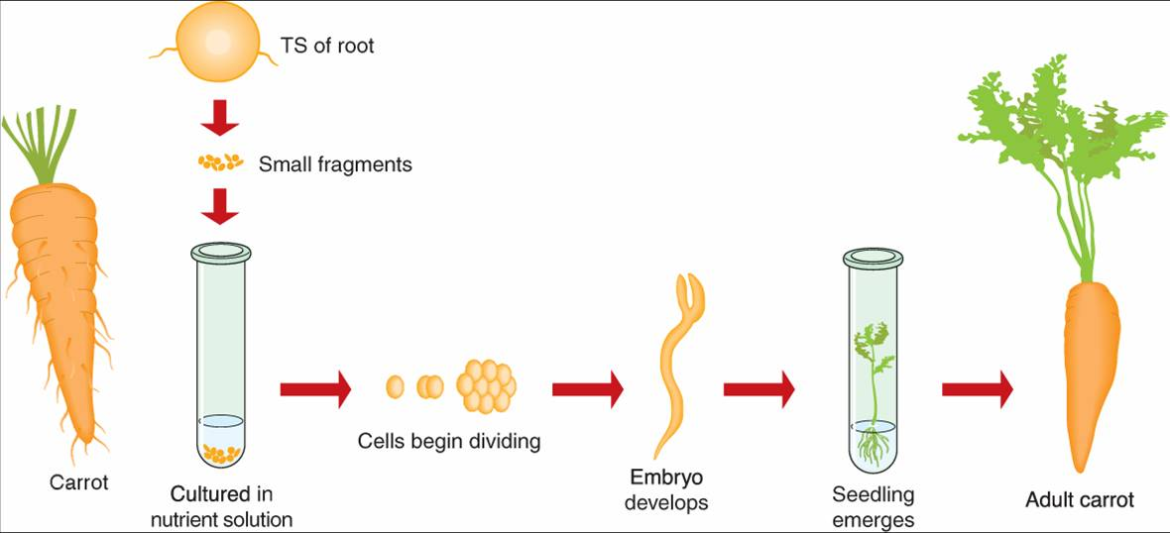

Advantages of Vegetative Propagation;
Sexual (seed) | Asexual (vegetative)
Complex process | Simple process
Depends on outside agents for seed dispersal | No outside agents needed
Slow growth of young plants to maturity | Rapid growth
Wasteful e.g. petals, pollen, fruit | No waste

