Plant Reproduction
There are 2 types of reproduction – sexual and asexual
Sexual Reproduction;
- Two gametes fuse to form a zygote
- Each gamete is produced by a parent
- Offspring produced show variation due to mixing of genes from two parents
Asexual Reproduction;
- Involves only one parent – offspring are therefore genetically identical to parent
- It not require meiosis – the cell divisions are by mitosis
- No gametes involved
Receptacle – supports the flower
Sepal – protects the flower when it is in bud and supports the open flower
Petals – attracts insects for pollen dispersal by colour and fragrance
Stamen – Male part of the plant - is made up of the anther and the filament
- Anther – produces and releases the pollen (male gamete)
- Filament – stalk that supports and holds up the anther
Carpel – female part of the plant – is made up of the stigma, style and ovary
- Stigma – sticky part on which the pollen lands
- Style – connects the stigma to ovary
- Ovary – contains the ovule. The ovule contains the egg (female gamete)

Formation of the Gametes
Formation of the Pollen Grain
- The pollen grain develops in the anther
- Each anther is made up of four chambers called pollen sacs
- Cells inside the anther are diploid which are called Microspore mother cells. These cells get a supply of food from a layer of cells called the tapetum
Fibrous Layer
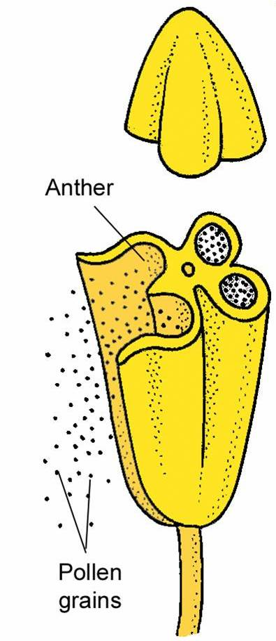
Pollen
Tapetum
Pollen Mother Cells (2n)

- The microspore mother cells divide by meiosis to produce 4 haploid daughter cells called tetrad
- Each haploid cell (pollen grain) divided by mitosis to form 2 haploid nuclei
- One of these is a tube nucleus and the other is called the generative nucleus
- The mature pollen grain forms a tough outer cell walled the exine. The inner wall of the pollen grain is called the intine.
Microspore Mother Cell (2n)
Exine

Intine
Generative nucleus
Tube nucleus
Meiosis
Each pollen grain undergoes mitosis
Tetrad of pollen

Formation of the Female Gamete
- Each ovule has 2 walls called integuments. There is a small opening in the integuments called the micropyle
- The megaspore mother cell (2n) is present in the ovule
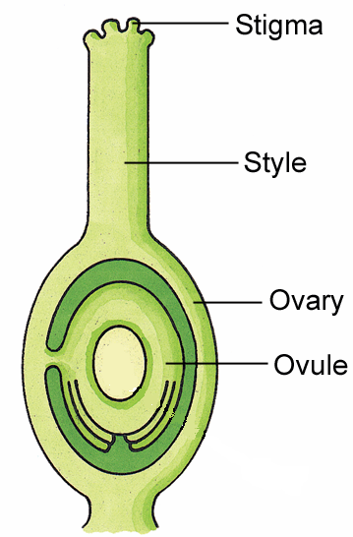
micropyle
Integuments
- The megaspore mother cell (2n) divided by meiosis to produce 4 haploid cells
- 3 of these cells disintegrate
- The fourth undergoes mitosis 3 times to form a single large cell called the embryo sac containing 8 haploid nuclei
- 2 nuclei become the polar nuclei
- One nucleus becomes the egg cell (female gamete)
Egg cell
Polar nuclei
Megaspore mother cell (2n)
Mitosis (3 times)
Embryo sac (n)

Stages of Plant Reproduction
- Pollination
- Fertilisation
- Seed Formation
- Seed Dispersal & Dormancy
- Germination
Pollination
Pollination – the transfer of pollen from the anther to the stigma
2 types of pollination; Self-Pollination & Cross-Pollination
Self pollination – the transfer of pollen from the anther to the stigma of the same plant
Cross-pollination – the transfer of pollen from the anther of one plant to the stigma of another plant
Note: Self-pollination leads to less variation in the offspring
Pollination can be carried out by Wind of Insects
Wind Pollination | Insect Pollination
Small, green petals | Large, coloured petals
No scent or nectar | Scented and has nectar
Anthers are large, outside petals | Anthers are smaller, inside petals

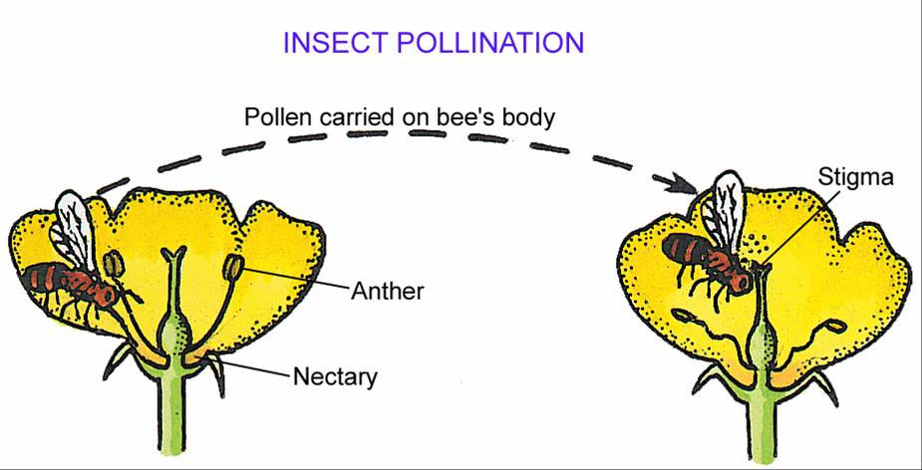
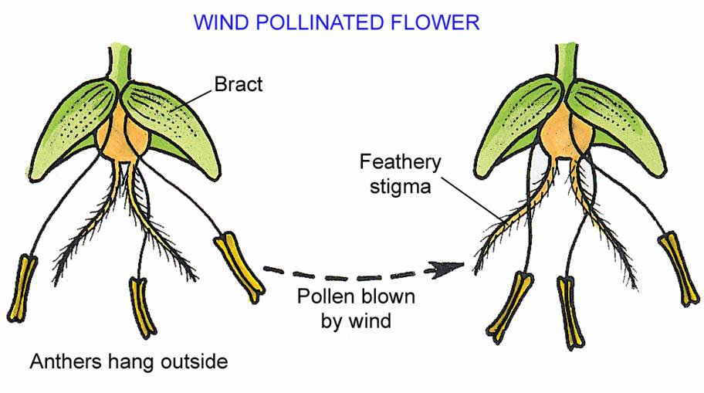
Fertilisation
Fertilisation – the fusion of the male (pollen grain) and female (egg cell) gametes to form a diploid zygote
- When a pollen grain lands on the stigma, it germinates
- The tube nucleus forms the pollen tube which grows down though the style and into the ovule at the micropyle – the pollen tube grows via chemotropism (towards chemicals released from the ovule).
- The generative nucleus moves down the pollen tube and divides by mitosis, which forms 2 haploid male gamete nuclei
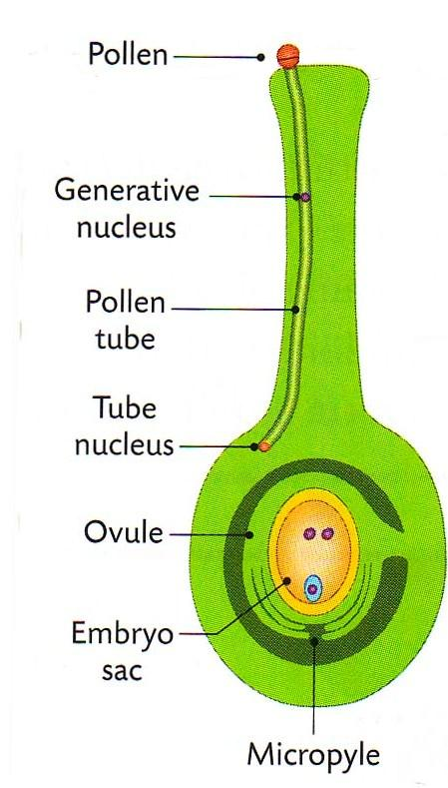
Double Fertilisation:
- One of the male gamete nuclei joins with the egg nucleus (in the egg cell) to form a diploid zygote
- The other male gamete nuclei joins with the polar nuclei to form a triploid endosperm nucleus (3n)
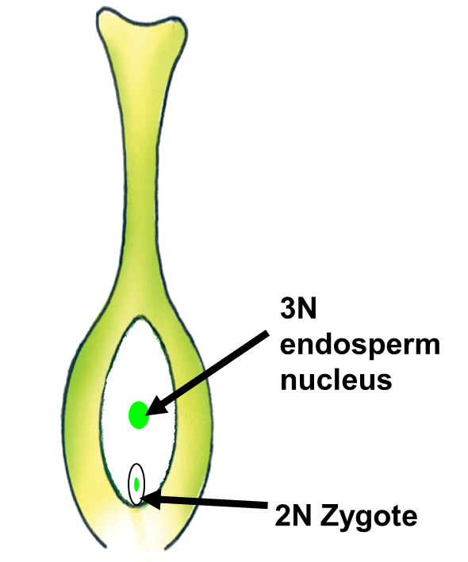
1 male gamete fuses with the egg nucleus to form the diploid zygote
1 Male gamete fuses with the 2 polar nuclei to form the triploid endosperm nucleus
Seed Formation
After fertilisation
- The ovule becomes the seed
- The integuments (walls of the ovule) become the testa (wall of the seed)
- The endosperm nucleus (3n) grows rapidly and forms the endosperm food storage tissue
- The zygote divides by mitosis to form the embryo (which is the new plant)
- The embryo is made up of
- The plumule – the immature shoot
- The radicle -the immature root
- Cotyledon – also called seed leaves – food stores in the seed

Plants that form a seed with a single cotyledon are called Monocots
Plants that form a seed with 2 cotyledons are called Dicots
In monocots, the cotyledon absorbs a small amount of the endosperm to form an endospermic seed
In dicots, the cotyledon absorbs all the endosperm to form a non-endospermic seed
Endosperm
Cotyledon
Plumule
Radicle

Non-endospermic Seed
Dicot Seed Endospermic Seed
Broad Been Monocot seed e.g. Maize

Fruit
Once the seed is formed, the ovary develops into the fruit (stimulated by auxins).
The wall of the ovary, becomes the wall of the fruit called the pericarp.
Fruits can be fleshy (apples) or dry (fruit coat surrounding maize seed or nuts)
Functions of Fruit
- Protect the seeds
- Allow seeds to be dispersed
Seedless fruits can be formed by treating flowers with plant growth regulators
False fruits develop from different parts of the flower other than the ovary e.g. strawberry develops from the receptacle rather than the ovary

Fruit & Seed Dispersal
Seed dispersal – the carrying of the seed as far as possible from the parent plant
Dispersal is necessary to
- Avoid large numbers of seeds competing with each other and the parent plant
- Increases the chances of survival of the plant
- Find new areas for growth
The main methods of seed dispersal are
- Wind Dispersal – usually light seeds that are blown long distances e.g. Dandelion
- Water Dispersal – light, air-filled fruits that can float e.g. Water lily
- Animal Dispersal – hooked fruits can cling to animals hair e.g. goose grass, while edible fruits such as strawberries are pass out of animals via egestion to new areas.
- Self-Dispersal – peas and beans have dry fruits called pods which shrivel and burst to release their seeds

Seed Dormancy
Dormancy – the resting period when seeds undergo no growth and have reduced their metabolism
Before seeds germinate, they go through a period of dormancy
Dormancy is brought about in the following ways
- Growth inhibitors (e.g. abscisic acid) may be present in the outer part of the seeds
- The testa may be too tough to allow the embryo to emerge
Horticultural practices may bring about dormancy
- Soaking the seeds in water
- Scraping their surface to break the tough testa
Advantages of dormancy include
- Helps the seed to avoid harsh winter weather conditions
- Allows time for seed dispersal
- Gives the embryo time to develop fully
Germination
Germination - The re-growth of the embryo after a period of dormancy, if the environmental conditions are suitable

Three conditions are needed for germination – Water, Oxygen & Temperature
Water - Activates the enzymes, Medium for germination reactions e.g. digestion, Transport medium for digested products

Oxygen- Needed for aerobic respiration

Suitable temperature - Allows maximum enzyme activity
Events in Germination;

- Water is absorbed
- Food reserves (Cotyledon & endosperm) are digested
- Digested food is moved to the embryo
- New cells are produced using amino acids
- Glucose is turned into ATP to drive cell division (Respiration)
- Radicle breaks through the testa
- Plumule emerges above ground
- New leaves begin to photosynthesise

Changes in dry weight of seeds during germination
Dry Mass – the mass of solid matter with all the water moved
Mass drops initially due to respiration of stored food, but then begins to increase due to photosynthesis
Mass increases as the seed can photosynthesise and the plant grows
Seed loses mass as it used up starch stores in the cotyledons and/or endosperm as the seed cannot photosynthesise yet
Dry mass of seed (g)
Time (days)

Embryo
Endosperm
Dry mass of seed (g)
Time (days)

As the endosperm tissue is used up, the mass of the embryo increases

Types of Germination
- Epigeal Germination – the cotyledons comes above the ground

- Hypogeal germination – the cotyledons remain below the ground

