Biomolecules
Strand: Organisation of Life
Learning Outcomes: 1.2.1, 1.2.2, 1.2.3, 1.2.4, 1.2.5, 1.2.6,

Revision Questions on Biomolecules
1
Cells need food. Outline three reasons why cells require food.

2
(a) Give the name of six major elements present in biomolecules.
(b) Name four biomolecules
(c) List the elements present in carbohydrates.
(d) Write down the general formula for carbohydrates.
(e) Distinguish between a monosaccharide and a disaccharide
3
- Identify the polysaccharide which is made by plants during photosynthesis.
- What is the role of cellulose in cells?
- Glycogen is a polysaccharide present in animals. What is its role?
- From what molecule is starch formed from?
- Give an example of a structural carbohydrate
- Glucose is an example of a metabolic carbohydrate. What is the role of glucose in cell metabolism?
4
- Proteins are composed of four main elements. Name these elements.
- Some proteins contain two other elements, in addition to the ones you have listed in part (a). Identify these elements.
- Write down the sub-units from which proteins are made from.
- Where in the cell are proteins made
- Distinguish between a peptide and a polypeptide

5
- Give an example of a structural protein in the human body.
- There are many proteins involved in metabolism. Identify the proteins which control the rate of metabolic processes.
- Antibodies are metabolic proteins involved in fighting infection. Protein receptors are also involved in immunity. Outline how protein receptors aid the immune response.
- Distinguish between channel proteins and transporter proteins.

6. Describe the difference between water-soluble vitamins and fat-soluble vitamins. In your answer refer to (i) Examples of each type (ii) Absorption in the body (iii) Storage in the body

7
Describe in detail an investigation you carried out to quantitatively measure the level of reducing sugars in a range of food samples. Draw a labelled diagram to support your answer.

8
A group of students tested various foods for the presence of biomolecules. Their results are shown in table. Analyse the results in the table and answer the questions that follow
Food Sample | Benedict's Test | Biuret Test | Iodine Test | Brown Paper Test
Apple | Orange precipitate | No change | Blue-black | No translucent spot
Chicken | No change | Purple | No change | Translucent spot
Bread | No change | No change | Blue-black | No translucent spot
Milk | Orange precipitate | Purple | No change | Translucent spot

- Is this an example of a quantitative or qualitative test? Justify your answer.
- Which food samples contain reducing sugar? Explain your reasoning.
- Identify which sample(s) contain protein.
- What biomolecules are identified using the brown paper test? Which samples test positive for it?
- Which biomolecule is present in both milk and chicken?
- Suggest why bread shows a positive result for the iodine test.
- To ensure this investigation was fair, with reference to one of the food tests, list three factors which should have been kept constant in that investigation.
- How could the students have increased the reliability of the results they obtained in this investigation?

9.

The data in the table shows the nitrogen content (g) per kg of each of the food item listed. Scientists in a laboratory measured the nitrogen content (g) of each food item three times.
Food item | Measurement 1 Nitrogen content (g/kg) | Measurement 2 Nitrogen content (g/kg) | Measurement 3 Nitrogen content (g/kg)
Cereal | 54.4 | 15.2 | 15.5
Livestock meat | 29.22 | 29.21 | 29.22
Fish | 28.77 | 28.77 | 28.77
Milk | 5.28 | 5.30 | 5.28
Poultry | 29.9 | 30.0 | 30.0
Eggs | 20.48 | 20.48 | 20.47

- The data in the table can be communicated in a graph or a chart. Choose a suitable graph of chart to represent this data. Represent this data using a suitable scales and axes.

- Identify the anomalous food item in the table. Give a reason for your choice.

- Outline how the scientists could have ensured fairness during this investigation

- Identify the food item with the most precise measurement for nitrogen content. Give a reason for your choice.

10

(a) Use biological reasoning to answer the following questions
A blood test reveals a patient has a low red blood cell count and is experiencing fatigue.
(i) Which mineral is likely deficient in this patient?
(ii) What is the role of this mineral in the body?
(iii) Suggest one dietary source to address this deficiency.

(b) A client following a vegetarian diet is advised to increase their protein intake.
(i) What are the basic building blocks of proteins?
(ii) Explain why proteins are essential for both structural and metabolic roles.
(iii) Suggest two suitable plant-based sources of protein for this person.

(c) A nursing home records a number of elderly patients showing signs of dehydration.
(i) What percentage of a human cell is water, approximately?
(ii) Explain how water helps to regulate body temperature.
(iii) Why is water described as a good solvent for transport and metabolic reactions?

(d) During a routine check-up, a patient is advised to reduce their saturated fat intake.
(i) What is the difference between a triglyceride and a phospholipid?
(ii) Why are phospholipids important for cells?
(iii) Name one structural and one metabolic function of lipids.

Exam-Style Questions on Biomolecules
3.1
Organisms are made up of six chemical elements. Fill table 3.1 by writing the name or symbol of each element into the appropriate section.
Name of element | Symbol of element
Nitrogen
 | O
 | C
Phosphorus
 | S
Hydrogen
Table 1.3
3.2
Carbohydrates are a group of biomolecules containing hydrogen, oxygen and carbon. These elements are always present in a fixed ratio, called the general formula for carbohydrates.
(a) Write down the general formula for carbohydrates. ______________________________
(b) Write down the formula for the monosaccharide glucose. _________________________
(c) In relation to carbohydrates, distinguish between a monosaccharide and a disaccharide by writing a sentence about each. _____________________________________________________________________________________________________________________________________________________
3.3
Fill in table 3.2 in relation to polysaccharides by identifying where they are found, and what their role is.
Name of polysaccharide | Where is this polysaccharide found in organisms? | What is the role of this polysaccharide?
Glycogen
Starch
Cellulose
Table 3.2

3.4
Describe one difference between the composition of carbohydrates and the composition of lipids
______________________________________________________________________________________________________________________________________________________
3.5
Lipids are made of sub-units referred to as ‘Triglycerides’. In the space provided, draw a large labelled diagram of a triglyceride

3.6
Figure 3.1 shows the Food pyramid. The recommended number of servings of each food type is given on the pyramid: more from the bottom, less from the middle and very small amounts from the top. Analyse the food pyramid and answer questions (a) to (e).
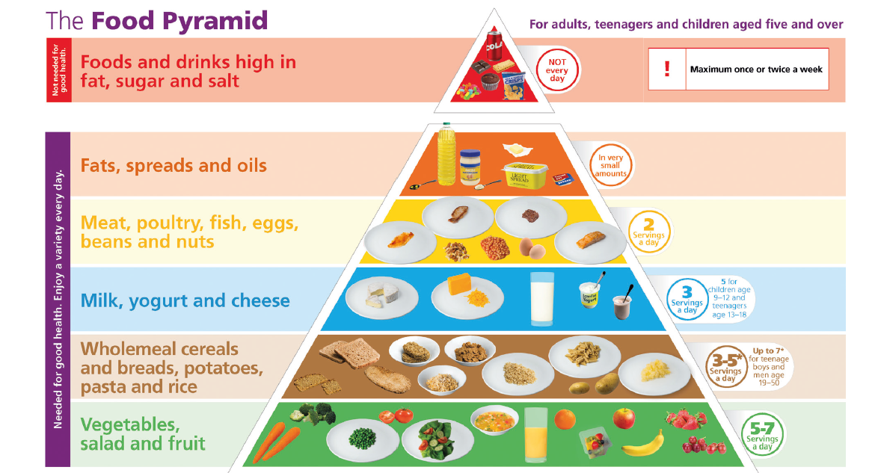
Figure 3.1 The Food pyramid
- From which two food groups listed are amino acids found?
_________________________________________________________
- The carbohydrate group is listed as the second group from the bottom of the pyramid. Write down an example of a structural carbohydrate _____________________________________________________________________
- Lipids, such as fats, spreads and oils are listed as the second from the top of the pyramid. Write down the metabolic role of lipids in cells. ____________________________________________________________________
- Identify a food illustrated in the food pyramid rwhich contains the following biomolecules
- Vitamin C
- Protein
- Starch
3.7
Fill in table 3.3 by identifying whether the molecular formula listed represents is a carbohydrate, a lipid or a protein
Molecular Formula | Type of biomolecule
CH₃(CH₂)_{n}COOH.
C₂H₅NO₂
C₁₂H₂₂O₁₁
C₉H₁₂N₄O_{3.}
C₁₉H₃₉COOH
C₆H₁₂O₆

3.8
Distinguish between a peptide and polypeptide by writing a sentence about each. ______________________________________________________________________________________________________________________________________________________
3.9
Figure 3.2 illustrates different types of proteins, based on their folding into particular shapes. Analyse the images and answer the questions that follow.
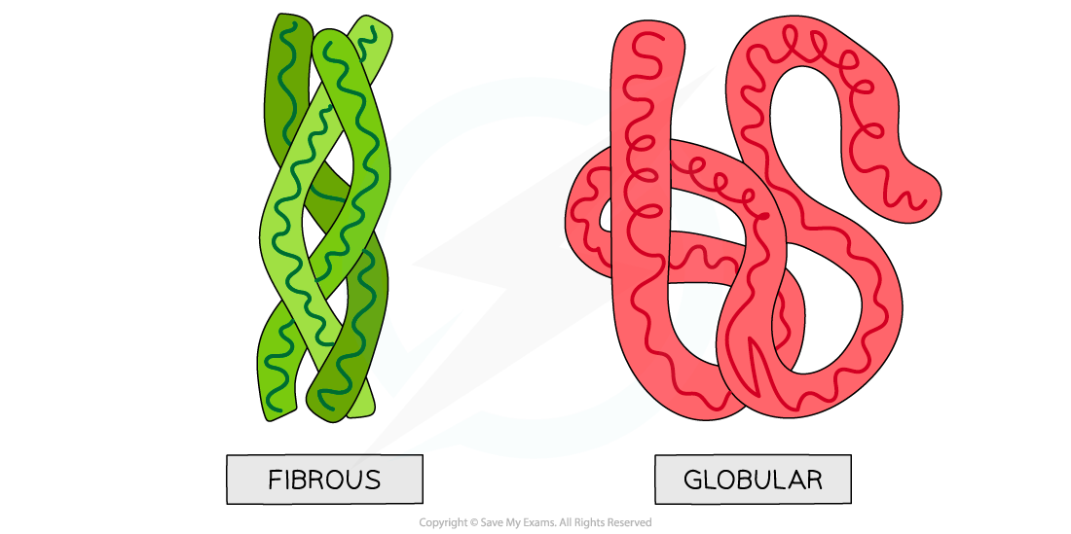
Figure 3.2 Proteins folded into different shapes
- Which protein, A or B, represents a globular protein? _________________________
- Which protein, A or B, represents the shape of an enzyme? ____________________
- Which protein, A or B, represents the shape of proteins found in the skin? _________
3.10
The illustration in Figure 3.3 represents the structure of a cell membrane. Analyse the illustration and answer the questions that follow
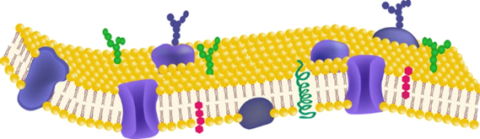
- Identify the biomolecule in labelled with this arrow, which is allows molecules to move in and out of the cell membrane. ____________________________________________________________________
- Identify the biomolecule labelled with this arrow, which is involved in detecting stimuli and trigger’s the cell’s immune system. ___________________________________________________________________
- Identify the biomolecule labelled with this arrow, which makes up the structure of the cell membrane. ____________________________________________________________________

3.11
A student designed an experiment to investigate the relationship between the amount of protein consumed (g) and the volume of urine produced per day (cm³). The student hypothesised that if more protein is consumed, a greater volume of urine is produced per day.
- Is this a testable hypothesis? Justify your answer.
_____________________________________________________________________________________________________________________________________________________
- Identify the independent variable this investigation. _________________________

- Identify the dependent variable in this investigation. _________________________

- Describe how the student could have ensured
- Fairness and (b) integrity in this investigation
_____________________________________________________________________________________________________________________________________________________
3.12
Answer the following questions in relation to a water-soluble vitamin you have studied
- Name the water-soluble vitamin. ______________________________________

- Identify two sources of this vitamin. ____________________________________

- Describe the role of this vitamin. _________________________________________________________________________________________________________________________________________

- Name a disease arising from a deficiency of this vitamin. ___________________________________________________________________
3.13 Compare fat-soluble vitamins and water-soluble vitamins in relation to their (a) ability to be absorbed into the blood and (b) ability to be stored in the body
____________________________________________________________________________________________________________________________________________________________________________________________________________________________________________________________________________________________________________

3.14
Fill in table 3.4 by naming the mineral that carries out the role listed.
Role of mineral in humans | Name of mineral
Regulates nerve function
Facilitates muscles to contract
Strengthens bones and teeth
Makes up part of haemoglobin

3.15
Water has many functions in organisms. Describe in detail, two roles of water in humans which maintain homeostasis.
____________________________________________________________________________________________________________________________________________________________________________________________________________________________________________________________________________________________________________________________________________________________________________________________________________________________________________________________________________________________________________________________________________
3.16
Describe in detail, the procedure you carried out to qualitatively investigate the presence of protein in a range of food samples. Include the description of a control in your answer. Draw a labelled diagram in the space provided to support your answer.
____________________________________________________________________________________________________________________________________________________________________________________________________________________________________________________________________________________________________________________________________________________________________________________________________________________________________________________________________________________________________________________________________________
____________________________________________________________________________________________________________________________________________________________________________________________________________________________________________________________________________________________________________________________________________________________________________________________________________________________________________________________________________________________________________________________________________
Labelled diagram:

3.17
A fizzy drink (red lemonade) containing 2% (2 g/100 cm3) glucose solution was used to prepare different concentrations of glucose solutions as shown in the table 3.5
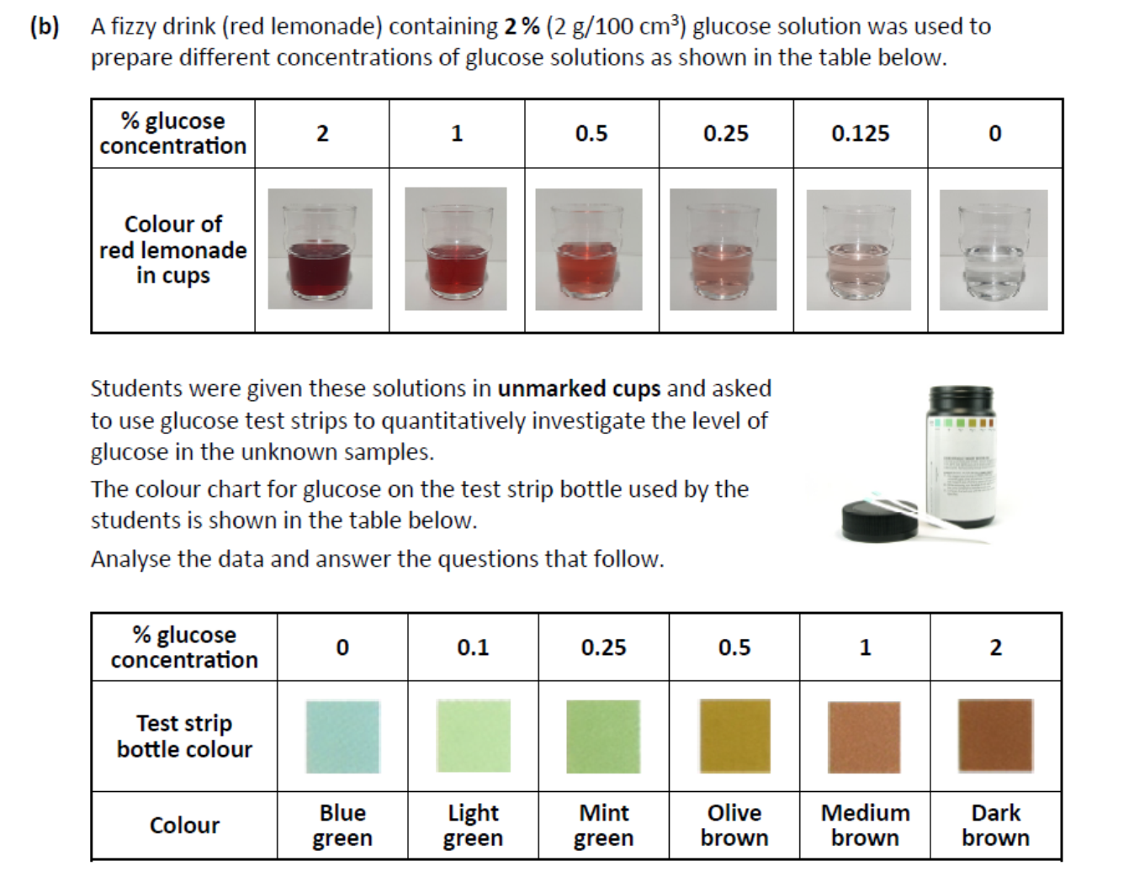Students were given these solutions in unmarked cups and asked to use glucose test strips to quantitatively investigate the level of glucose in the unknown samples.
The colour chart for glucose on the test strip bottle used by the students is shown in table 3.6. Analyse the data and answer the questions that follow.

- How would a student know that is a sample they tested contained 1% glucose solution _______________________________________________________________________________________________________________________________________________________________________________________________________________
- Would a student be able to accurately identify a 0.375 % glucose solution using this technique? Justify your answer.
______________________________________________________________________________________________________________________________________________________________________________________________________________

- Aside from using glucose test strips in the investigation outlined above, describe how you quantitatively investigated the amount of glucose present in a range of food samples.
____________________________________________________________________________________________________________________________________________________________________________________________________________________________________________________________________________________________________________________________________________________________________________________________________________________________________________________________________________________________________________________________________________
____________________________________________________________________________________________________________________________________________________________________________________________________________________________________________________________________________________________________________________________________________________________________________________________________________________________________________________________________________________________________________________________________________
3.18
To carry out a quantitative test for glucose, students used a colorimeter in their school laboratory. A colorimeter is an instrument which passes light through a solution and measures the amount of light absorbed by the solution. Glucose itself is colourless, so it does not absorb visible light directly. To measure glucose concentration using a colorimeter, Benedict’s solution is used. Benedict’s solution reacts with glucose to produce a brick-red product. The graph in figure 3.4 represents the relationship between glucose concentration and absorbance of red light. Analyse the graph and answer the questions that follow.
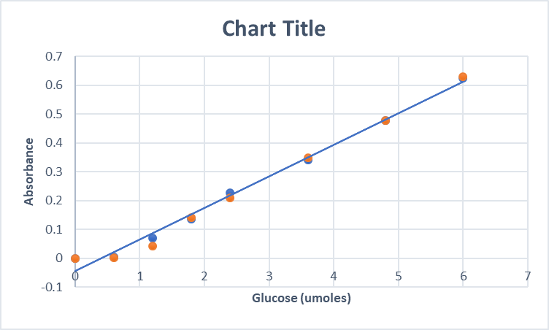
- What is the relationship between glucose concentration and absorbance of light?
_________________________________________________________________________________________________________________________________________

- Describe in detail how the students could have prepared seven solutions of different glucose concentrations.
____________________________________________________________________________________________________________________________________________________________________________________________________________________________________________________________________________________________________________________________________________________________________________________________________________________________________________________________________________________________________________________________________________________________________________________________________________________________________________

- Using the graph in figure 3.4, estimate the concentration of a glucose solution with absorbance of 0.45 Au.
______________________________________________________________________________________________________________________________________________________
3.22
The chemical structure for the hormone adrenaline is shown below. It is made up of the elements C, H, O and N.


