Transport across membranes
Strand: Structures and Processes of Life
Learning Outcomes: 2.6.1, 2.6.2

6.1
Membranes play a vital role in the functioning of cells. Membranes are referred to as semi-permeable.
(a) What is meant by the term ‘semi-permeable’ in relation to membranes.
____________________________________________________________________________________________________________________________________________________________
(b) Write down two examples of semi-permeable membranes found in eukaryotic cells
____________________________________________________________________________________________________________________________________________________________
(c) Define the term ‘diffusion’
____________________________________________________________________________________________________________________________________________________________
(d) Fill in table 6.1 by writing in the word ‘active’ or ‘passive’ in relation to the transport processes listed
Process of transport | ‘Active’ or ‘Passive’
Osmosis
Active transport
Diffusion
Table 6.1
6.2
(a) Identify two locations in plants where diffusion occurs.
____________________________________________________________________________________________________________________________________________________________
(b) Distinguish between diffusion and osmosis by writing a sentence about each
________________________________________________________________________________________________________________________________________________________________________________________________________________________________________________________________________________________________________________________
6.3
The images show red blood cells placed in salt solutions of different concentrations. Animal cells such as red blood cells do not have a cell wall.
A B C
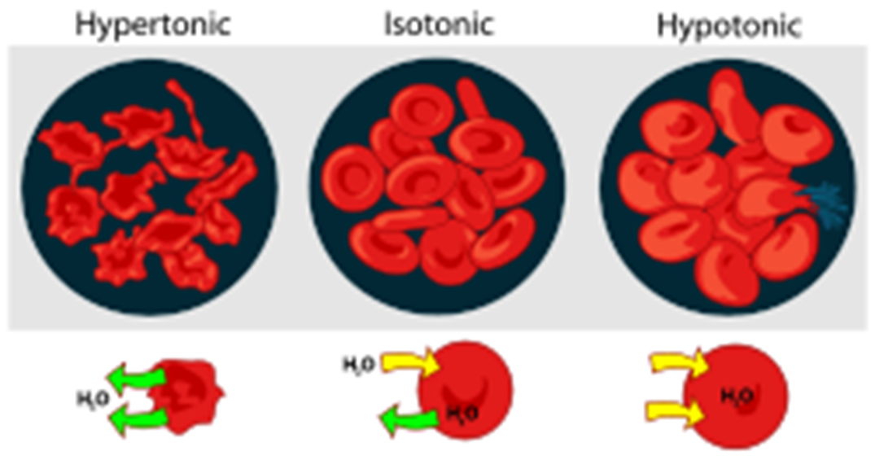
- Fill in table 6.2 by writing A, B or C next to the appropriate description of the movement of water.
Movement of water | Image which matches description
Water moves in and out of the cell by osmosis at the same rate resulting in no net change in mass
Water moves out of the cytoplasm into the surrounding environment by osmosis
Water moves into tje cytoplasm from the surrounding environment by osmosis

Table 6.2
- Analyse the images above and suggest what is occurring to the red blood cells in image C.
____________________________________________________________________________________________________________________________________________________________
- If a plant cell was placed in the same salt solution as the red blood cell in image C, would the same process you outlined in part (b) occur? Justify your answer.
____________________________________________________________________________________________________________________________________________________________

6.5
Students carried out an experiment to investigate the effect of concentration on the rate of osmosis in carrots. 10 carrots were obtained and cut into cylinders. The mass of the carrots was recorded. Some carrots were placed in a solution of tap water. The other carrots were placed in a sugar solution. After a period of time, the mass of the carrots was once again found. The results obtained are displayed in table 6.3.
Carrots | Initial mass (g) | Final mass (g)
Carrots in tap water | 12.6 | 13.2
Carrots in a salt solution | 12.9 | 11.3
Table 6.3
- Identify the independent variable in this investigation: _____________________________________________________________________
- Identify the dependent variable in this investigation: _____________________________________________________________________
- Calculate the change in mass of the carrots in tap water and hence calculate the percentage change in mass. __________________________________________________________________________________________________________________________________________
- Calculate the change in mass of the carrots in the salt solution and hence calculate the percentage change in mass. __________________________________________________________________________________________________________________________________________
- Suggest how the students could have ensured fairness in this investigation. __________________________________________________________________________________________________________________________________________
- Using biological reasoning, give an explanation for the results obtained in table 6.3. ______________________________________________________________________________________________________________________________________________________________________________________________________________________________________________________________________________________________________________________________________________________________________________________________________________________________
- The students notice that the electronic balance being used incorrectly added 0.3g to each data value. Is this an example of a random or systematic error? Justify your answer. __________________________________________________________________________________________________________________________________________

6.6
Figure 6.3 shows the effect of concentration on osmosis in plant cells, and its ultimate effect on plants. Analyse the images in figure 6.3 and answer the questions that follow.
[
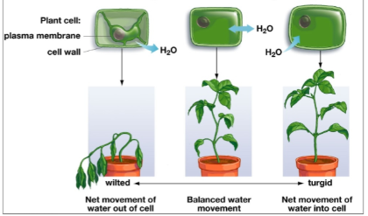

- Identify the image which shows a plant with turgid plant cells. ____________________
- In the space below, draw a labelled diagram of a plant cell which is turgid

- The plant in the first image appears to be wilting. Describe the environmental conditions likely responsible for this. Hence, explain how these conditions affect the direction of osmosis in the plant’s cells.
_____________________________________________________________________________________________________________________________________________________________________________________________________________________________________________________________________________________________________________________________________________________________________________________________________

6.7
A group of students carried out an experiment to investigate the effect of concentration on the rate of osmosis in potatoes. Figure 6.4 displays a graph of the results obtained by the students.
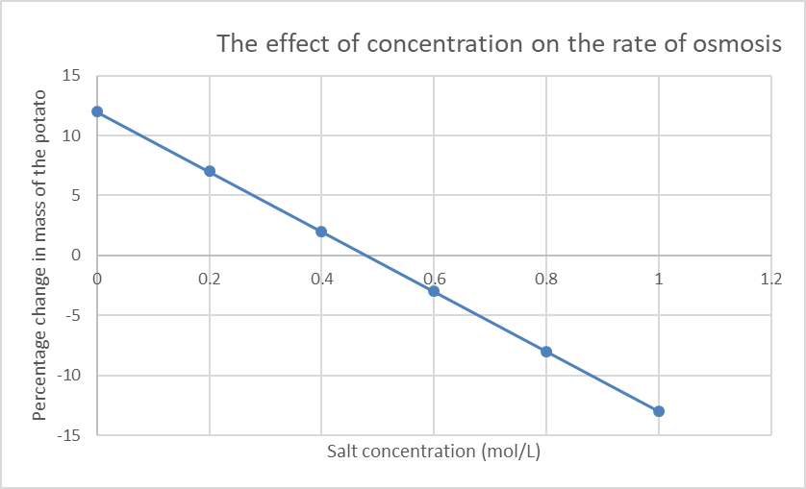
- Identify the percentage change in mass when the potato was placed in a salt concentration of 0.4 mol/L. _____________________________________________
- Name the substance that caused the change in mass of the potatoes. ______________________________________________________________________.
- Identify the process by which the substances you have named in part (b) enter and leave the potato cells. _______________________________________________________
- Write down the salt concentration at which there was no change in the mass of the potato. _____________________________________________________________________
- What does the concentration you have named in part (d) suggest about the concentration of the potato cells. ___________________________________________________________________________________________________________________________________________________________
- Describe the appearance of the potato cells exposed to a salt concentration lower than 0.2 mol/L. ___________________________________________________________________________________________________________________________________________________________
- Describe the effect on the health of potato exposed to salt concentration of 1 mol/L
___________________________________________________________________________________________________________________________________________________________
- Suggest how the students could have ensured reliability in this investigation. ___________________________________________________________________________________________________________________________________________________________
- Write down two other factors, aside from concentration, that affect the rate of osmosis. ___________________________________________________________________________________________________________________________________________________________
6.8
The image displayed in figure 6.4 shows fruit being preserved.
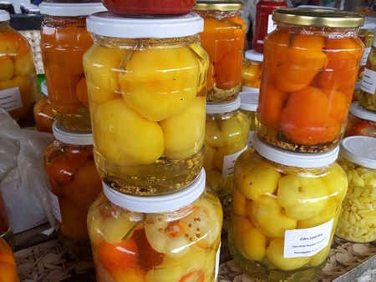
Describe the role of osmosis in food preservation.
________________________________________________________________________________________________________________________________________________________________________________________________________________________________________________________________________________________________________________________________________________

6.9
A student carried out an investigation on the movement of water in and out of plant tissue. During the investigation, 10g of cucumber were placed in different salt concentrations (M= molarity) and the final mass of each was recorded after 1 hour. The student collected the data outlined in table 6.3. Analyse the data and answer the questions that follow. Note molarity is a measure of concentration
Salt concentration (M) | 0.0 | 0.2 | 0.4 | 0.6 | 0.8 | 1.0 | 1.2 | 1.4 | 1.6
Change in mass (g) | + 0.5 | 0 | -0.3 | -0.6 | -0.9 | + 0.2 | -1.5 | -1.6 | -1.8
- Using the grid provided, draw a suitable graph of the data the students obtained.


- Name the dependent variable in this investigation. _______________________________________________________________________

- What term describes the movement of water across a semi-permeable membrane.
_______________________________________________________________________

- Circle the anomaly in the graph you have drawn. Give a reason for your choice. ________________________________________________________________________________________________________________________________________________
- Suggest whether the anomaly had been caused by a random or systematic error. Justify your answer.
________________________________________________________________________________________________________________________________________________________________________________________________________________________
- Ignoring the anomaly, what conclusion can the student make from this investigation based on the data collected?
_______________________________________________________________________________________________________________________________________________________________________________________________________________________
- Molecules such as chlorine and glucose are taken into plants by active transport. What is meant by the term ‘active transport’. ________________________________________________________________________________________________________________________________________________________________________________________________________________________

Review Questions
6.1
(a) Define diffusion.
(b) Give two examples of substances that enter or leave cells by diffusion.
(c) What is osmosis?
(d) Define the term ‘semi-permeable'.
(e) Write down two examples of semi-permeable membranes in cells.
(f) What role does the semi-permeable membrane play in osmosis?
6.2
(a) State one example of osmosis in (a) plants (b) animals.
(b) Why does a plant cell become turgid when placed in pure water?
(c) Define the term ‘turgid’.
(d) Explain what happens to plant cell if placed in a concentrated salt solution, for example if a plant is placed in soil with high salinity.
(e) Farmers often spray concentrated salt solutions on slugs. Explain why this kills the slugs in terms of osmosis.
6.3
(a) How does active transport differ from diffusion and osmosis?
(b) How does active transport help root hair cells absorb minerals from the soil even when their concentration is lower in the soil?
(c) Why is energy required for active transport but not for diffusion or osmosis?
6.4
Answer the following questions in relation to an experiment in which you investigated the effect of a named factor on the rate of osmosis
(a) Identify the independent variable in this investigation
(b) Outline how the independent variable was changed in this investigation
(c) List three factors which were kept constant during this investigation.
(d) Draw a labelled diagram of the apparatus used to carry out this investigation.
(e) Describe how the rate of osmosis was measured in this investigation.
(f) Outline how you ensured your results were accurate during this investigation.
6.5
Use the data in table 6.5 showing the percentage change in mass of potato pieces placed in different sucrose solutions:
Sucrose Concentration (%) | Initial Mass (g) | Final Mass (g) | Percentage Change (%)
0 | 5.0 | 6.0 | +20%
5 | 5.0 | 5.5 | +10%
10 | 5.0 | 5.0 | 0%
15 | 5.0 | 4.5 | -10%
20 | 5.0 | 4.0 | -20%
Table 6.5
- Plot a line graph of percentage change in mass against sucrose concentration.

- At what sucrose concentration is there no net change in mass? What does this suggest about the solution and the potato cells?

- Explain why the potato gains mass in low sucrose concentrations but loses mass in high sucrose concentrations.

- Predict what would happen if the potato piece was placed in a 25% sucrose solution. Explain your reasoning.

- If the temperature was increased during the experiment, how might this affect the rate of osmosis?

6.5
Bubble Tea is a Taiwanese drink that has become popular in Ireland. It gets its name from the flavoured bubbles, or ‘boba’ that sits at the bottom of the drink. To make these ‘boba’, sugary tapioca pearls are boiled in water. This causes the tapioca pearls to swell up and become soft and ‘chewy’. The tapioca pearls absorb water by osmosis.
(a) Define the term osmosis
(b) List two factors that affect the rate of osmosis
(c) Sometimes bubble tea parlous make too many boba for one day. To avoid waste, the bubble tea parlous store the boba overnight. It is important to store the boba correctly to ensure they maintain their shape and size.
Boba contains approximately 10% sugar. It is stored at room temperature (20^{O}C)
Explain what would happen to boba if it were stored in
(i) Pure water
(ii) 10% sugar solution
(iii) Pure water at 35^{O}C
6.7
The images and table below show how a student prepared an activity to investigate the effect of surface area on the rate of osmosis
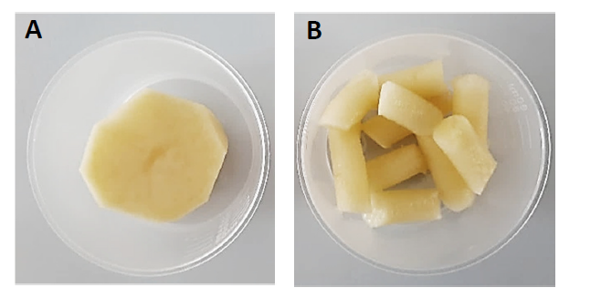
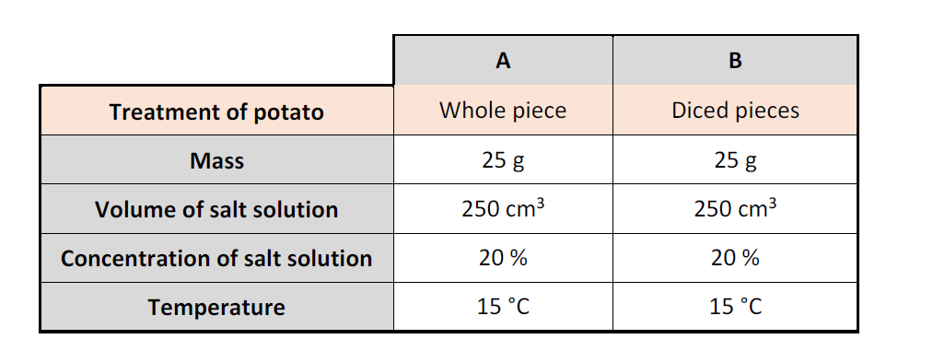
- Analyse the images and the table, and pose a hypothesis for this investigation

- State one way in which the students ensured this investigation was fair

- Identify the dependent and independent variables in this investigation

- The student measured the rate of osmosis by measuring the loss in mass of the potatoes every 10 minutes for 60 minutes. The results of the investigation were presented in the table below. Using suitable axes and scale draw a graph of the data in the table.

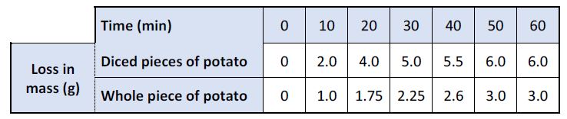
- Using the graph, how long did it take the whole piece of potato to lose 2 g of water?

- Analyse the graph. State a conclusion for the student’s investigation.
6.9 Using biological reasoning to explain each of the following phenomena
(i) Organs donated for transplant are stored in special cold solutions that match the internal concentrations of the organ’s cells. Why is it important that the solution has the right salt concentration? What would happen if the solution was too dilute or too salty?
(ii) In hospitals, IV fluids must match the patient’s internal water and salt concentrations. What might happen to red blood cells if pure water is accidentally given via IV instead of a balanced solution?

