Cell Continuity
Cell Continuity – all cells develop from pre-existing cells that underwent cell division
Growth and reproduction depend on cell division.

Chromosomes & Genes
Chromosomes are thread-like structures made of DNA and protein which are found in the nucleus of cells.
Chromosomes are made of 60% protein and 40% DNA.
When a cell is not dividing (in interphase) the chromosomes are in long thin threads that are known as chromatin.
At cell division, the chromatin contracts to form a number of clearly distinguishable chromosomes.
Sections of DNA that are found along chromosomes which contain the instructions for the formation of a protein are called Genes
Genes are said to be units of inheritance.
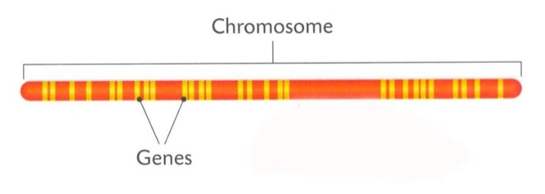
Each gene controls the development of a particular characteristic or trait of an individual.
Each gene has a specific position (called a locus) on a chromosome
Somatic cells are cells in the body that are not involved in reproduction.
Gametes are sex cells which are involved in reproduction.
In humans, each somatic cell contains 46 chromosomes which are present in 23 pairs – this means the nucleus contains 2 sets of each chromosome 1 to 23.
The first 22 pair in each somatic cell are called autosomes. These carry genes for every day functioning of the cell. The 23rd pair is the sex chromosomes which control gender.
Humans have 23 pairs of chromosomes. Each pair contains a chromosome from the mother and a chromosomes from the father. This means that each pair carries genes that control the same characteristic. They are called homologous chromosomes.
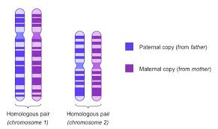

Chromosome Pair 23 determines the sex of the individual. The sex chromosomes also carry genes that control other characteristics
In Humans;
XX = Female
XY = Male
The Y chromosomes is much shorter than the X chromosome

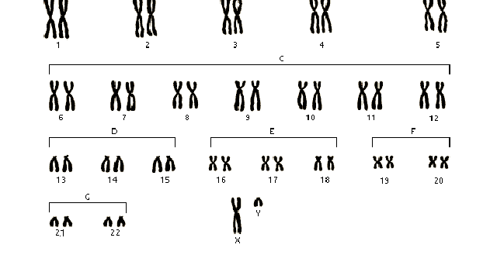

Female Karyotype
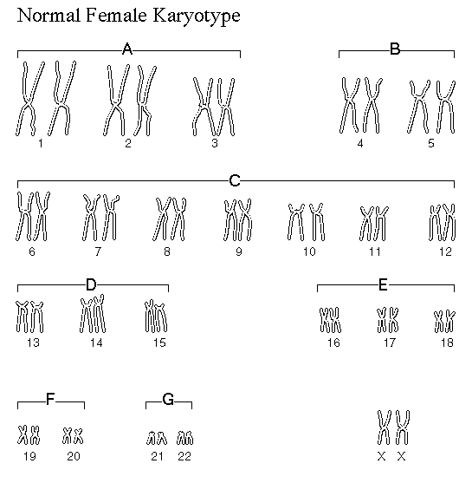

A Haploid Cell has one set of each chromosome
The letter n represents a haploid cell
In humans, sperm and egg cells (gametes) are haploid ( n = 23)

A Diploid Cell has two sets of each chromosome
Diploid is represented by 2n
In humans the diploid number is 46 -> 2n = 46
As each pair of chromosomes has similar genes, they are homologous pairs

The Cell Cycle
The Cell Cycle is divided into
- A non-dividing Phase called Interphase
- A dividing phase in which the nucleus divides first (mitosis) followed by the cell dividing in two (cytokinesis)
Interphase
The Cell spends 90% of its life cycle during interphase.
During interphase metabolic processes such as DNA replication, Protein synthesis and Respiration occur.
Towards the end of Interphase, the chromatin contract becoming clearly visible as chromosomes.
The chromosomes make a copy of themselves to form double stranded chromosomes (also called sister chromatids)
Mitosis
Mitosis is the division of the nucleus to produce two daughter nuclei containing the same number of chromosomes as the parent nucleus
Mitosis is divided into 4 stages: Prophase, Metaphase, Anaphase, Telophase
- Prophase
- Chromosomes become visible as short, double stranded structures that are held together at a point called the centromere
- At both poles of the cell, the centriole begins to form spindle fibres
- The nuclear membrane breaks down
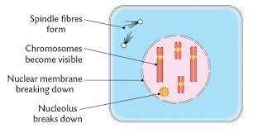
- Metaphase
- The nuclear membrane completely breaks down
- The chromosomes line up along the equator of the cell
- The spindle fibres (attached to the centriole) now attach to the centromeres holding the double stranded chromosomes together
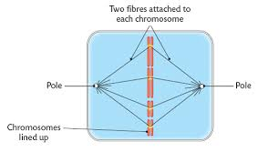
- Anaphase
- The spindle fibres contract which causes the centromeres to split and the chromosomes are pulled to opposite poles of the cell

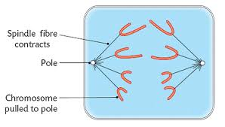
Telophase
- A nuclear membrane forms around each group of chromosomes
- Chromosomes elongate to become chromatin
- Spindle fibres break down
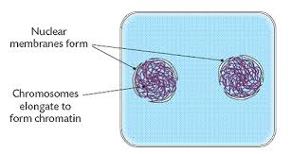
Cytokinesis
Cytokinesis is the dividing of the cell following the division of the nucleus
In animal cells, the cell splits to divide into two when a groove called a cleavage furrow at the equator of the cell. The furrow deepens until the cell splits.

In plant cells, the cell wall prevents a cleavage furrow from forming. A cell plate made of cellulose and calcium forms at the equator of the cell and then the cell divides. The region between two adjacent plant cells is called the middle lamella.
Functions of Mitosis
- Single-celled organisms such as Bacteria & Amoeba – Mitosis is the method of asexual reproduction (Very fast but no variation)
- Multicellular organisms – purpose of mitosis of the growth and repair of cells.

Cancer
Cancer is a group of disorders that result from a loss of control of mitosis
A change (mutation) in the DNA which controls the cell cycle causes uncontrolled and rapid cell divisions resulting in a tumour of cells which can destroy and invade other tissues.
A carcinogen is an agent which causes cancer.
Examples of carcinogens are cigarette smoke and ultraviolet radiation.

Meiosis
Meiosis is a form of nuclear division where the parent cell produces four daughter cells with each containing half the number of chromosomes of the parent cell
In a human cell when meiosis occurs the parent nucleus, which contains 46 chromosomes (diploid) divides to produce daughter cells containing 23 chromosomes (haploid).
Meiosis occurs in the testes and ovaries of humans to produce the gametes (sex cells). In plants, the gametes (pollen and egg) are produced by meiosis.
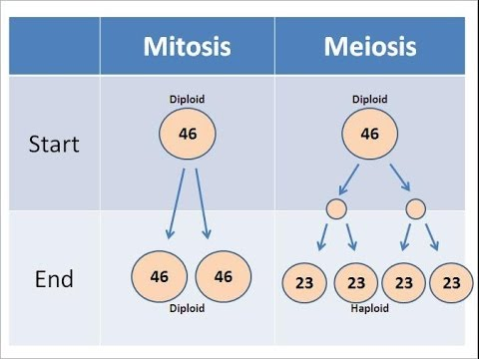

Functions of Meiosis
- It allows for sexual reproduction without increasing the number of chromosomes in the offspring – it produces haploid gametes in diploid organisms which at fertilisation, ensures that the chromosomes number of 46 is maintained
- It allows for variation to exits amongst members of the same species

