Genetic Engineering
Genetic Engineering – the manipulation or alteration of genes.
The genetically modified organism (GMO) is the living organisms whose DNA has been altered artificially.
The DNA that is altered is called the recombinant DNA.
The organism that contains genes from another species is called the transgenic organism.
Genetic Engineering involves cutting a section of DNA from the genetically modified organism and inserting it into the DNA of the transgenic organism.
Tools involved in Genetic Engineering
- DNA Source – DNA that is taken from one organism to be placed into the DNA of another organism –– example is Human genes

- Cloning Vector – special type of DNA that can accept foreign DNA and replicate itself and the foreign DNA – example is the Bacteria plasmid

- Restriction Enzymes – these enzymes recognise DNA sequences and cut the DNA at specific places. The same enzyme is used to cut both sets of DNA i.e. the recombinant DNA and the cloning vector

- DNA Ligase – an enzyme which is used to join foreign DNA with the DNA of the cloning vector – this forms the recombinant DNA

Stages of Genetic Engineering
- Isolation
The Human DNA containing the target gene is removed from it’s chromosome. The plasmid DNA is removed from the bacterium.

- Cutting
Human DNA and Plasmid DNA are cut open using the same restriction enzyme

- Ligation
Target gene is placed into the plasmid (cloning vector) and joins onto it. DNA ligase is used to bind the Human DNA to the plasmid which forms the recombinant DNA

- Transformation
The recombinant DNA is taken into the bacterial cell

- Cloning
Identical copies of the bacterium are produced. A nutrient medium is used.

- Expression
The cell is stimulated to produce a product of the particular gene. The product is later isolated and purified.
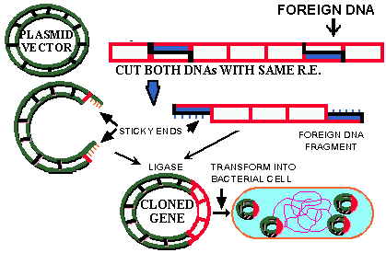
Donor DNA
Plasmid

Donor DNA
Sticky Ends

Applications of Genetic Engineering

- Plant:
Bacterial genes are inserted into crop plants such as Barley which are then resistant to herbicides

- Micro-organism
Human gene Insulin has been inserted into a bacterium which allows the bacterium to produce insulin for diabetics

- Animal:
A human gene has been inserted into a sheep which allows the adult sheep to produce a clotting chemical needed by haemophiliacs to clot their blood

