Biomolecules
Strand: Organisation of Life
Learning Outcomes: 1.2.1, 1.2.2, 1.2.3, 1.2.4, 1.2.5, 1.2.6,

Most organisms are made up of six main chemical elements
-Carbon (C)
- Hydrogen (H)
- Oxygen (O)
- Nitrogen (N)
- Phosphorus (P)
- Sulfur (S)
These elements join together in different ways to form biomolecules.
The four main biomolecules are carbohydrates, lipids, proteins and vitamins
Biomolecules are the molecules found in organisms.

All organisms need food.
Food is needed for:
- For energy (for heat and to drive metabolism)
- To form structural units in cells
- To control chemical reactions in cells – anabolism, catabolism & energy transfer

Carbohydrates
Carbohydrates contain the elements Carbon (C), Hydrogen (H) and Oxygen (O).
These elements are always present in the fixed ratio (C_{x}(H₂O)_{y}). In this ratio, x is equal to y.
For example, the formula for Glucose is C₆H₁₂O₆. There is always twice as much hydrogen present compared to the amount of oxygen present.

There are 3 main types of carbohydrates
- Monosaccharides – the smallest unit of a Carbohydrate. They consist of one sugar unit. Examples include Glucose
- Disaccharides – consists of two sugar units (two monosaccharides) joined together. Examples include Maltose (glucose + glucose),

- Polysaccharides – consist of many monosaccharides joined together. Examples include;
Starch is made from many glucose molecules joined together. Starch is made by plants during photosynthesis and is stored by plants. Starch is found in bread, flour, potatoes and pasta.
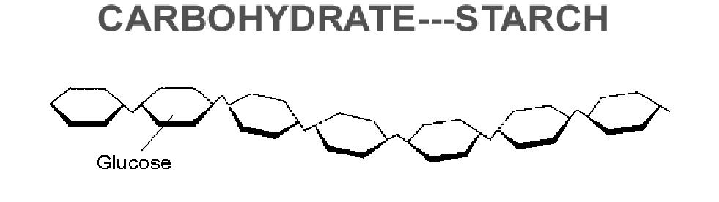
Glycogen: When excess glucose molecules are present in the blood, the liver converts these molecules into a polysaccharide called glycogen. Glycogen is then stored in human muscle cells as an energy reserve, which can be broken down into its component glucose molecules when needed for energy.

Functions of Carbohydrates
Structural role –Cellulose is very strong and makes up the cell wall of plants
Metabolic role –When glucose is broken down during respiration, it releases energy. This energy is used for metabolic reactions in the cell.
Sources of carbohydrates
Carbohydrate | Name | Source
Monosaccharide | Glucose | Fruit
Disaccharide | Maltose | Barley
Polysaccharide | Starch | Bread

Lipids
Lipids contain the elements Carbon (C), Hydrogen (H) and Oxygen (O) but unlike carbohydrates they have no particular ratio and do not contain much oxygen.
An example of a molecular formula for a lipid is CH₃(CH₂)_{n}COOH. This molecular formula shows that the substance contains carbon, hydrogen and oxygen, but there is no elemental ratio.
Lipids that are solid at room temperature are called fats e.g. butter Lipids that are liquid at room temperature are called oils e.g. vegetable oil
The basic unit of a lipid is called a triglyceride, which is made up of three fatty acids joined to one glycerol molecule
A triglyceride is a basic unit of a lipid. Triglycerides consist of three fatty acids joined to one glycerol molecule.
There are different fatty acids, and the type of lipid depends on which fatty acids it contains. For example, a phospholipid, found in the cell membrane, has the same structure as a triglyceride expect that one of the fatty acids is replaced by a phosphate group
Phospholipids consist of two fatty acids and one phosphate group joined to one glycerol molecule.

Functions of Lipids
Structural role – phospholipids, along with proteins, form a major component of cell membranes. In addition, lipids protect delicate organs such as the kidneys.
Metabolic role – When the body contains excess lipids, lipids are converted into adipose tissue under out skin which acts as a long-term energy store in the body. On a cellular level, during respiration lipids are broken down to release energy. Our cells use this energy for metabolic reactions.

Fats are commonly found in butter, cream and cheese. Oils are mainly found in sunflower oil, mackerel and salmon.

Protein
Proteins always contain the elements Carbon (C), Hydrogen (H), Oxygen (O) and Nitrogen (N). Sometimes they contain Phosphorus (P) and Sulphur (S). Protein is the only biomolecule to contain Nitrogen; the element needed for growth.
An example of a molecular formula for proteins is C₉H₁₂N₄O_{3.} This formula shows that the substance contains the elements carbon, hydrogen, nitrogen and oxygen.
These elements combine to form the basic units of a protein called amino acids.
There are 20 common amino acids. Amino acids are bonded together via peptide links.
A chain of less than 20 amino acids is known as a peptide.
A chain of more than 20 amino acids a polypeptide
A protein consists of at least 200 amino acids.
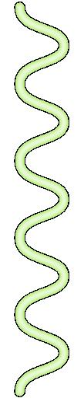
Proteins are made in the cells, in an organelle called the ribosome.
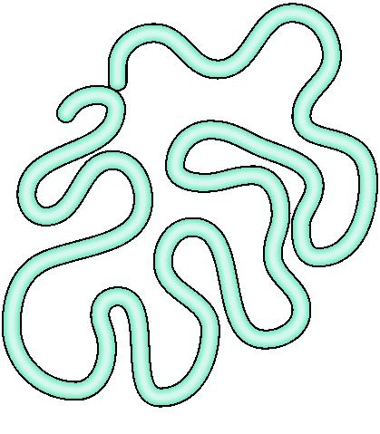
Polypeptide chains fold into a particular shape such as;
Fibrous Proteins – these proteins form long straight chains. Examples include Keratin, a protein found in hair, skin & nails, and Collagen, a protein which holds tissues together such as blood vessels.
Globular Proteins – these proteins are folded into spherical shaped chains. Examples include enzymes, which control metabolic reactions, and hormones such as Insulin, which regulates blood sugar levels.

The role of proteins
Structural role – a protein called Keratin forms our hair, skin and nails

Metabolic role
- All enzymes are made from protein. Enzymes alter the rate of chemical reactions.

- All hormones are made from proteins. For example, the hormone testosterone is produced by the testes in males and travels in the blood to cause puberty.

- Our white blood cells produce proteins called antibodies which are involved in fighting infection.

- Channel proteins allow molecules through the cell membrane (e.g. sodium, potassium or glucose). These proteins move molecules from one side of the membrane to the other without binding to them and without using energy

- Transport proteins or carrier proteins are proteins that are specific for a molecule. Carrier proteins change shape after binding to that molecule and bring that molecule across the cell membrane.

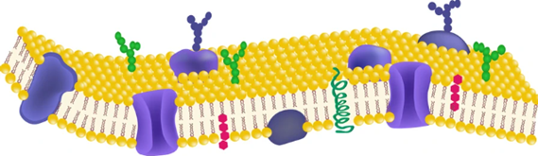

- Protein receptors are found on the surface of cell membranes. These proteins act as cellular sensors, detecting stimuli and triggering appropriate responses. For example, some receptor proteins such as antigens detect infected or abnormal cells, and trigger the body’s immune response to fight the infection.
Sources of protein in the diet.
Proteins are found in lean meat, egg white, fish, soya and beans.

Vitamins
Vitamins are needed in small amounts by organisms. They only have a metabolic role and no structural role. There are two main types of Vitamins, based on their solubility.
- Fat soluble Vitamins – A, D. E and K. Fat-soluble vitamins are not soluble in water.
- Water-Soluble Vitamins – B and C. Water-soluble vitamins dissolve in water.
Vitamin | Solubility | Biological significance of solubility | Function | Source | Deficiency
Vitamin D | Fat Soluble | A fatty diet aids absorption.  Can be stored for a long time in fat tissues such as adipose tissue under the skin or in the liver. | Absorb calcium from the small intestine into the blood | Fish Oils  Milk | Rickets in children and osteoporosis in the elderly (brittle bone disease)
Vitamin C | Water soluble | Easily absorbed into the bloodstream.  Not easily stored in the body, as they become part of the water excreted in urine. | Form connective tissue in gums, ligaments and blood vessels | Green vegetables  Oranges  Lemons | Scurvy which includes bleeding gums and loose teeth

Minerals
Mineral | Source | Function
Sodium | Regulates pH balance in an organism | Salt
Iron | Makes haemoglobin a protein present in red blood cells which carries oxygen around the body. | Red meat
Magnesium | Regulates nerve function | Nuts & seeds
Calcium | Strong bones & teeth  Muscle contraction | Milk

3.8 Water
- It is a medium for transport as it is an excellent solvent. Many molecules can dissolve in it - important for biochemical reactions to take place

- Water is involved in metabolic reactions.

- Water is involved in temperature regulation, which ensures homeostasis. During warm conditions, the body excretes water from the skin, this helps to keep the body temperature constant.

- Water, being a neutral solvent, helps to regulate the pH of the body by preventing extreme pH changes.

- Water is involved in osmoregulation. Osmoregulation is the maintenance of water and salt in the body. Water moves across membranes to ensure the correct balance between water and salt is achieved.
Testing for the presence of biomolecules in food
A qualitative study records the presence or absence of the biomolecule.
Biomolecule | Chemical used to test for the presence | Heat | Original colour of chemical | Colour of chemical if Positive result | Control
Starch | Iodine | No | Orange | Blue/black | Water instead of starch. No colour change observed.
Reducing Sugar (Glucose) | Benedict's Solution | Yes, but do not boil | Blue | Brick Red | Water instead of glucose. No colour change observed.
Protein | Biuret Solution | No | Blue | Violet | Water instead of protein. No colour change observed.
Lipid (Fat) | Brown Paper | No | Not translucent | Translucent | Water instead of fat. No colour change observed.

Carrying out a quantitative food test
A quantitative study involves estimating the amount of a particular biomolecule present in a food sample.
Investigate quantitatively the level of reducing sugars in a range of food samples.
If reducing sugars are present in a food sample, benedict’s solution forms a precipitate. In general, the greater then quantity of reducing sugar, the more red in colour.
The independent variable is the concentration of glucose solution.

The dependent variable is the colour of the benedict’s solution upon heating.

The controlled variables are the volume of water, the volume of benedict’s solution, the temperature of the solutions and the length of time at which the solutions are heated.

The amount of glucose in a solution is measured by the degree of redness of the benedict’s solution upon heating.

To ensure fairness only one variable was changed – the concentration of glucose in the solutions – while all other variables were kept constant.

Safety precautions: Wear gloves to protect your hands. Wear safety glasses.
Procedure
- Set up a water bath at 60^{O}C
- Using a graduated cylinder, add 10cm³ of water each to six test tubes.
- Create a range of glucose solutions of different concentrations – 0%, 0.25%, 0.5%, 1%, 2% and 4% respectively.
- Using a dropper, add 2cm³ of benedict’s solution to each of the solutions.
- Place the test tubes in the water bath for three minutes.
- Note any colour changes.
- Record your results.
- Create a colour chart
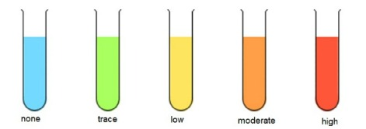
- No colour change (remains blue) → No reducing sugar present
- Green precipitate → Very low concentration of reducing sugars
- Yellow precipitate → Low concentration of reducing sugars
- Orange precipitate → Moderate concentration of reducing sugars
- Brick-red precipitate → High concentration of reducing sugars

- Obtain 10cm³ of a food sample such as apple juice. Place this sample into a test tube.
- Add 2cm³ of benedict’s solution to this sample.
- Place the test tube in the water bath and leave for three minutes.
- Observe any colour change and compare the result to the colour chart.

Comments:
- The control in this experiment was the test tube with O% glucose. The control was used as a standard for comparison against the other results.
- To ensure reliability, repeat the test multiple times.
- To ensure precision, time the heating period exactly (e.g., 3 minutes) with a stopwatch.
- To ensure accuracy, avoid parallax error when reading volumes — keep your eye level with the measurement line.
- To limit sources of error, ensure the test tubes are clean and dry before use, and keep light levels consistent when comparing colours

