The Earth, Sun & Moon

Gravity
- Gravity is the ‘glue of the universe’.
- If any two masses are placed near each other, they will be attracted to each other by aforce of gravity.
- If the masses are small, the force of attraction is very small – too small to take into account, for example, a person sitting on a chair, a book on a table, etc.
- If one of the masses is very large, for example, a moon, a planet or a star, the force of gravity is much larger, i.e. we can’t jump off the surface of the Earth.
- The force of gravity is also affected by distance. The smaller the distance from the centres of the masses, the greater the force of attraction.
- The force of gravity varies depending on a person’s location.
Mass & Weight
- Mass is the amount of matter in an object. Mass is measured in grams or kilograms
- Mass does not change depending on a person’s location.
- The weight of an object the force of gravity acting on it. Weight is measured in Newtons (N).
- Weight is calculated as follows:

- Weight = mass (of the person) x gravity value (at that location)

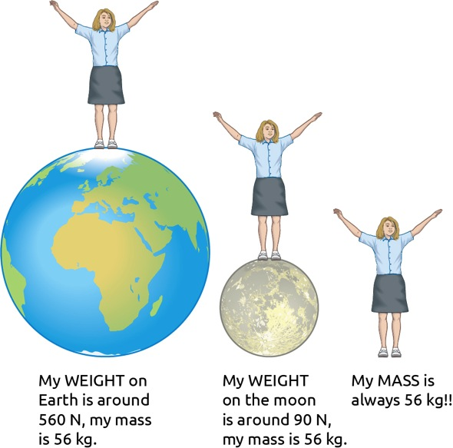

Mass | Weight
The amount of matter in a substance | The force of gravity on an object
Remains the same everywhere in the universe | Varies depending on a location  Weight = mass x gravity
Measured in kg or g | Measured in Newtons (N)

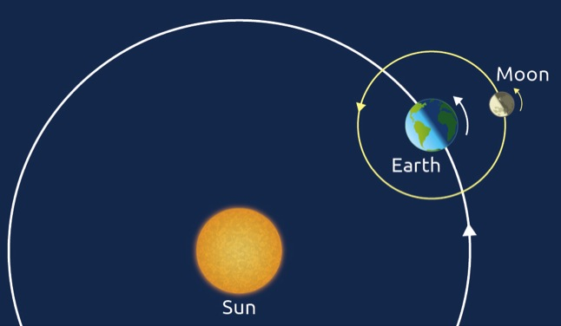

- It takes a year (365.25 days) for the Earth to make one full revolution or orbit around the Sun.
- The Moon is a satellite of the Earth. It makes one revolution of the Earth every 27.3 days.
- As well as the Earth orbiting around the Sun, it also revolves on its own axis every 24 hours.

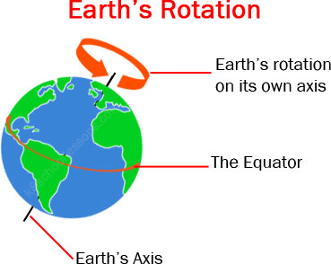

Days

- At any time only half of the Earth is facing the Sun. as the Earth orbits the sun and rotates on it’s own axis.
- When it is facing the Sun, we have daytime.
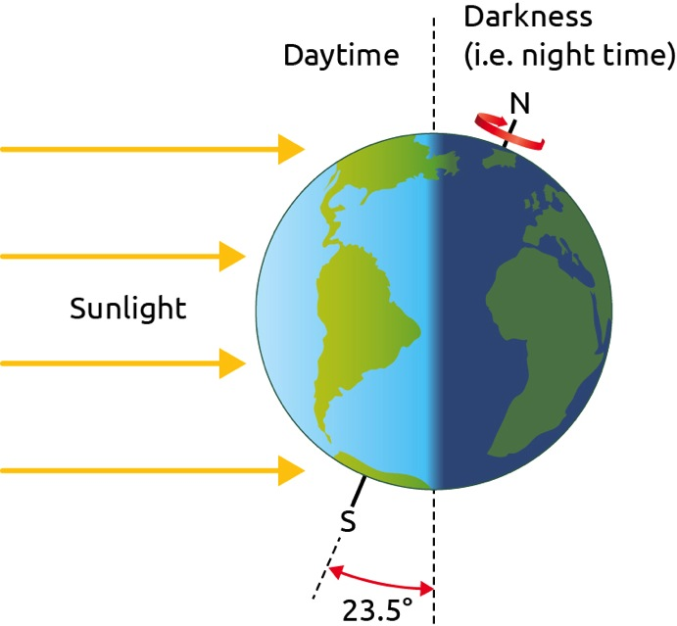

- The light from the Sun heats the planet.
- The more light energy falling on a region, the warmer it will be.
- Notice in the figure on this slide that the first ray is spread over a small surface area. This happens in the hottest area of the planet. (next page).
- The second ray of light is spread over a much larger area. Since the same amount of energy is spread over a larger area, the second region is colder than the first.
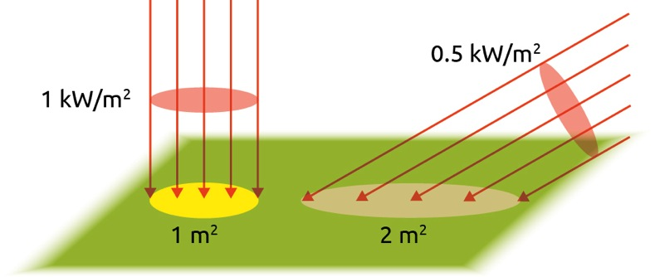

Seasons
The seasons are caused by the axis of the Earth being tilted at 23.5º
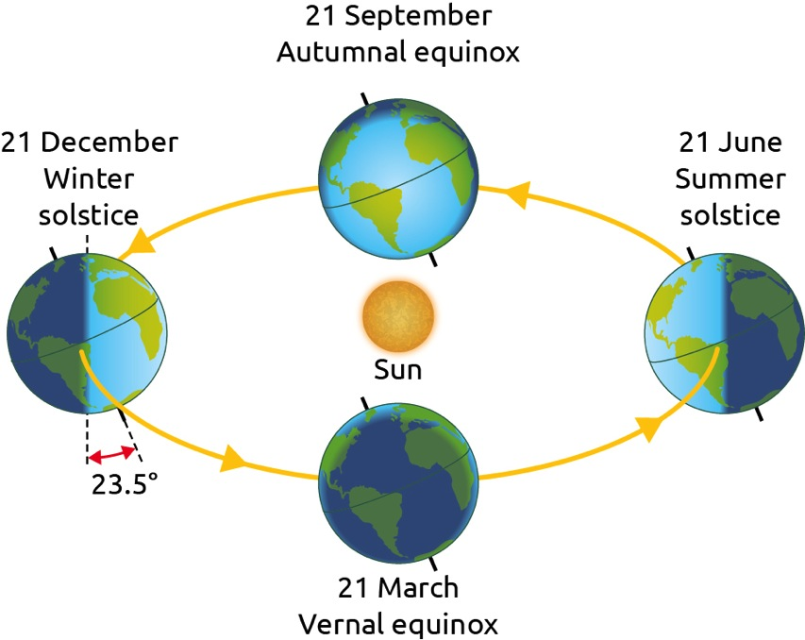
- In the figure, due to the rotation of the Earth around the Sun, the part tilted towards the Sun changes during the year, which gives us our seasons.
- If asked to explain how winter occurs in Ireland, it is incorrect to say that the Earth is further from the Sun and therefore colder.
- The distance between the Earth and the Sun does not have much of an effect on the seasons: it is the tilt towards or away from the Sun.

The phases of the moon

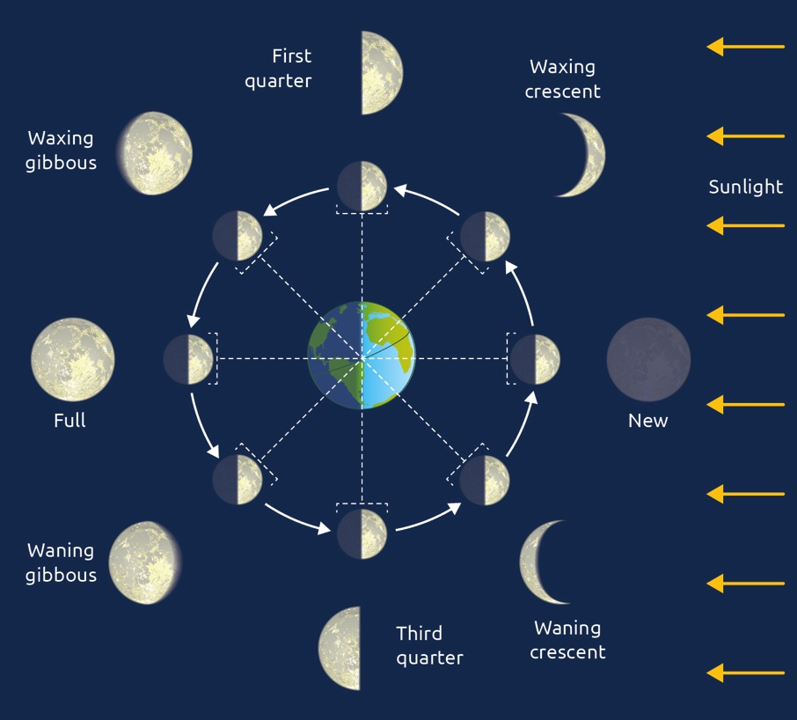

- The Moon orbits the Earth every 27.3 days.
- The Moon also rotates on its own axis every 27.3 days.
- The Moon is visible on Earth when it reflects light from the Sun.
- However, different amounts of the illuminated face are visible from the Earth as the Moon orbits the Earth.
- Day 1 is the new Moon (which we cannot see). Day 2–6 is the waxing crescent, and so on until day 27 when we are back to the new Moon.
Eclipses
- A lunar eclipse happens when the Earth comes between the Sun and the Moon. This happens only during a full Moon and only if the Moon passes part of the Earth’s shadow.
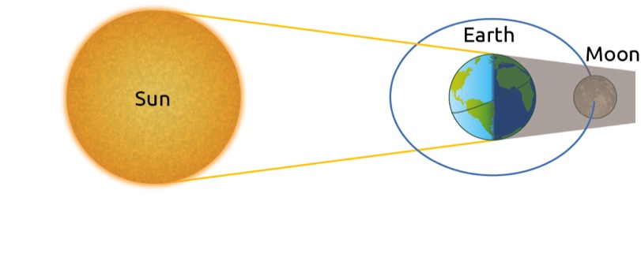
- A solar eclipse occurs when the Moon comes between the Sun and the Earth. This can only happen during a new Moon and only if the Earth passes through the shadow of the Moon.
- 