The Circulatory System
Unicellular organisms such as Amoeba have no need for a circulatory system. In these organisms diffusion is adequate to allow exchange of materials.
In multicellular organisms, diffusion is too slow to transport substances to each cell, so a circulatory system is needed.
There are 2 types of Circulatory Systems;
Open Circulatory System –the blood leaves the blood vessels and flows around the cells of the organism before re-entering the blood vessels again e.g. insects, spiders and crabs
Closed Circulatory system – blood remains in a continuous system of blood vessels as it travels around the body e.g. Humans

Blood Vessels
There are three main types of blood vessels; Arteries, Veins and Capillaries.
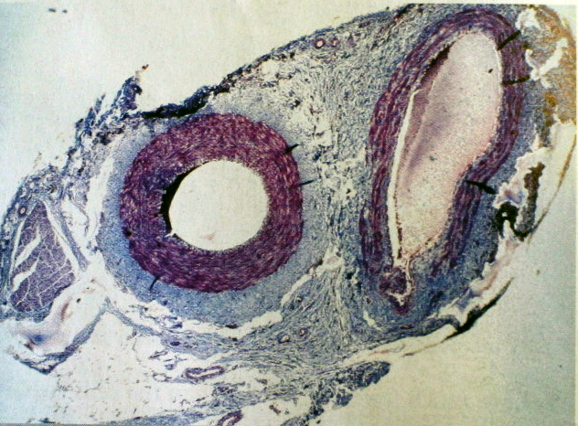
Arteries & Veins have in common
- Outer wall made of collagen
- Middle layer made of smooth muscle – involuntary muscle
- Endothelium – single layer of cells – example of epithelial tissue
Arteries carry blood from the heart into smaller blood vessels called arterioles which join organs
Veins carry blood from small blood vessels called venules towards the heart.

Arteries | Veins
Thick tough wall made of collagen (protein) | Thin wall made of collagen (protein)
Small lumen | Large lumen
No valves | Valves present to stop blood from flowing backwards
Blood is under high pressure and flows in pulses | Blood is under low pressure and flows slowly
Carries oxygenated blood away from the heart towards the body organs (except for the pulmonary artery which carries deoxygenated blood towards the lungs) | Carries deoxygenated blood from the body organs towards the heart (except for the pulmonary vein which carried oxygenated blood from the lungs towards the heart)

Blood pressure is highest in arteries as when the heart contracts it pushes blood into arteries which causes the arteries to expand. The expansion causes the blood to flow in fast pulses through arteries.
Pressure is low in veins. Skeletal muscle contract during movement which moves blood in the veins back to the heart. Valves in veins prevent the backflow of blood

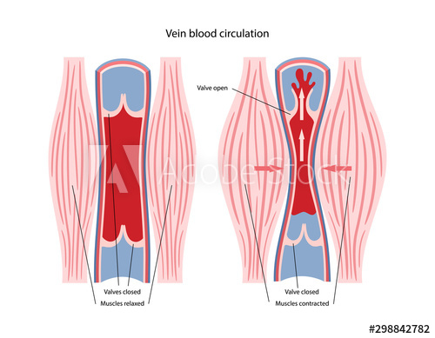

Capillaries
- Tiny blood vessels that have very thin walls (1 cell thick) through which materials can pass in and out
- The function of capillaries is to exchange materials between the blood and the cells of the body
- Capillaries also connect arterioles to venules

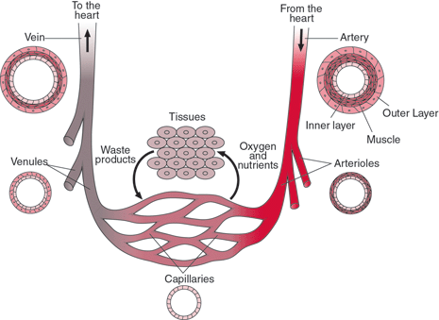
The Heart
- Located in the Thoracic Cavity / Thorax
- Found between the lungs and above the diaphragm
- Under involuntary control
- Made of cardiac muscle which never tires
- Surrounded by a membrane called the pericardium which prevents friction with the nearby organs
- The left side and right side are separated by a wall called the septum
- The 2 upper chambers are called the atria
- The 2 lower chambers are called the ventricles
- The left ventricle is much thicker than the right ventricle, this is because it pumps blood to all the body organs while the right ventricle only pumps blood to the lungs
- The atria and ventricles are separated by valves in the heart which stop the backflow of blood

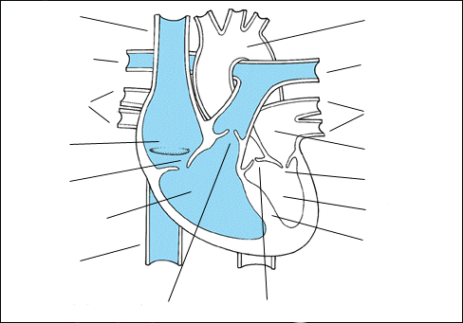

Blood flow through the heart
Deoxygenated blood enters the right atrium of the heart (from all over the heart) through the Vena Cava.
The right atrium pumps blood down to the right ventricle through the tricuspid valve (has 3 flaps of tissue).
The right ventricle pumps the blood out through the pulmonary artery to the lungs.

Oxygenated blood enters the left atrium of the heart (coming from the lungs) through the pulmonary vein
The left atrium pumps blood through the bicuspid valve (2 flaps of tissue) to the left ventricle
The left ventricle pumps blood out through the aorta to the rest of the body
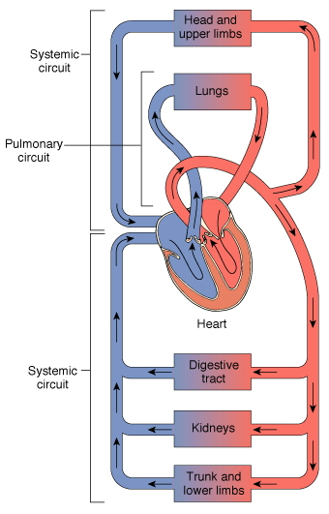
Double Circulation
The heart is a double pump.
The pulmonary circuit pumps blood from the heart to the lungs and back to the heart.
The systemic circuit pumps blood from the heart to the other organs of the body and back to the heart.
Advantages of double circulation
- Oxygenated and deoxygenated blood are kept separate
- Blood pressure is high enough to reach all the part of the body

Portal System
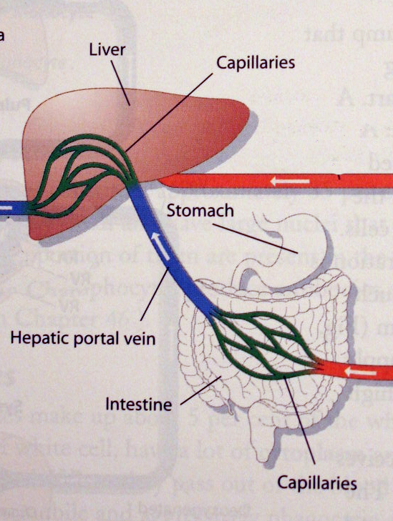
A portal system is a blood pathway that begins and ends in capillaries

The Hepatic Portal Vein connects the stomach and the intestines with the liver
Coronary Blood Vessels
The Coronary arteries branch from the aorta to bring blood to the cardiac muscle of the heart.
The coronary veins drain blood from the heart wall into the right atrium.

The Stages of the Heartbeat / Cardiac Cycle
Diastole = heart muscle is relaxed
Systole = heart muscle is contracting
- Diastole
Blood enters the atria. The atria & ventricles are relaxed & valves are closed.

- Atrial Systole
Atria contract pushing blood through the bicuspid and tricuspid valves into the ventricles

- Ventricular Systole
Ventricles contract
Tricuspid and bicuspid valves are forced closed
Semi-lunar valves are forced open and blood is pumped out of the heart to the lungs and the body

Control of Heartbeat
The pacemaker (also called Sino-atrial or SA node) is found in the right atrium and it controls the heart rate.
The pacemaker (nervous tissue) sends out electrical impulses which cause the atria muscles to contract (atrial systole).
The pulses from the pacemaker reach the AV node (atrio-ventricular node) which is found in the septum.
The AV node sends impulses along the special fibres in the septum which cause the ventricles to contract (ventricular systole)

Exercise, increased body temperature, stress and infection raise heart rate
Sleep, physical fitness and relaxation reduces the heart rate

Blood Pressure
Blood pressure is the force exerted by the blood.
Blood pressure is the pressure needed to stop the flow of blood in the arteries of the upper arm.
High blood pressure indicates the heart must pump harder to get blood around the body.

Pulse
Pulse is caused by the contraction of the artery wall due to the pumping of the ventricles. Pulse rate increases the rate of heartbeat.

Effects of smoking, diet and exercise of the circulatory system
Smoking | Diet | Exercise
Nicotine increases heart rate | Salt raises blood pressure | Enlarges and strengthens the heart
Carbon monoxide reduces the amount of oxygen carried by the blood | Cholesterol blocks arteries which may cause heart attack | Improves blood circulation
Other chemicals in tobacco | Cholesterol raises blood pressure | Causes weight loss which helps to reduce blood pressure

