The Scientific Method
- Biology = The study of living things
Biology is a huge subject with many areas of study including
- Botany = the study of plants
- Genetics = the study of the inheritance of characteristics
- Ecology = the study of the interactions between animals, plants & their environment
- Microbiology = the study of micro-organisms (bacteria, fungi & viruses)
The Scientific Method
The scientific method is an ordered, logical approach to solving problems

- Making observations
- Forming a Hypothesis – this is an educated guess based on an observation
- Conducting an experiment to test the hypothesis
- Data is collected. Data is analysed. Data is interpreted
- A conclusion is formed – the conclusion will either confirm the hypothesis or not
- The conclusion is compared with existing knowledge
- The experiment is repeated.
- The results are published in a scientific journal – so that other scientists can study the report and repeat the experiment themselves
- When a hypothesis has been supported by many experiments over long periods of time it becomes a Theory
- When a theory has been shown to be valid under all conditions that can be tested, it becomes a Law or Principle

Definitions:
Hypothesis = educated guess based on an observation
Data – information gathered during an experiment
Theory – a repeatedly proven hypothesis
Law/Principle – A repeatedly proven theory over long periods of time
Conclusion – explanation of results
Replicate – repeat of an experiment

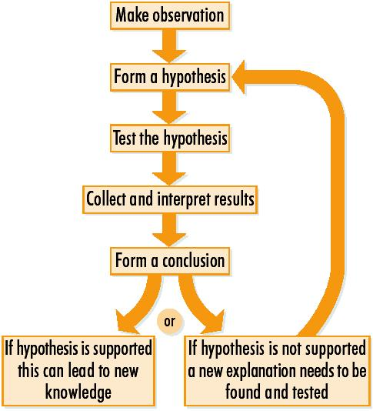

The Principles of Experimentation
- All Experiments must be carefully planned to be fair.
During a fair experiment, only one variable is changed, while all other variables are kept constant.
Variable = factor that can affect the outcome of an experiment.

- Standard Laboratory rules must be followed so that the experiment is carried out safely.

- An experiment must include a control. A control is used to provide a standard against which the actual experiment can be compared. The purpose of a control is for comparison.

- An Experiment must be free from bias.

Freedom from bias is achieved by:

- Using a large number of samples
- The organisms for the experiment must be randomly selected
- The experiment must be repeated a number of times
- Double-blind testing – this is when neither the tester nor the person being tested knows who getting the active medication and who is getting the placebo

- Replicate = repeat of an experiment
- Placebo = a substance with not active medication and acts as a control

Limitations of the Scientific Method

- The extent of our knowledge – lack of knowledge can lead to incorrect hypotheses

- The design of the experiment – inadequate observation of design can lead to misleading results

- Interpreting results – results interpreted incorrectly could give faulty conclusions

- Changes in the natural world – as changes occur, scientific theories have to be updated

- Accidental discoveries – some discoveries are made by chance rather than the scientific method

Ethics
Ethics – this refers to whether issues are right or wrong
Examples of ethics include cloning, testing on animals, IVF and abortion

