The Digestive System
Nutrition is the way an organism obtains and uses food.
- Autotrophic – a type of nutrition where an organism makes its own food

- Heterotrophic – a type of nutrition where an organism cannot make its own food
There are 3 types of Heterotrophic Organisms;
- Herbivores – organisms that feed on plants only e.g. Rabbit
- Carnivores – organisms that feed on animals only e.g. Fox
- Omnivores – organisms that feed on both plants and animals e.g. Humans

Digestion: The breakdown of food into soluble pieces
Digestion is a catabolic process.
Function of Digestion: To break down food into soluble pieces so that they can be absorbed and utilised by the body
Stages of Human Nutrition
- Ingestion – the taking of food into the mouth

- Digestion – the breakdown of food into soluble pieces

- Absorption – small, soluble molecules pass from the digestive system into the blood

- Egestion – the removal of unabsorbed food from the body

Types of Digestion
- Physical (Mechanical) Digestion – the food is physically broken down into smaller pieces by the action of the teeth and the stomach wall

- Chemical Digestion – Catabolic Enzymes break down the large food molecules into simpler molecules

Mouth
Food is broken down physically by the teeth & chemically by the enzyme Amylase

4 types of Teeth
- Incisors – cut and slice food (4 on each jaw)
- Canines – tear food (2 on each jaw)
- Pre-Molars – chew and grind down food (4 on each jaw)
- Molars – chew and grind down food (6 on each jaw)
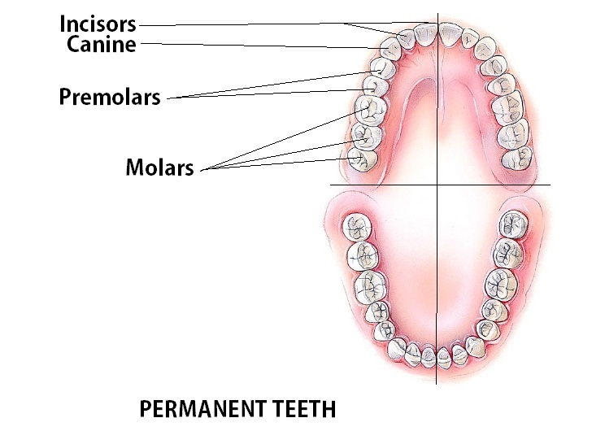
The Human Dental formula tells us the number of each type of tooth in one side of the adult mouth
Chemical Digestion is carried out in the mouth by the enzyme Amylase.
Amylase is present in saliva which is produced in the salivary glands.
Saliva contains water, salt and lysozyme (which destroys microorganisms)
Amylase converts starch (a polysaccharide) into maltose (a disaccharide)
The optimum pH for Amylase is the pH of the mouth – pH 8
In the mouth, food is formed into a bolus and is pushed back into the pharynx a flap of tissue called the epiglottis covers the trachea (windpipe) to ensure that the bolus of food passes down the oesophagus.
Oesophagus
The oesophagus is an involuntary muscle.
This muscle regularly contracts to push food along the alimentary canal – peristalsis
Fibre (cellulose) stimulates peristalsis.
Peristalsis – the involuntary wave of muscular contraction that causes food to move down the alimentary canal

Stomach
Food enters the stomach through the cardiac sphincter muscle at the top of the stomach.
The stomach can hold up to 1 L of food for up to 4 hours.
The Stomach contains
- Mucous – produced by cells that line the inner surface of the stomach. Mucous prevents self-digestion of the stomach wall.

- Hydrochloric Acid – gives the stomach a pH of 1 -2. This acid kills bacteria and activates pepsinogen.

- Pepsinogen – an inactive enzyme, which becomes activated by the HCL to form pepsin. Pepsin is an enzyme which breaks down proteins into peptides.

The Stomach carries out physical and chemical digestion.
Physical Digestion
- Stomach is a muscular bag which contracts and relaxes churning food into a soupy mixture called chyme
Chemical Digestion
- Pepsinogen (an inactive enzyme) is activated by HCl to form Pepsin which digests proteins into peptides
- The stomach is prevented from being digested by pepsin as it is lined with a protective mucous.
Food leaves the stomach through the pyloric sphincter and into the duodenum
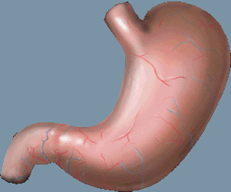
Stomach
Cardiac Sphincter
Pyloric Sphincter
Small Intestine
The small intestine is small in diameter but it is a very long tube (6m). It has two parts; the duodenum and the ileum.
The Duodenum
The duodenum is the first 25cm of the small intestine.
In the duodenum, food is moved along via peristalsis.
The liver and the pancreas secrete substances into the duodenum (associated glands)
The Liver
The liver is the only organ to receive blood from 2 major organs – the hepatic artery and the hepatic portal vein.
Blood enters the liver from the heart in the hepatic artery.
Blood leaves the liver in the hepatic vein.
Functions of the liver;
- Breaks down old red blood cells
- Forms bile
- Breaks down poisons and toxins
- Breaking down excess amino acids into urea (deamination)

- Converting glucose to glycogen
- Forming cholesterol (used to make hormones)

The liver secretes bile into the duodenum via the bile duct. Bile contains water, bile salts and sodium hydrogen carbonate.
Functions of bile:
- To Emulsify fats
- To neutralise the acidic chyme coming from the stomach
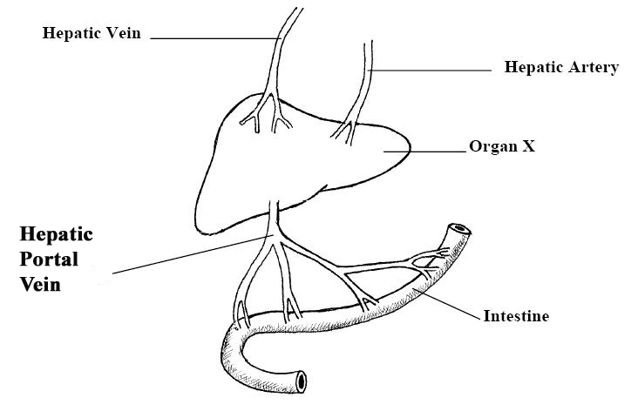

The Pancreas
The pancreas releases 2 enzymes into the duodenum; Pancreatic Amylase and pancreatic Lipase
Pancreatic Amylase has the same function of salivary Amylase – it converts starch into maltose
Pancreatic Lipase converts fats into fatty acids and glycerol.
Both enzymes work best at pH 7-9 – the pH of the duodenum.

Summary of Enzymes
Enzyme | Made in | pH | Substrate | Product
Amylase | Salivary glands & Pancreas | 8 | Starch | Maltose
Pepsin | Stomach lining | 2 | Proteins | Peptides
Lipase | Pancreas | 7-8 | Fats | Fatty acids & glycerol

The ileum
The ileum is 24 feet long.
The function of the ileum is absorption.
The ileum has numerous infoldings called villie – these increase surface area for absorption
Inside each villus is a lacteal. Each lacteal contains lymph. Fatty acids and glycerol are absorbed by the lacteal and are passed into the blood system in the subclavian vein.
Glucose and amino acids are absorbed directly into the blood capillaries. These molecules are transported by the hepatic portal vein to the liver.

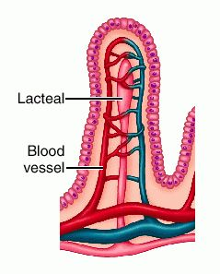
Adaptations of the small intestine (ileum) for absorption
Very long – increased time for absorption
Contains villi and microvilli which increase surface area for absorption
Willi have a rich capillary blood supply to transport absorbed food molecules

The Large Intestine
The function of the large intestine is to re-absorb water
The appendix and caecum are vestigial organs – organs that no longer have a function
Faeces is stored in the rectum and egested through the anus
The colon contains trillions of symbiotic bacteria which
- Produce Vitamins B & K
- Digest cellulose and food waste
- Complete with pathogens
This type of relationship where two organisms live closely together where there is mutual benefit from the relationship is known as symbiosis
Fibre stimulates peristalsis by;
- Fibre absorbs and stores water
- This causes unabsorbed wastes to expand
- The bulk of the waste stimulates the muscles of the large intestine to work and in this way stimulates peristalsis

Balanced Human Diet
A balanced diet is one which contains the 6 nutrients in their correct amounts
The 6 nutrients are
- Proteins
- Carbohydrates
- Lipids (fats)
- Vitamins
- Minerals
- Water

The amount of food eaten/energy required depends on
- Age of the individual
- Activity level
- Gender
- Health status

Food can be arranged into 4 food groups
- Cereal, bread and potato group – 6 portions per day
- Fruit and vegetable group – 5 portions per day
- Milk, cheese and yoghurt group – 3 portions per day
- Meat and fish group – 2 portions per day

