Chapter 24 – Structure of the Atom
An atom is the smallest part of an element that still has the properties of that element.
For example, oxygen is an element, made of oxygen atoms. Oxygen is colourless, therefore the oxygen atoms have the same properties of that element, so oxygen atoms too are colourless.
An atom is made of 3 sub-atomic particles;
- Protons
- Neutrons
- Electrons
Sub-Atomic Particle | Charge | Mass | Location
Protons | Positive | 1 a.m.u | Nucleus
Neutrons | Neutral | 1 a.m.u | Nucleus
Electrons | Negative | 1/1840 a.m.u | Orbitals/Shells
All atoms are neutral, which means there is no charge. Therefore, the number of protons is always equal to the number of neutrons in an atom.
The electrons are located in shells or orbitals located around the nucleus.
The first shell can contain a maximum of 2 electrons, while every other subsequent shell can contain a maximum of 8 electrons.
Octet Rule: In order for an atom to be stable, it must have 8 electrons in its outer shell.
This means that when an atom does not have 8 electrons in it’s outer shell, the octet rule is not obeyed, the atom is not stable, instead the atom is reactive and will combine with other elements and form compounds in order to obtain the octet rule.
Elements such as Helium (He), Neon (Ne) and Argon (Ar) do not form compounds with other elements as they have a full set of 8 outer shell electrons and are therefore unreactive (inert) elements.
Atomic & Mass Numbers
Each Element has two numbers – one bigger than the other
The smaller number = the Atomic Number
The bigger number = the Mass Number
- Atomic Number = the number of protons in an atom
Note: Number of protons = number of electrons
- Mass Number = the number of protons + neutrons
To calculate number of neutrons = Mass Number – Atomic Number
Example: Draw the Atomic (Bohr) Structure of the element Potassium. Potassium has atomic number of 19 & mass number of 39
Protons = 19 Electrons = 19
Neutrons = 39-19 = 20
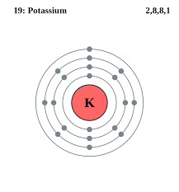
Electron Configuration
The electron configuration lists the number of electrons in each shell of an atom.
For example, in potassium (previous page), there are 2 electrons in the first shell, 8 electrons in the second shell, 8 electrons in the third shell and 1 electron in the fourth (outer) shell.
The electron configuration of potassium = 2, 8, 8, 1

Chapter 25 – The Periodic Table
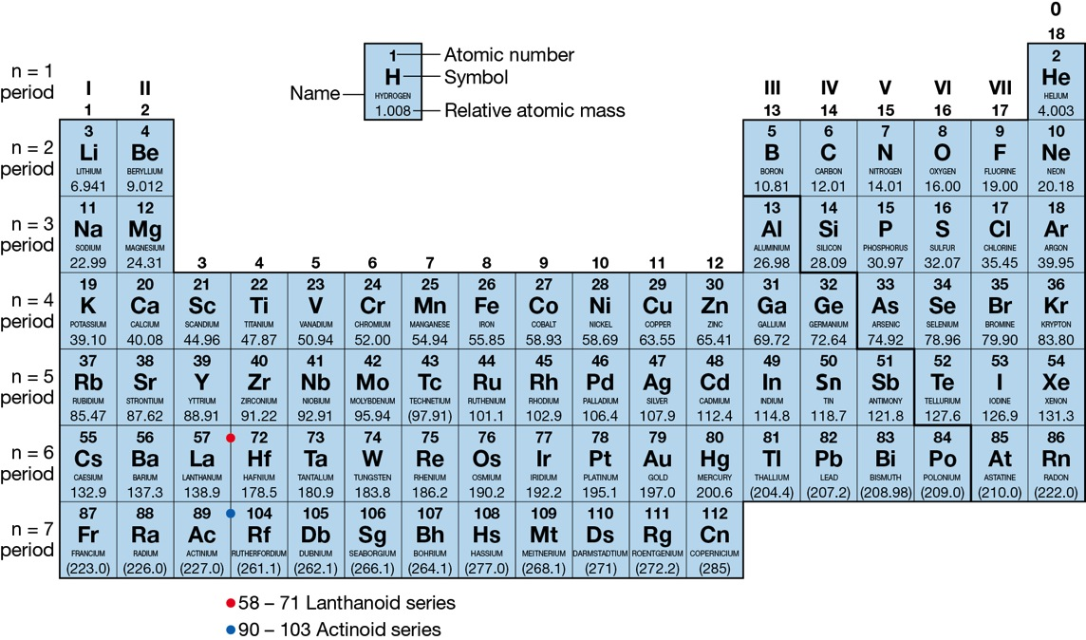

The word Periodic means ‘at regular intervals’
-> The periodic table is so called because the properties of the elements repeat at regular intervals
Groups
Elements with similar properties are arranged under one another in vertical columns. We call these columns groups
There are 8 groups.
These are numbered using the Roman numerals I, II, III, IV, V, VI, VII and VIII

Group I – The Alkali Metals
Group II – The Alkaline Earth Metals
Group VII – The Halogens
Group VIII – The Noble (inert) Gases
For each of the groups numbered I – VIII, the group number is also the number of electrons in the outer shell of the elements in that group

So, group I elements all have 1 electron in their outer shell
Group II elements all have 2 electrons in the outer shell
And so on ….
Because of this, elements in the same group of the periodic table have similar chemical properties.
Group I – The Alkali Metals – is the most reactive group of elements as they only have one electron in their outer shell
Group VIII – The Noble Gases – is the most stable/least unreactive group of elements as they have a full 8 electrons in their outer shell (obey the Octet Rule).

Periods
- The horizontal rows of elements are called periods
- There are 7 period in the periodic table
- The first period only contains hydrogen and helium
- The second period contains the elements from lithium to neon
- Beside each period is the symbol n (for example n=2), this means that these elements have 2 electron shells in their atomic structure

