Chapter 15 – Conservation of Biodiversity
Energy flow in an ecosystem
Biodiversity – the variety of living things
The sun is the main source of energy on Earth. It provides us with light and heat energy. Without it, life on Earth would be impossible.
The energy form the Sun is changed into many useful forms. Some of it is used by green plants (producers) to make food by photosynthesis.
During photosynthesis, light energy is converted into chemical energy. This chemical energy is stored as glucose or starch within the plant. When plants are eaten, the energy they contain is passed onto other organisms.

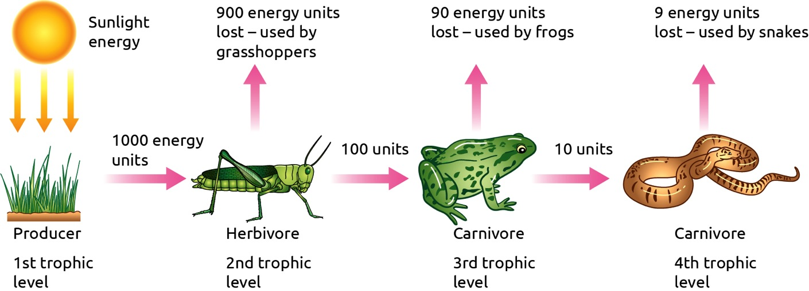

Each of the feeding levels in a food chain is known as a trophic level.
All the other living organisms in an ecosystem depend on the producers for energy. Plants and animals release energy from their food by respiration. Respiration converts the chemical energy in their food into other forms.
At each stage of the food chain, only 10% if the total available energy is passed on to the organism at the next trophic level.
The other 90% of energy is converted into heat, kinetic and sound energy. This energy is lost from the ecosystem and not passed onto other organisms.
Respiration also releases carbon dioxide and water into the atmosphere. These gases are matter which can be reused by other living organisms.
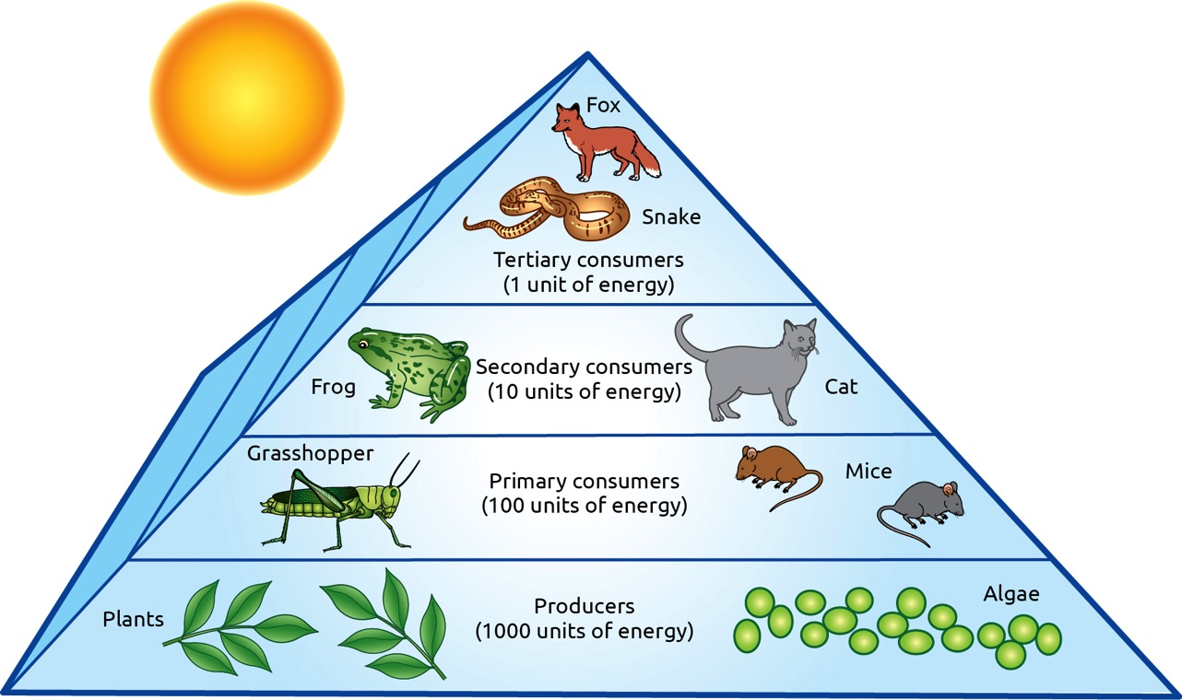
The flow of matter through ecosystems
Nutrients from the environment are used by organisms for energy, growth and repair.
When plants and animals respire they release carbon dioxide and water back to the environment. When they die, they are broken down by decomposers, releasing elements such as carbon and nitrogen into the air and soil.
In this way, matter flows between living and non-living part of our ecosystems. (See Water & Carbon Cycle Notes).
Benefits people get from ecosystems
- We use crops to deed livestock and ourselves
- Bees are needed to pollinate flowers for sexual reproduction in plants
- Plants provide us and other animals with food to eat and oxygen to respire
- Micro-organisms such as fungi produce antibiotics
- The natural world provides areas for walking, cycling and swimming
Biodiversity is threatened by many human activities such as;
- Modern methods of food production
- Extracting raw materials such as metals, coal and oil
- Pollution
- Burning of fossil fuels

Conserving Ecological Biodiversity
Conservation – the wise management of our natural resources
Examples:
- Forest management/ replanting of trees
- Reducing consumption of resources by Reducing, Reusing and Recycling
- Creating national parks
- Organic farming – no use of chemical herbicides or pesticides
- Providing economic incentives for conserving biodiversity
- Education programmes to explain the damage that large scale hunting is doing to biodiversity
- Quotas on the amount of fish being caught
- Large mesh sizes on fishing nets allow smaller fish to escape

Global Food Production
The World’s population is increasing and the demand for food will increase dramatically.
Sustainable food production involves a balanced approach of producing food for our growing population while at the same time, avoiding any negative impact on the natural world
We need to improve how we grow, transport and consume food to ensure sustainable food production
Growing Food
- Fertilise land without leaching minerals into water ways
- Breed good quality seeds
- Reuse land
Transporting Food
- Rely on food from less far away
- Consume foods that are in season
- Rely more on local growers

Consumption of Food
- Lesson our food portions
- Eat healthier food
- Stop wasting food

___________________________________________________

