Enzymes
1
(a) What is an enzyme? __________________________________________________________________________________________________________________________________________________________________
(b) What is the role of enzymes in cells? __________________________________________________________________________________________________________________________________________________________________
(c) Name two catabolic processes controlled by enzymes. __________________________________________________________________________________________________________________________________________________________________
(d) Name two anabolic processes controlled by enzymes. __________________________________________________________________________________________________________________________________________________________________
(e) From which biomolecule are enzymes derived? ________________________________________________________________________________
(f) Where in the cell are enzymes made? _________________________________________________________________________________
(g) Enzymes are referred to as ‘selective catalysts’. Explain why enzymes are referred as such? ___________________________________________________________________________________________________________________________________________________________________________________________________________________________________________________
2
(a) In relation to human enzymes,
- Identify the optimum temperature for human enzymes: ______________________
- Identify the optimum pH for enzymes found in the mouth: ____________________
- Identify the optimum pH for enzymes found in the stomach: __________________
- Identify the optimum pH for enzymes found in the intestine: __________________

(b) What is meant by the term ‘optimum temperature’ in relation to enzymes? __________________________________________________________________________________________________________________________________________________________________
(c) What term is used to describe the substance upon which the enzyme acts? _________________________________________________________________________________
(d) Explain how enzymes are specific. ___________________________________________________________________________________________________________________________________________________________________________________________________________________________________________________
3
(a) Describe the shape of enzymes. __________________________________________________________________________________________________________________________________________________________________
(b) Outline, with the aid of a large labelled diagram, the Induced Fit model of enzyme action. _____________________________________________________________________________________________________________________________________________________________________________________________________________________________________________________________________________________________________________________________________________________________________________________________________________________ [Higher Level Only]
Diagram:

4
(a) Name three factors which affect the rate of enzyme activity. __________________________________________________________________________________________________________________________________________________________________
(b) What is meant by the term denaturation? __________________________________________________________________________________________________________________________________________________________________
(c) Outline how an enzyme, such as amylase, becomes denatured. ___________________________________________________________________________________________________________________________________________________________________________________________________________________________________________________
(d) Answer the following in relation to the enzyme Amylase
(i) Name its site of action: _____________________________________
(i) Name its substrate: ________________________________________
(ii) Name the product of the action of amylase on its substrate named in part (ii) _______________________________________________________________________________.
5
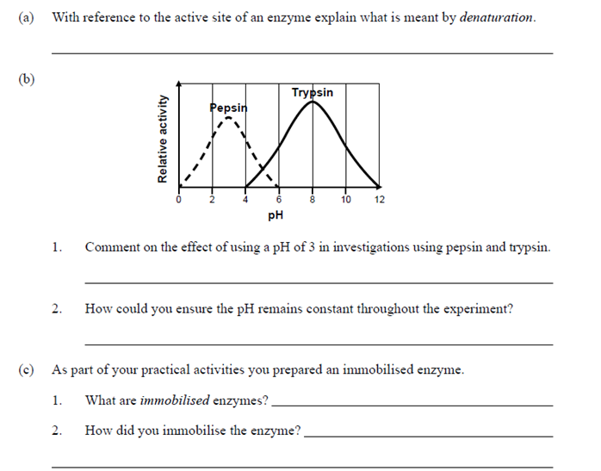(a) Identify the optimum pH for the enzyme trypsin ______________________________________________________________________________
(b) Suggest where in the human body would the enzyme pepsin work best. ________________________________________________________________________________
(c) Comment on the effect of using a pH 3 n investigations using pepsin and trypsin. __________________________________________________________________________________________________________________________________________________________________
(d) In an experiment, how could you ensure the pH remains constant throughout the experiment. _________________________________________________________________________________________________________________________________________________________________
6
Define each of the following terms
- Metabolism _____________________________________________________________________________________________________________________________________________________
- Catalyst _____________________________________________________________________________________________________________________________________________________
- Substrate _____________________________________________________________________________________________________________________________________________________
- Optimum pH _____________________________________________________________________________________________________________________________________________________
- PH Buffer solution _____________________________________________________________________________________________________________________________________________________
- Active Site _____________________________________________________________________________________________________________________________________________________
- Enzyme-Substrate Complex [Higher Level Only] _____________________________________________________________________________________________________________________________________________________
7
Answer the following questions based on an experiment to investigate the effect of pH on the rate of enzyme activity
- Name the enzyme used in this experiment. _____________________________________________________________________________________________________________________________________________________
- Name the substrate used in this experiment _____________________________________________________________________________________________________________________________________________________
- State the optimum temperature for the named enzyme
__________________________________________________________________________________________________________________________________________________
- Explain how the temperature is kept constant during this experiment _____________________________________________________________________________________________________________________________________________________
- Identify the independent variable in this investigation _____________________________________________________________________________________________________________________________________________________
- Why must only one variable be changed in this investigation? _____________________________________________________________________________________________________________________________________________________
- Describe how different pH values are obtained. _____________________________________________________________________________________________________________________________________________________
- How is the rate of enzyme activity measured. _____________________________________________________________________________________________________________________________________________________
- In the space below, draw a graph to represent the relationship between pH and rate of enzyme activity for the named enzyme. Be sure to label both axes.

8
Hydrogen peroxide is catabolised by the enzyme catalase into oxygen and water. Catalase is made in the liver. A student investigated the effect of temperature on catalase action. At each temperature 2cm³ of hydrogen peroxide was dropped onto a 1cm³ cube of liver. The volume of gas collected every minute at each temperature was measured. The results are displayed in table 4.1
Temperature (ºC) | 0 | 10 | 20 | 30 | 40 | 50 | 60
Rate of activity cm³/min | 0 | 2.5 | 20 | 55 | 105 | 45 | 0
Table 4.1
- Draw a suitable graph to represent the data in table 4.1 using the grid provided

(b) List two factors which are kept constant during this investigation. _____________________________________________________________________________________________________________________________________________________
(c) Describe how the students could have ensured the results they obtained were more precise. ______________________________________________________________________________________________________________________________________________________
(d) Describe how the students could have ensured the results they obtained were more accurate ______________________________________________________________________________________________________________________________________________________
(e) At 60°C no oxygen was produced. What would happen to the volume of oxygen produced if this same cube of liver was cooled to 30°C and another 2 cm³ of hydrogen peroxide was added? Justify your answer. ________________________________________________________________________________________________________________________________________________________________________________________________________________________________

9
A group of students carried out an experiment to investigate the effect of substrate concentration on the rate of enzyme activity. The students obtained data. A rough sketch was drawn to represent the data obtained and is displayed below. Analyse the sketch and answer the questions that follow.
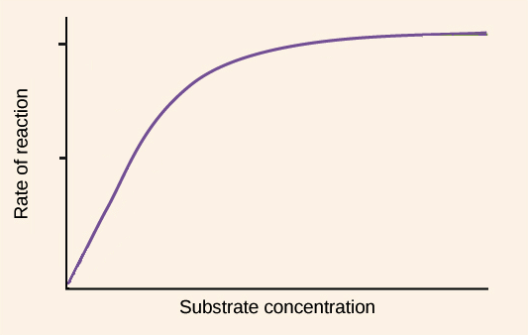
- Describe the relationship between substrate concentration and rate of enzyme activity. ____________________________________________________________________________________________________________________________________________________________________________________________________________________________________________________________________________________
- Name a suitable substrate the students could have used in this investigation and describe how this substrate could be varied. ___________________________________________________________________________________________________________________________________________________________________________________________________________________________________________________________________________________
- Outline how the students could have ensured their results were reliable. ___________________________________________________________________________________________________________________________________________________________________________________________________________________________________________________________________________________
- Aside from substrate concentration, name two other factors that affect the rate of enzyme activity. __________________________________________________________________________________________________________________________________________
10 [Higher Level Only]

The illustration below models a theory of enzyme action. Analyse the illustration and answer the questions that follow.
[insert image – see snapshot. Next to each black line insert letters A, B, C and D respectively for students to label]
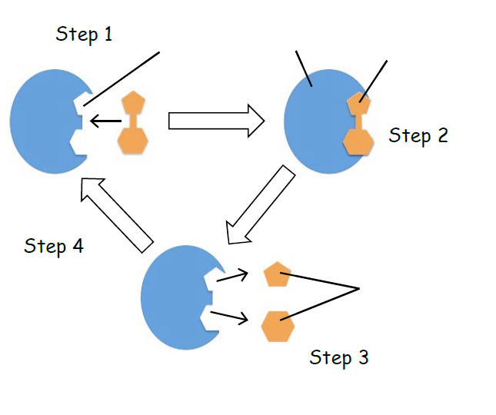
- Name this theory of enzyme action illustrated above. ___________________________________________________________________________
- What is meant by the term theory? _____________________________________________________________________________________________________________________________________________________

- Label the part of the illustration A, B, C and D above.
A: _________________________________ B: ___________________________
C: ________________________________ D: ___________________________

- Describe what is occurring at each of the steps numbered 1- 4 above.
Step 1: ________________________________________________________________________________________________________________________________________________________________________________________________________________________________
Step 2: ________________________________________________________________________________________________________________________________________________________________________________________________________________________________
Step 3: ________________________________________________________________________________________________________________________________________________________________________________________________________________________________
Step 4: ________________________________________________________________________________________________________________________________________________________________________________________________________________________________

- Outline why enzymes are referred to as ‘selective catalysts’. ___________________________________________________________________________________________________________________________________________________________________________________________________________________________________________________________________________________________________________
11

(a) What is a bioreactor? __________________________________________________________________________________________________________________________________________________________________

(b) Describe the use of enzymes in each of the following industries
(i) Food and/or beverages. ________________________________________________________________________________________________________________________________________________________________________________________________________________________________
(ii) Biofuels: ________________________________________________________________________________________________________________________________________________________________________________________________________________________________
(iii) Medicine: ________________________________________________________________________________________________________________________________________________________________________________________________________________________________
(iv) Pharmaceuticals. ________________________________________________________________________________________________________________________________________________________________________________________________________________________________

(c) What are biofuels? __________________________________________________________________________________________________________________________________________________________________

12

(a) Many enzymes used in industrial processes are immobilised enzymes. Explain the meaning of the underlined term. __________________________________________________________________________________________________________________________________________________________________
(b) List two benefits to industries for using immobilised enzymes. ________________________________________________________________________________________________________________________________________________________________________________________________________________________________

(d) List two uses of immobilised enzymes in industry. ________________________________________________________________________________________________________________________________________________________________________________________________________________________________

13

- What are biochemical reactions? ______________________________________________________________________________________________________________________________________________________
- What is metabolism? ______________________________________________________________________________________________________________________________________________________
- Outline the importance of enzymes in metabolism. ____________________________________________________________________________________________________________________________________________________________________________________________________________________________________________________________________________________________________________
- Where in the cell are enzymes made? _________________________________________________________________________

- Identify the part of the enzyme which allows it to carry out its particular function. __________________________________________________________________________

- From what biomolecule are enzymes derived? _________________________________________________________________________

- What is meant by the term enzyme specificity? _____________________________________________________________________________________________________________________________________________________
- Enzymes play important roles in anabolic and catabolic reactions. Distinguish between an anabolic and a catabolic reaction. ___________________________________________________________________________________________________________________________________________________________________________________________________________________________________________________________________________________

14

- What is meant by the term rate of enzyme activity? ______________________________________________________________________________________________________________________________________________________
- List four factors which affect the rate of enzyme activity. ____________________________________________________________________________________________________________________________________________________________________________________________________________________________________________________________________________________________________________
- Fill in table 4.2 by identifying the relevant substrate, product, optimum pH and optimum temperature for each human enzyme listed
Substrate | Enzyme | Product | Optimum pH | Optimum temperature
Starch |  |  |  | 37 ^{O}C
Maltose |  | Glucose
Proteins
Lipids
Table 4.2

15
Answer the following questions in relation to an experiment you carried out to investigate the effect of pH on the rate of enzyme activity

(a) Name an enzyme you used during the investigation. ______________________________________________________________________

(b) Name the substrate you used, and the product formed as a result of the action of the named enzyme. ______________________________________________________________________

(c) Identify the independent variable in this investigation. ______________________________________________________________________

(d) Describe how you varied the factor named in part (c). ______________________________________________________________________
______________________________________________________________________

(e) Outline how you measured the rate of enzyme activity. ______________________________________________________________________
______________________________________________________________________

- Name three factors that were kept constant during the experiment? _________________________________________________________________________________________________________________________________________
- What step could have been taken to ensure your results were precise? _________________________________________________________________________________________________________________________________________
- Outline one safety precaution you followed during this investigation. ____________________________________________________________________
_____________________________________________________________________
- Sample data from the same investigation carried out by a group of students in Cork is is presented below. The students repeated the investigation twice.

Trial 1
pH | 2 | 4 | 6 | 8 | 10 | 12 | 14
Rate of Reaction cm³/min | 0 | 5 | 16 | 36 | 18 | 5 | 0

Trial 2
pH | 2 | 4 | 6 | 8 | 10 | 12 | 14
Rate of Reaction cm³/min | 0 | 5 | 2 | 34 | 16 | 5 | 0

- What was the benefit of repeating the investigation? __________________________________________________________________________________________________________________________________________

- Identify the anomaly in the data presented in the table. Be sure to indicate which trial the anomaly was present in.

_____________________________________________________________________________________________________________________________________________________

- Using the grid provided, draw two appropriately scaled line graphs to represent the data presented in the tables above.

- Based on the graphs you have drawn, outline two conclusions which can be determined from analysing the graphs.
_______________________________________________________________________________________________________________________________________________________________________________________________________________________________________________________________________________________________________________________________________________________________________________________
16
(a) Define the term denaturation. ______________________________________________________________________________________________________________________________________________________
(b) Describe two ways in which enzymes can be denatured. __________________________________________________________________________________________________________________________________________________________________________________________________________________________________________________________________________________

(c) Describe how denaturation affects enzyme ability to be selective catalysts ____________________________________________________________________________________________________________________________________________________________________________________________________________________________________________________________________________________________________________
(d) The graph represents the relationship between temperature and rate of enzyme activity for the enzyme Catalase.
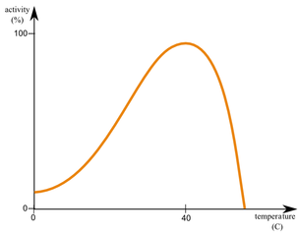
- Identify the optimum temperature for the enzyme catalase. _____________________________________________________________________
- Suggest a temperature which would denature the enzyme catalase. __________________________________________________________________
- Describe the relationship between the variables as represented by the graph. _________________________________________________________________________________________________________________________________________________________________________________________________________________________________

17
The graph above represents the relationship between enzyme concentration and rate of enzyme activity. Analyse the graph and answer the questions that follow.

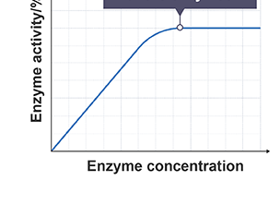
- Describe what is occurring while the blue line is going up. _________________________________________________________________________________________________________________________________________________________________________________________________________________________________
- Outline why the blue line levels off. _________________________________________________________________________________________________________________________________________________________________________________________________________________________________
- Describe the relationship between enzyme concentration and rate of enzyme activity ___________________________________________________________________________________________________________________________________________________________________________________________________________________________________________________________________________________________________________

18
In the space provided, describe an experiment you carried out to investigate the effect of denaturation on the rate of enzyme activity. In your description, name the enzyme and substrate used. Outline how you measured the rate of enzyme activity. Give one safety precaution taken by you during this investigation. Draw a labelled diagram of the apparatus used.
______________________________________________________________________________________________________________________________________________________________________________________________________________________________________________________________________________________________________________________________________________________________________________________________________________________________________________________________________________________________________________________________________________________________________________________________________________________________________________________________________________________________________________________________________________________________________________________________________________________________________________________________________________________________________________________________________________________________________________________________________________________________________________________________________________________________________________________________________________________________________________
Diagram:

19
(a) Name two industries in which enzymes are used in. __________________________________________________________________________________________________________________________________________________________________
(b) In relation to both industries listed in part (a), write down an example of an enzyme used and its purpose in the industrial process. ____________________________________________________________________________________________________________________________________________________________________________________________________________________________________________________________________________________________________________________________________
(c) What is the name of the vessel in which enzyme-controlled reactions occur? ________________________________________________________________________________
(d) Define the term bioprocessing. __________________________________________________________________________________________________________________________________________________________________
20
(a) Define the term immobilisation. __________________________________________________________________________________________________________________________________________________________________
(b) List two benefits to industries for using immobilised enzymes. __________________________________________________________________________________________________________________________________________________________________
(c) Give an example of an industrial process in which immobilised enzymes are used. __________________________________________________________________________________________________________________________________________________________________

