Enzymes
Metabolism is the sum of all the chemical reactions that take place within an organism.
Metabolism is closely associated with energy conversions as during metabolism energy is released or absorbed.
There are two types of metabolic reactions;
- Anabolic Reactions (Anabloism) use energy to convert smaller molecules into larger molecules e..g Photosynthesis & Protein Synthesis
- Catabolic Reactions (Catabloism) release energy to convert molecules into smaller molecules e.g. Respiration & Digestion
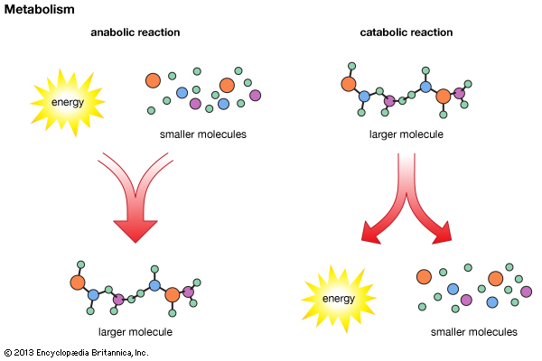
Sources of Energy for Metabolism
- Solar Energy – the energy that comes from the Sun. This form of energy is obtained for Photosynthesis.
- Cellular Energy – the energy stored in the bonds of biomolecules. This source of energy is obtained during Respiration.
Enzymes
Enzymes are Biological Catalysts.
Enzymes control the rate at which metabolic reactions occur.
Enzymes are referred to as Catalysts as they alter the rate of a chemical reaction without being used in the reaction itself
Enzymes are made of chains of amino acids (which are made in the ribosome) which are folded into a globular 3D shape.
Features of Enzyme Action
A substrate is the substance an enzyme joins with.
The product is the substance produced by the action of an enzyme
Enzymes work because they have the correct shape to fit the substrate. Anything that changes the shape of an enzyme (pH, temperature etc) will reduce the efficiency of the enzyme to speed up a reaction.
Enzyme Specificity: Enzymes will only reach with one particular substrate
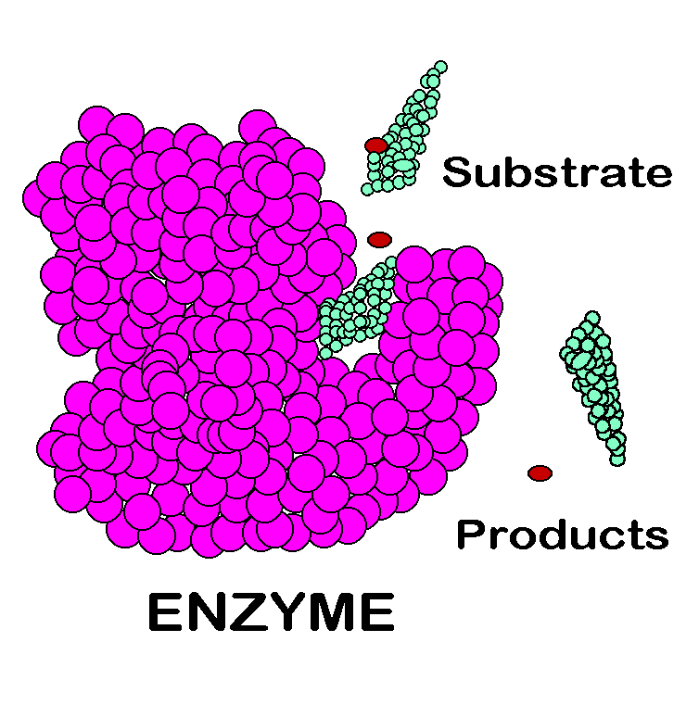
Substrate | Enzyme | Product
Starch | Amylase | Maltose
Maltose | Maltase | Glucose
Lipids | Lipase | Fatty acids & glycerol
Pepsin | Pepsin | Amino acids

The part of the enzyme that binds with the substrate is called the Active Site
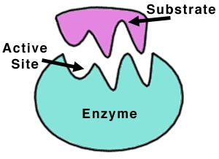
Active-Site Theory / Induced-Fit Theory
The Active site of an enzyme closely fits the shape of that enzymes’ substrate. Therefore, a certain enzyme will only work on its own specific substrate.
- The substrate binds to the active site, forming an enzyme-substrate complex

- The enzyme now slightly alters the shape of its active site to fit the substrate more exactly and to put the substrate under strain.

- The product is then released from the active site. The active site is not available to repeat the process with more of the substrate (not used up in the reaction – Catalyst).

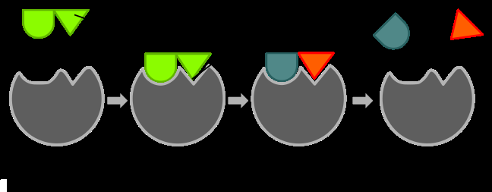
Factors affecting Enzyme Activity
Anything that alters the shape of an active site will reduce the ability of the enzyme to work effectively.
The shape of the active site is particularly sensitive to pH and Temperature.
pH
For most enzymes, the optimum activity occurs at pH 7 (neutral). Some enzymes such as Amylase works best at pH 9 (basic) while others such as Pepsin work best at pH 2 (acidic).
Optimum pH = the pH at which the enzyme works best at.
If an enzyme is present in an unsuitable pH, then the active site of the enzyme will change shape and will no longer be able to bind to the substrate. The Enzyme is said to be Denatured.
Denaturation = the permanent loss enzyme shape and function due to extreme pH or temperature
During an experiment involving enzymes, the pH must be kept constant. To do this a buffer solution is used. E.g., to keep a constant pH of 7, the buffer 7 solution is used.
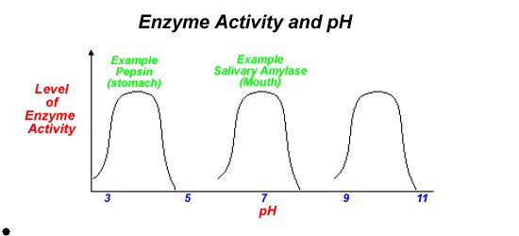
Temperature
For Human enzymes, their optimum activity occurs at 37^{O}C while plant enzymes work best at 25^{O}C
A rise in temperature causes the active site to change shape and it will no longer be able to carry out it’s function. It will be Denatured.

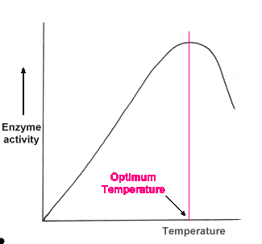
Enzyme Inhibitors
Enzyme Inhibitors are chemicals that attach to an enzyme and destroy it’s shape. Examples include
- Heavy metals such as arsenic and lead
- Cyanide – blocks enzymes involved in respiration
- Nerve gas
Immobilised Enzymes
Bioprocessing is the use of enzyme-controlled reactions to make a product
Bioprocessing is used by many pharmaceutical and food companies to produce high quality products very quickly and cheaply.
A bioreactor is a vessel in which these useful products are made by cells
Enzymes are no immobilised before partaking in bioprocessing.
Immobilised enzymes are enzymes that are attached to or trapped to an inert (inactive) material
Enzymes are immobilised by attaching them to each other using a gel such as Sodium Alginate
Benefits of Immobilised Enzymes
- Immobilised enzymes can be reused many times
- The product does not contain any enzymes, this saves on the cost of separating the product from the enzyme
- Immobilised enzymes are protected in gel and so are more stable
Uses of Immobilised Enzymes
- The substrate glucose is acted upon by the enzyme glucose isomerase to make the product fructose. Fructose is much sweeter low calorie sugar used when dieting
- The substrate sucrose is acted upon by the enzyme sucrase to make the product sucrase

