Nutrient Recycling
- Nutrient Recycling is the way in which elements (such as carbon and nitrogen) are exchanged between the living and non-living components of an ecosystem
- Unlike the energy that flows in from the Sun and through the ecosystem, the elements that make up the bodies of living organisms are recycled and used time and time again. There cycles are also called biogeochemical cycles.
Carbon Cycle
The organisms involved in the carbon cycle include
- Plants and algae which remove CO₂ from the environment in photosynthesis and return it in respiration
- Animals who obtain their carbon by eating plants and release CO₂ in respiration
- Fungi and bacteria who return CO₂ to the environment when they decompose dead organisms
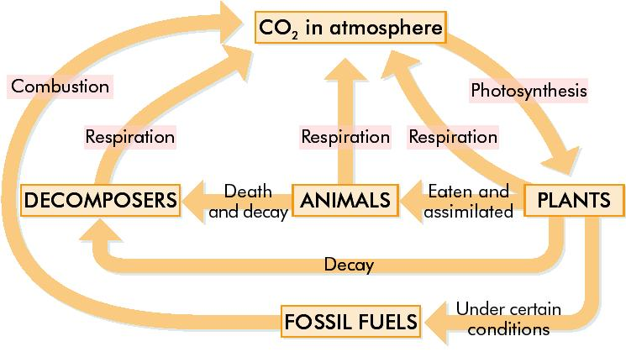

The concentration of CO2 in the atmosphere is increasing
Reason 1. There has been a significant increase in the burning of fossil fuels
Reason 2. Deforestation results in fewer trees resulting in less photosynthesis and thus more CO₂ in the air
Nitrogen Cycle
Plants need nitrogen in order to make proteins. Plants cannot use nitrogen gas in the air, it must be converted into other forms to be utilised.
4 types of Bacteria are involved in the Nitrogen cycle;
- Nitrogen Fixing Bacteria – live in the soil and root nodules (swellings) of certain plants e.g. clover and peas. They convert atmospheric nitrogen into nitrates
- Decomposing Bacteria – live in the soil. They break down dead animals and plants to release ammonia
- Nitrifying Bacteria – live in the soil. They convert ammonia into nitrates
- Denitrifying Bacteria – live in the soil. They convert nitrates back to nitrogen gas.
1: Nitrogen Fixation:
This is the conversion by nitrogen-fixing bacteria of nitrogen gas into nitrates which the plants can then absorb. These bacteria are symbiotic and are mutualistic (both the bacteria and the legumes benefit from the relationship). Some nitrogen fixation also occurs due to volcanic activity and lightning.
2: Absorption
The plants can then absorb the nitrogen from the soil in the form of nitrate ions to make protein. This nitrogen in plants is transferred to animals when they eat plants.
3: Decomposition
Dead animal and plants are broken down by bacteria and fungi of decay. Nitrogen compounds such as ammonia and ammonium salts are released from the dead animals and plants into the soil
4. Nitrification
Nitrifying bacteria in the soil then convert the ammonia and ammonium salts into nitrites and then into nitrates. These nitrates may be absorbed by the roots of plants to make plant proteins
5. Denitrification
Denitrifying bacteria in the soil convert some of the nitrates back into nitrogen gas which is released into the atmosphere

