Microscopy & Cell Structure
A microscope is needed to see animal and plant cells.
There are two types of microscopes; The Light Microscope & The Electron Microscope
The Light microscope sends a beam of light through the cell which is then focused on by two lenses – the eyepiece lens and the objective lens.
The Electron Microscope sends a beam of electrons through the cell and the beam is focused by electromagnets. The electron microscope has far greater resolution and magnification than the light microscope. There are two types of Electron Microscopes; The Transmission Electron Microscope (TEM) and the Scanning Electron Microscope (SEM).

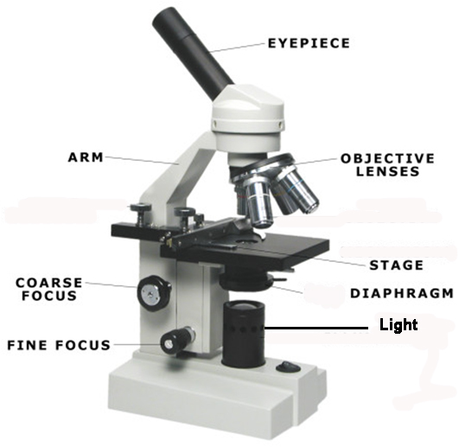
Part of the Light Microscope | Function
Eyepiece Lens | Magnifies the object
Stage | To place the slide on / support slide
Objective Lens | Magnifies the image
Diaphragm (like a shutter in a camera!) | Controls the amount of light reaching the object
Coarse focus wheel | For rough/approximate focusing
Fine focus wheel | To precisely focus the image
The total magnification of a microscope if found by multiplying the power of the two lens
Magnification = Objective Lens Power x Eyepiece Lens Power
Cell Structure
- A Cell = the basic structural and functional unit of all living organisms
- Cells only come from the reproduction of existing cell – this is called Cell Continuity
- Cells contain a variety of internal structures called organelles
- The Light Microscope can view the cell membrane, cytoplasm, nucleus, cell wall, vacuole and chloroplast
- In addition to the organelles listed, the Electron Microscope can view the mitochondria and ribosomes.
Animal Cells
- Animal Cells contain the cell membrane, nucleus, ribosomes, cytoplasm and mitochondria
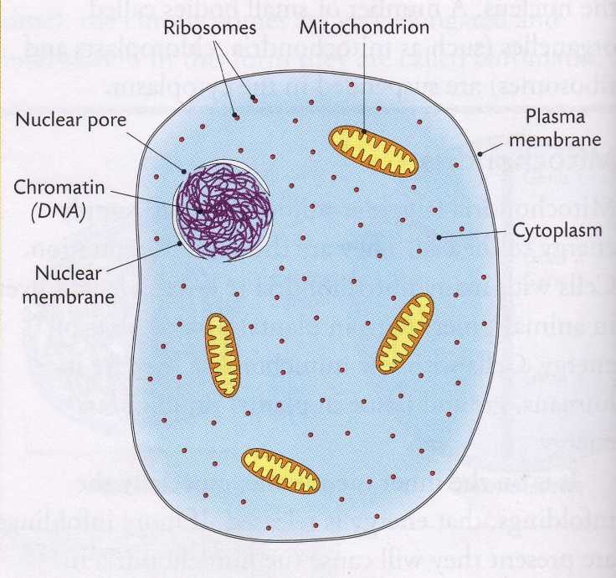
- Cytoplasm – a watery substance in which the cell organelles are suspended. This is where metabolic reactions occur in the cell.
- Nucleus – the control centre of the cell. It contains DNA of which chromosomes are made. Chromosomes contain the instructions for the manufacture of proteins in the cell. These proteins determine the function of the cell.
- Cell membrane – surrounds all cells. It gives support to the cell and controls what enters and leaves the cell.
The Cell Membrane

Cell Membranes are made of phospholipids and proteins

The Cell membrane is selectively permeable – this means is can control what enters and leaves the cell.
Pores present allow movement of molecules in/out of the cell
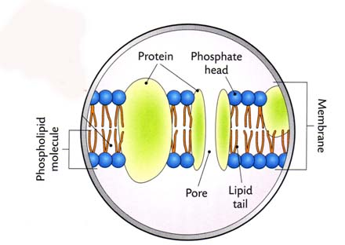
Nucleus

The nucleus contains DNA (Deoxyribonucleic acid) which is organised into chromosomes.

The nucleus of somatic (non-sex cells) contains 46 chromosomes.

The nucleus of gametes (sex cells) contains 23 chromosomes.

When a cell is not dividing, the chromosomes are usually a thing thread-like form called chromatin.

The nucleus is surrounded by a double membrane with many pores, these pores allow substances to pass in and out of the nucleus.
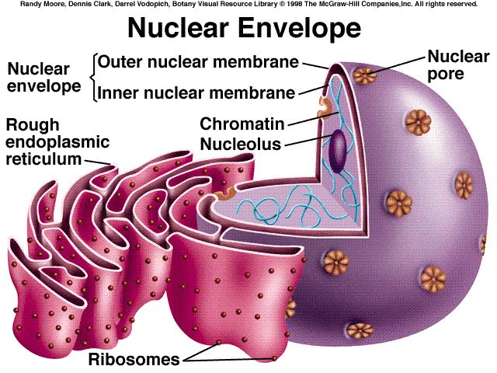
Mitochondria
The Mitochondria carries out aerobic respiration.
The mitochondria is surrounded by a double membrane.
The inner foldings of the mitochondria are called cristae. The more cristae present in a mitochondrion, the more energy it produces.
Mitochondria contain DNA (non-nuclear DNA).
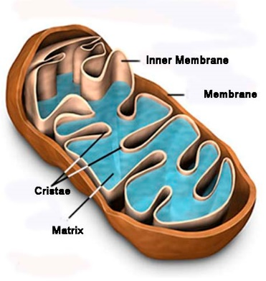
Ribosomes
The function of ribosomes are to make proteins. Proteins are made during Protein Synthesis in which amino acids are joined together

Plant Cells
In common with animals cells, plant cells contain a cell membrane, nucleus, cytoplasm, ribosome and mitochondria. In addition, they contain a cell wall, chloroplast and large vacuole.
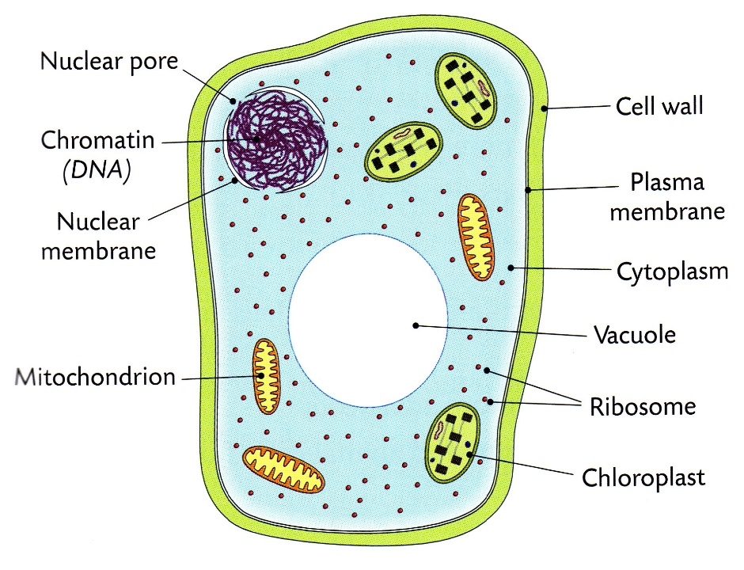
Chloroplasts (plant cells only)
Photosynthesis occurs in the chloroplasts
Chloroplasts contain the green pigment chlorophyll which traps sunlight energy for photosynthesis
Chloroplasts contain DNA

Cell Wall (plant cells only)
The cell wall gives shape and strength to plant cells
It is made from cellulose (polysaccharide)
The cell wall is fully permeable which means it allows all substances to pass in and out of it
Adjacent cell walls are held together by a cement-like substance called the middle lamella. The middle lamella is formed by the mineral calcium.

Large Vacuole (plant cells only)
- Vacuoles are membrane-bound sacs within the cytoplasm of a cell

- Vacuoles provide structural support, as well as serving functions such as storage, waste disposal, protection and growth

Eukaryotic and Prokaryotic Cells
- Organisms whose cell contain a nucleus and other membrane-bound organelles are called eukaryote. E.g. Plant and Animal Cells

- Organisms whose cells never contain (or lack) a nucleus and other membrane-bound organelles are called prokaryotes. E.g. Bacterial Cell

Experiment: To be familiar with and use the light microscope
- Plug in the light microscope or adjust the mirror so that light is seen through the eyepiece lens
- Place the slide on the centre of the stage
- Using low power, turn the coarse focus wheel to lower the objective lens
- Looking through the eyepiece lens, turn the coarse focus wheel to raise the objective lens and bring the slide into focus
- Move the slide very slightly on the stage to centre the object on the slide perfectly
- Change the objective lens to medium or high power and fine ficus using only the fine focus wheel

Experiment 2: To prepare and examine animals cells using the light microscope
- Scrape the inside of your cheek with a cotton bud
- Transfer and smear the cells onto a glass slide
- Add a few drops of methylene blue stain to the slide using a dropper
- Blot off any excess stain with filter paper and add 2 drops of water
- Lower a coverslip at 45^{O} to avoid trapping air bubbles
The function of the cover slip is to protect the lens.
- Examine and draw under low and high powers
Result: Nuclei is darker, cytoplasm is lighter.
Experiment 3: To prepare and examine plant cells using the light microscope
- Cut a small square of onion and peel off a thin layer of epidermis
- Place the epidermal layer on the slide
- Add 2 drops of iodine to the epidermal layer
- Bot off any excess stain with filter paper and add 2 drops of water
- Lower a cover slip slowly at 45O to avoid trapping air bubbles
The function of the cover slip is to protect the lens.
- Examine and draw under low and high power
Result: Plant cells have a regular shape, staining the cells makes them easier to see’; the nucleus becomes darker in colour, the cytoplasm becomes lighter in colour.

