The Nervous System
The Nervous System is divided into
- Central Nervous System – consisting of the Brain and Spinal Cord

- Peripheral Nervous System – consisting of a network of nerves carrying messages between the Central Nervous System and the rest of the body

Four processes are involved in responding to a stimulus;
- Reception – the detection of the stimulus by the sense organs
- Transmission – the passage of messages between the Peripheral Nervous System and the Central Nervous System. This is carried out by nerve cells.
- Integration – the messages are sorted and processed by the brain and a response is decided upon
- Response – a solution to the stimulus detected is carried by nerve cells to the effectors (muscles/glands)

Neurons
- A neuron is a nerve cell
- A neuron is the basic unit of the nervous system
- A neuron carries an electrical impulse from one place to another

There are 3 types of Neurons
- Sensory (afferent) Neurons – carry messages from the sense organs to the Central Nervous System
- Motor (efferent) Neurons – carry messages from the Central Nervous System to effectors
- Interneurons (intermediate/relay/association neurons) – found only in the Central Nervous System and carry messages between sensory and motor neurons
Sensory Neurons
These carry information from the sense organ to the CNS.
The impulse is carried from the sensory receptor towards the cell body along a dendron and then along an axon away from the cell body to the CNS.
In sensory neurons, the impulse is carried towards the cell body and the cell body lies in the middle of the neuron.
Motor Neurons
These carry impulses away from the CNS to an effector. The impulse is carried away from the cell body which lies at one end of the axon
Interneurons
Small neurons that link sensory with motor neurons. They are found in the spinal cord and the brain i.e. they carry impulses within the CNS
Parts of Neurons
Name | Structure | Function
Cell Body | Cell with nucleus & organelles | Forms dendrites, axons & neurotransmitters
Dendrites | Fibres | Carry impulses towards the cell body.  Motor neurons have very short dendrites.
Nerve endings | End part of dendrites | Connect dendrite to receptor cells (sense organ)
Axons | Fibres | Carry impulses away from the cell body.  Motor neurons have very long axons.
Schwann Cells | Cells along the length of neurons | They make up the myelin sheath
Myelin Sheath | Fat-rich membrane | Insulates the electrical impulses, protects the axons and dendrites, and speeds up the electrical impulse
Nodes of Ranvier | Gaps in the myelin sheath | Speeds up the passage of impulses causing the impulse to jump from node to node

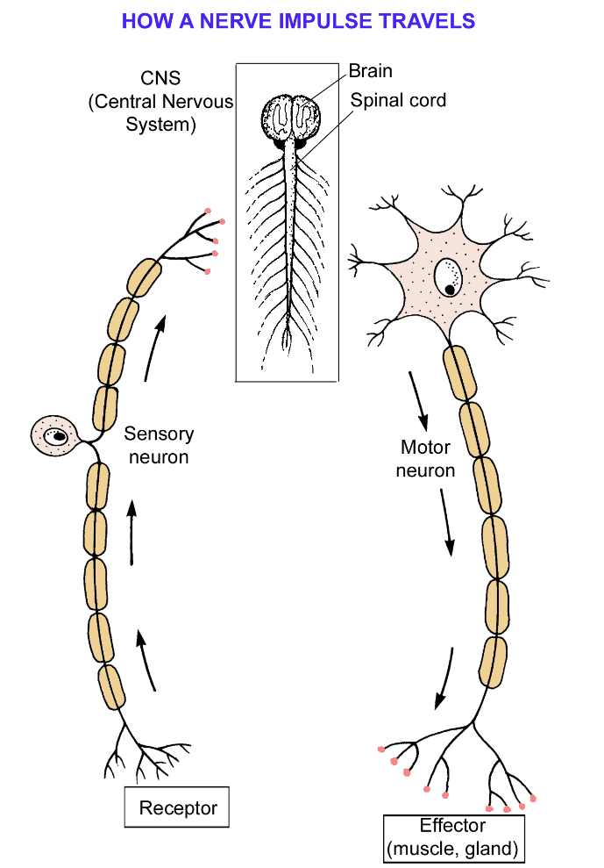
Transmission of a Nerve Impulse
- The nerve impulse is caused by the movement of ions
- When a neuron is not carrying an impulse, ions are pumped in and out of the axon resulting in the inside of the axon being negatively charged and the outside being positively charged.
- The Threshold is the minimum stimulus required to start a nervous impulse.
- Any stimulus below the threshold has no effect. One that is at or above the threshold causes an electrical impulse to travel along a neuron.
- The All or Nothing Law states that the size of the stimulus has no effect on the size of the impulse. This means that a mild stimulus or a sever stimulus will cause the same impulse to travel along the axon.
- Sensitivity to different degrees of stimulation depends on
- The number of neurons stimulated
- The frequency with which they send their impulses
- When a threshold stimulus is reached, the axon/dendrite changes its permeability to ions
- At the site of stimulation, the inside of the axon becomes positive, the outside becomes negative
- This change in charge causes the next section of dendrites to change its permeability to ions in a similar way
- This is repeated along the length of the axon and uses energy to occur (in the form of ATP)
- Once the impulses passes, the area behind it is restored to its resting state
- Refractory Period: this is the delay period between two impulses which usually lasts 5 milliseconds. During this period, the neuron can’t be stimulated.

Speed of an Impulse
The speed of an impulse depends on the presence or absence of the Myelin Sheath and the Diameter of the Axon/Dendrite
- Myelin Sheath absent – changes in positive and negative ions occur all along the axon/dendrite causing a slow impulse
- Myelin Sheath present – changes in charge occur at nodes of Ranvier causing the impulse to jump from node to node – fast impulse
- Larger diameter of axon/dendrite – the faster the impulse

Synapse
A synapse is a region where t neurons come in close contact (usually between axon terminals of one neuron and dendrites of another neuron).
The bridge (tiny gap) between the two neurons is called the synaptic cleft
Electrical impulses cannot cross a synapse
Impulse in the presynaptic cleft stimulates its neurotransmitter swellings to release a chemical called a neurotransmitter. Examples of neurotransmitters are Acetylcholine and Noradrenaline.
This neurotransmitter diffuses across the synaptic cleft
The neurotransmitter combines with receptors in the postsynaptic neuron causing the electrical impulse to be regenerated
Neurotransmitters are digested by enzymes such as cholinesterase and are reabsorbed back into the neurotransmitter swellings (recycling).
Functions of synapses
- Transmit impulses from one neuron to another or to an effector
- Control the direction of the impulse
- Prevent overstimulatino of effectors. Benefit – impulse can be blocked at a synapse e.g. pain killers
The Central Nervous System
The Brain interprets the incoming impulses and decides on the response.
The cell bodies and synapses form the grey matter.
The nerve fibres (dendrites and axons) form the white matter.
The skull protects the brain
The brain is surrounded by three membranes called the meninges. The meninges act as a shock absorber.
Cerebrospinal fluid if found in between the meninges.
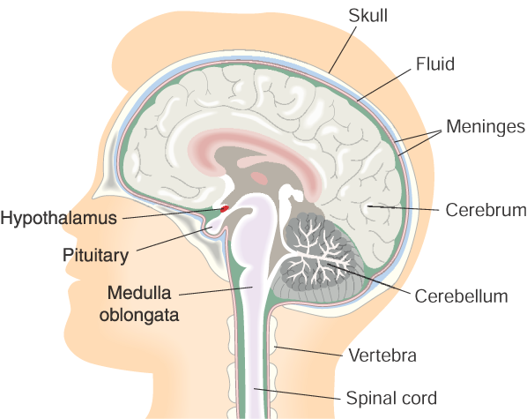
Part of the Brain | Function
Cerebrum | Controls voluntary myscles.  Receives information from the sense organs.  Divided into left & right cerebral hemispheres.  Left cerebral hemisphere – hand use, language, logic, maths  Right cerebtal hemispphere – art, music, emotion  Outer part of cerebrum is the cerebral cortex – heavily infoled layer to increase surface area
Cerebellum | Controls balance and muscular co-ordination
Medulla oblongata | Controls involuntary muscles such as breathing (diaphragm), peristalsis and heart rate
Thalamus | Sorting centre of the brain which directs messages to the correct part of the cerebrum.
Hypothalamus | Regulates the internal environment of the body (homeostasis) by moniotoring body temperature, hormone levels and osmoregulation
Pituitary gland | Master hormone gland. Controlled by the hypothalamus.

The Spinal Cord
The spinal cord is surrounded by vertebrae for protection. It transmits impulse to and from the brain, and controls reflex action.
White matter is found in the outside of the spinal cord, while grey matter is found to the insde.
The spinal canal contains cerebrospinal fluid.
Pairs of projections called spinal roots arise from each side of the spinal cord. These unite a short distance from the cord to form the spinal nerves of the PNS.

There are two types of spinal root;
- The Dorsal Root – carries sensory nerve axons into the spinal cord. It has a swelling called the dorsal root ganglion which contains the cell bodies of the sensory neurons.

- The Ventral Rot – carries motor nerve axons away from the spinal cord.
Note: cell bodies of motor neurons are contained in the grey matter of the spinal cord.
The PNS does not contain any cell bodies – these are only found in the CNS and the dorsal root ganglion.
Reflex Action
A reflex action is an automatic, involuntary, unthinking resposne to a stimulus
The pathway taken by impulses during a reflex actionn make a reflex arc.
Examples of reflex actions include: grasp reflex in children, movement of the iris of the eye, and the falling response.
Advatnage of reflex action: fast responses for protection against damage.

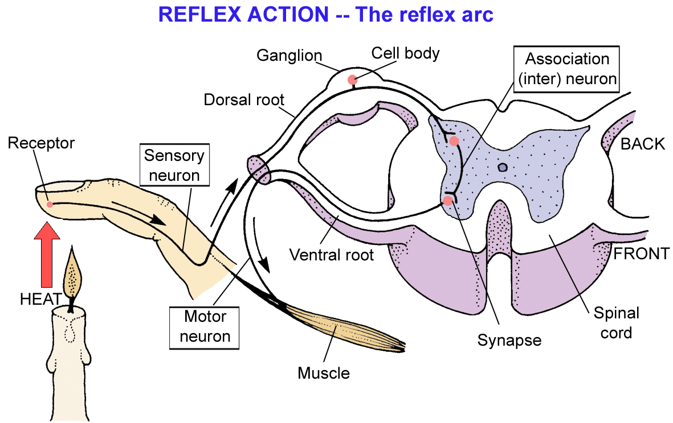
Interneuron

Steps in Reflex Action
- Receptors in finger stimulated by a flame

- Sensory neurons carry impulse to spinal cord.

- Interneuron in spinal cord carries impulse to a motor neuron. Another neuron carries the message to the brain.

- Motor neurons take the impulse to the effector causing the hand to pull away from the heat source

- As the hand withdraws, the impulse reaches the brain making the person aware of what has happened.

Nervous System Disorder
Example: Parkinson’s Disease
Cause: failure to produce a neurotransmitter, Dopamine, which results in the inability to control muscle contraction.
Symptoms: trembling of hands and legs, muscles become stiff and rigid, unblinking stare
Prevention: no known way to prevent or cure
Treatment: drug treatment to lesson symptoms only. Exercise initially is used as treatment.

