Human Breathing System
Structure of the Breathing System;
Nose: The nasal cavity contains tiny hairs which filter the air as it passes as well as warming and moistening the air which allows the air to diffuse mor easily from the lungs into the blood
Pharynx: connects the mouth and nose to the trachea. At the base of the pharynx is a flap of tissue called the epiglottis which covers the trachea when food is swallowed.
Larynx: Known as the voice-box and produces sound.
Trachea: Also called the windpipe. The trachea divides up into subdivisions called the Bronchus and the Bronchiole. They are all made of muscle with rings of cartilage which prevents the tubes from collapsing as air enters. The Trachea is lined tiny hairs called cilia and mucous-producing cells. The mucous traps dust and the cilia then waft it back towards the mouth where it is swallowed.
Lungs: Soft organs contained in a double membrane called the pleural membranes, both of which are filled with fluid that help prevent friction during breathing. Gas exchange in the lungs. The lungs are protected by the rib cage.
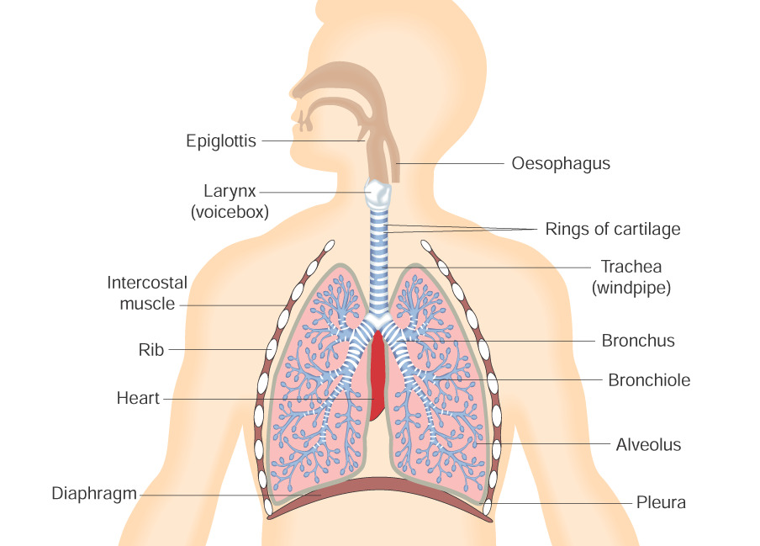
Each Bronchus enters a long.
The Bronchi divide to form many bronchioles. Each bronchiole ends in a sac called an alveolus. The alveoli are covered in a network of blood capillaries.
Gas Exchange in the Alveoli
Blood returning from the body to the lungs is rich in CO2 and low in O2. Therefore, the concentration in the alveolus is higher than that in the blood. Oxygen in the alveolus diffuses through the alveolus wall, then through the blood capillary wall into the blood. This oxygenated blood is sent to the heart via the pulmonary vein and then pumped around the body.
CO2 is produced by each cell as a product of respiration. It diffuses into the blood system where it reaches it lungs and diffuses out of the blood and into the alveolus from where it is exhaled.
Water vapour and heart are also lost from the lungs to the air.
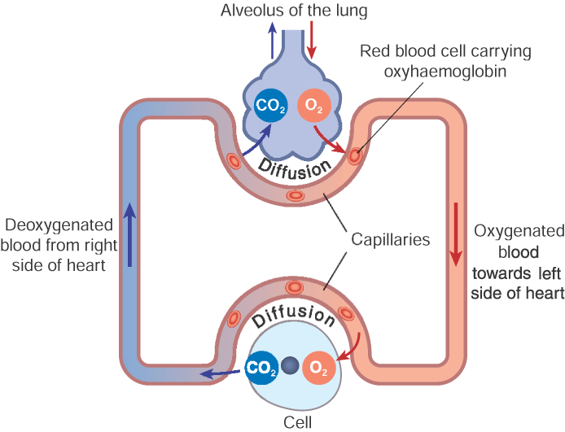
Features of the Alveoli which allow for gas exchange
- 1. Large surface area of contact between alveoli and blood capillaries - faster rate of gas exchange.
- 2. Alveoli and capillaries are only one-celled thick. The short distance between air and blood establishes a steep conc. gradient for rapid diffusion.
- 3. Slow blood flow gives max. time for oxygenation and excretion of carbon dioxide.
- 4. Alveoli are elastic for efficient inspiration and expiration.
- 5. Alveoli lining is moist - dissolved gases diffuse faster.

Breathing Mechanism
- Inhalation
1. Brain (medulla oblongata) detects a rise in CO₂ levels and sends a message, via nerves, to the intercostal muscles and diaphragm to contract.
2. Then the ribs and sternum move up and outwards, the diaphragm flattens.
3. The volume of the thoracic cavity increases.
4. As the volume increases the pressure inside the lungs decreases
5. Hence air rushes into the lungs to equalise the pressure (of the atmosphere and chest).
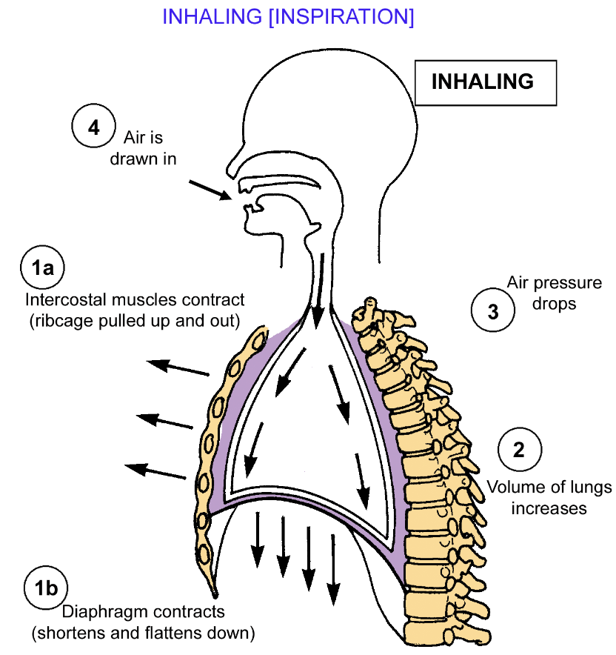
- Exhalation
1. Intercostal muscles and diaphragm relax - ribs and sternum move down and in and diaphragm becomes dome-shaped.
2. Volume of thoracic cavity decreases.
3. As a result air pressure on lung walls increases.
4. Therefore air is forced out of the lungs.
Note: inspiration is active (requires energy – muscles contract) expiration is passive.

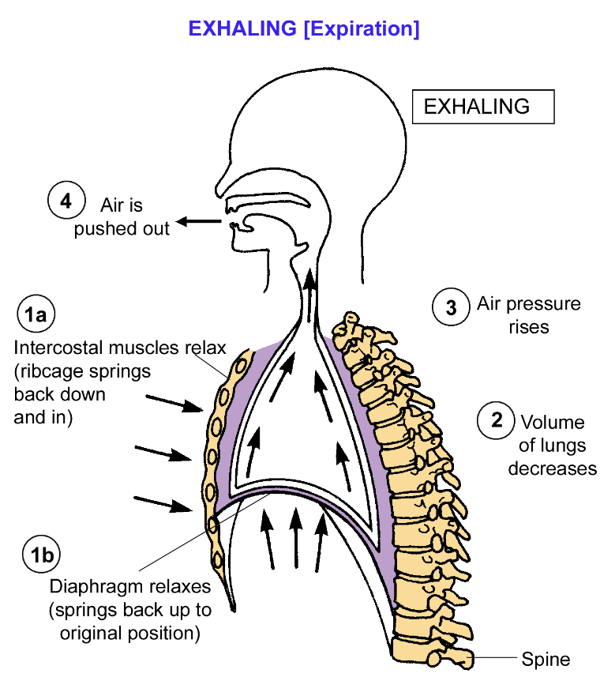

Control of Breathing
- Breathing is an involuntary action. It is under the control of the medulla oblongata in brain.
- Cells in the medulla oblongata are sensitive to carbon dioxide levels in the blood
- If high carbon dioxide levels are present, breathing is deepened so that more oxygen can be taken in. This occurs during strenuous exercise when muscle cells are producing a lot of carbon dioxide due to increased cellular respiration.

Breathing System Disorder – Asthma

Cause allergy inflammation causes airways to narrow e.g. pollen or dust mites
Prevention: Clean air, avoiding the cause of the allergy
Treatment: Steroid inhalers are taken to widen the airways

