Excretion
Excretion is the removal of waste products of metabolism from the body.
In plants, substances are excreted through the Stomata (pores in the leaf) and the Lenticels (pores in the stem). Carbon Dioxide is excreted during Respiration. Oxygen is excreted during Photosynthesis.
In Humans;
Organ | Substances Excreted
Skin | Water & Salts
Lungs | Carbon Dioxide & Water
Kidneys | Water, Salts & Urea

The excretory system plays a role in homeostasis:
(i) maintains the correct composition of body fluids
(ii) prevents the build-up of toxic wastes in the blood
Amino Acids are transported from the ileum to the liver via the hepatic portal vein. In the liver, excess amino acids are broken down to form urea - known as Deamination. Urea is transported via the aorta to the renal artery where it enters the kidney.
Functions of the Kidney
- Excretion – removal of waste products of metabolism from the body
- Osmoregulation – the maintenance of a balance between salt and water content in the body
The Human Urinary System
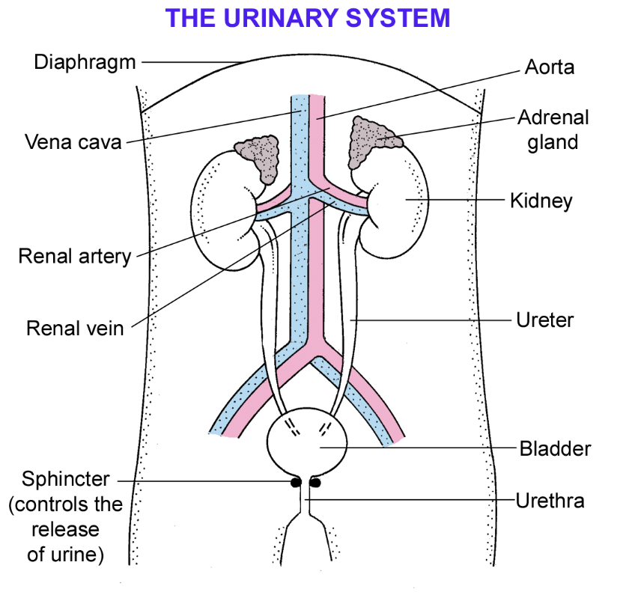
Kidneys – filter the blood which removes urea, salt and water. These substances are then sent to the bladder. Surrounded by a thick layer of fat for protection.
Bladder – stores urine
Renal artery – branch of the aorta that brings unfiltered blood into the kidney
Renal vein – brings the filtered blood from the kidney to the vena cava which returns it to the heart
Ureters – connect the kidneys to the bladder
Urethra – tube that carries urine from the bladder during urination
Urine is made up of urea, salt & water which are removed from the blood by the kidneys.
The Nephron
The Nephron is the functional unit of the kidney. There are millions of nephrons found in each kidney.
Nephrons are structures that make urine by filtering the blood.
Thus, urine is formed in the nephron of the kidneys.
Three main processes occur in the nephron of the kidneys to form urine;
- Filtration – the removal of substances from the blood such as urea, uric acid, salt, water, amino acids and vitamins - takes place in the cortex
- Reabsorption – the useful substances that were removed are reabsorbed back into the blood - takes place in medulla
- Secretion – if blood is too acidic or alkaline, substances are secreted from the blood into the cortex of the kidney for excretion – this maintains the ideal pH of the blood.

Urine Formation
- Filtration
- Blood enters the nephron via the afferent arteriole which leads to a network of capillaries called the glomerulus
- The blood entering the glomerulus is under high pressure due to the 1. Afferent arteriole being a direct branch of the aorta 2. The narrowing of the blood vessels increases the pressure
- Small molecules such as glucose, amino acids, urea and water are forced out of the glomerulus and into the bowman’s capsule where they form the glomerular filtrate
- Proteins and blood cells remain in the glomerulus are they are too large to be filtered
- Reabsorption
- The glomerular filtrate enters the proximal convoluted tubule
- In the proximal convoluted tubule water is reabsorbed by osmosis while substances such as glucose, vitamins, amino acids are reabsorbed by either diffusion or active transport
- To help the process of reabsorption, the proximal convoluted tubule is
- Long – more time for reabsorption
- Thin walled (1 cell thick)
- Has a large number of mitochondria to provide energy for active transport
- Has many microvilli to increase the surface for reabsorption
- More water is absorbed in the Loop of Henle and the Distal Convoluted Tubule
- The remainder, now urine, passes into the pelvis of the kidney and through the ureter to the bladder for storage. It is then expelled from the bladder to the outside via the urethra.

- Secretion
- Occurs in the convoluted tubules by active transport
- Potassium ions and hydrogen ions are actively secreted into the distal and convoluted tubules which are then excreted as urine
- This maintains the pH balance of the blood

Osmoregulation by the Nephron
Osmoregulation - The kidneys regulate the amount of water in the body by varying the volume of urine produced.
ADH is Anti-diuretic hormone. ADH is a hormone made by the pituitary gland.
ADH controls the permeability of the collecting duct, causing it to become more permeable or impermeable.
If a lot of salt has been consumed or a lot of water has been lost
- Blood is too concentrated
- ADH is released
- ADH causes the walls of the collecting duct to become more permeable to water

If a lot of water is consumed
- Less ADH is produced
- The walls of the collecting duct become impermeable to water
- A watery urine of greater volume results

