Transport, Storage and Gas Exchange in Plants
Plants are autotrophic (they make their own food) and thus water, carbon dioxide and oxygen must be acquired by plants and transported around the plant for photosynthesis and other metabolic reactions to occur.
Gas Exchange in the Leaf
The leaf is adapted for gas exchange during photosynthesis, respiration and transpiration.
- Many chloroplasts in the leaf’s ground tissue allow for photosynthesis

- The dermal tissue of the leaf contains pores called stomata for gas exchange

- Many air spaces in the ground tissue allow gases to diffuse in, out and around the leaf

- The leaf is very thin to allow for rapid diffusion of gases

- Leaves contain xylem vessels to transport water to the leaf and phloem sieve tubes to transport food (made in the leaf) out of the leaf

Control of Gas Exchange in the Leaf
The stomata are the pores in the leaf that allow for gas exchange.
The opening of the stomata is controlled by the activity of two dermal cells called guard cells.
Guard cells are kidney-shaped and have a thick inner wall.
When the stomata are turgid, their walls move apart which forms a stoma (singular for stomata)
When the stomata are not fully turgid, their walls are in contact with each other and close the stoma.

In good light, photosynthesis takes place, using up the CO2 concentration in the leaf. The plant needs more C02 so the guard cells take in water by osmosis, making them more turgid. Their walls move apart and a stoma forms which enables gas exchange.

In poor light, photosynthesis reduces or stops so CO2 is not used. CO2 builds up in the leaf so the guard cells lose water and become less turgid. The adjacent walls come together to close the stoma so no more CO2 enters the plant cell.
Gas Exchange in the Stem
The stem of woody plants contain pores called lenticels
Lenticels are pores in the stems of plants that allow gas exchange.
Transpiration
Transpiration is the loss of water from the leaves.
Most transpiration takes place through the stomata.
If plants do not replace the water that is lost they may wilt or even die.
To prevent this, plants must reduce their rate of transpiration
- Leaves have a waxy cuticle which stops water cannot pass

- Stomata are usually located on the lower surface of the leaf, which is not in direct sunlight and thus is cooler. The rate of water evaporation is lower on the lower surface of the leaf.

The transport of water up though the xylem is caused by
- Root pressure
- Cohesion-Tension Model of Transpiration
Root Pressure
Root pressure is generated by water entering the roots by osmosis. This pressure causes the water to move up the xylem.
Root pressure can only push water to a height of 1 metre at most
Cohesion-Tension Model of Transpiration
The Cohesion-Tension model of transpiration, put forward by scientists Dixon and Joly explains how water is transported in plants to extreme heights against the force of gravity.
Cohesion – the attractive force between similar molecules
Water is highly cohesive – this means water molecules tend to stick together.
Adhesion –force of attraction between different molecules– water molecules sticking to the xylem vessel
Water Transport to great heights in Plants
- Root pressure – water enters via osmosis, which creates pressure and forces water upwards to 1 metre
- Transpiration – water is leaving the plant via the stomata. This creates tension and pulls subsequent water molecules upwards.
- Adhesion – wate molecules are attracted to the xylem walls
- Cohesion – water molecules are attracted to each other and form a transpiration stream
Diagram:

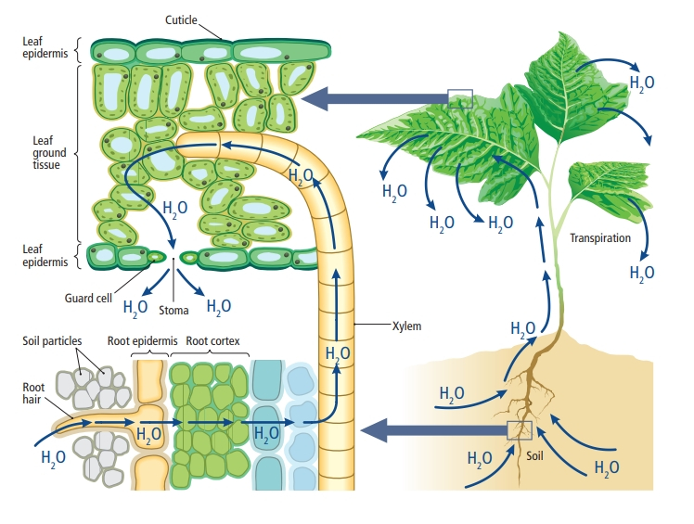

How the xylem is adapted for water transport

- Narrow lumen – water rises upwards
- No end walls between xylem vessels
- Water sticks to xylem vessels – adhesive property
- Thick lignin walls of xylem can withstand tension of water molecules being pulled upwards

