Population Control
A population consists of all the members of the same species in an area.
The size of a population is controlled by the following biotic factors
- Competition
- Predation
- Parasitism
- Symbiosis
Competition
- Competition – the struggle between organisms for a resource that is in short supply in a habitat
- Animals compete for food, water, shelter and mates
- Plants compete for light, space, water and minerals
- Competition can occur between members of the same species, this is called inter-specific competition
- Competition can occur between members of different species, this is called intra-specific competition
- Competition tends to reduce the population size
There are 2 types of Competition
- Contest Competition – an active physical struggle between organisms in which only one organism wins the resource
- Scramble Competition – an active physical struggle between organisms in which all organisms get some of the resource
Adaptations to survive Competition;
- In order to survive competition, organisms are adapted to their environment
- Thistles have long roots to absorb as much nutrients from the soil as possible
- Rabbits have large ears for optimum hearing to avoid predators
- Roses have thorns to prevent predators attacking them
Predation
Predation is the catching, killing and eating of another organism
The predator is the organism that catches, kills and eat another organism
The prey is the organism that is eaten
Adaptations of Predators;
- A fox’s coat colour can help to camouflage it
- Spiders catch prey using webs
- Hawks have excellent eyesight to allow them to see their prey
Adaptations of Prey;
- Rabbits have large hind legs to allow them to run very fast
- Frogs are camouflaged to avoid being spotted
- Hedgehogs have tough spines to protect them against predators
The Predator-Prey Relationship;
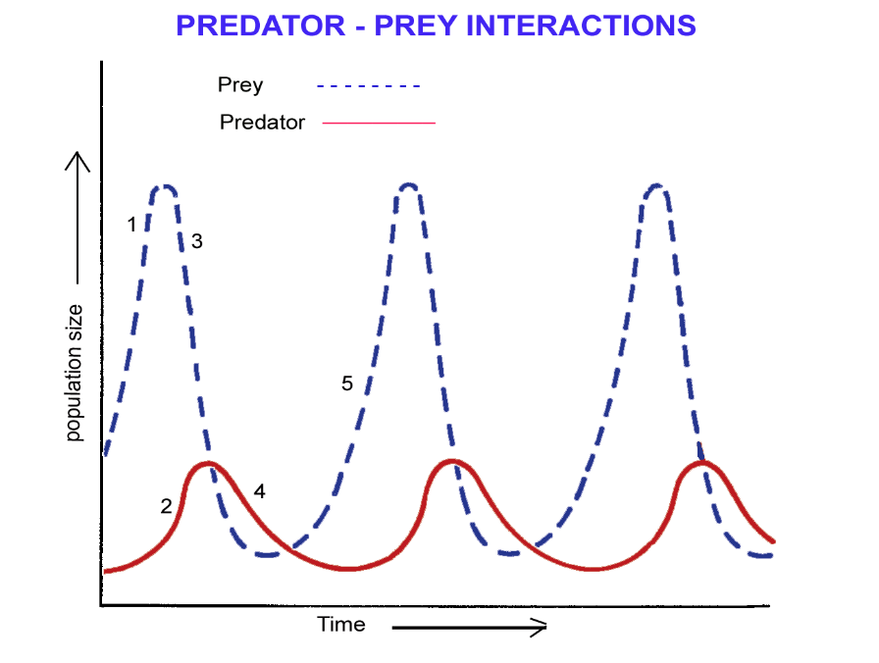
- When predators first feed on the prey, the predator numbers rise, and the number of prey fall
- Because the number of prey falls, the number of predators falls too due to less food available
- When the numbers of predators fall the number od prey can start to rise again
Predator-Prey Relationships are affected by
- Availability of food – less prey due to more numbers of predators, lead to food shortage for those predators
- Concealment – prey can do this to prevent extinction
- Movement – less prey cause predators to move out of the area
Parasitism A parasite lives in or on a living thing causing it harm Examples of parasites include mosquitoes on humans, tapeworms in humans or animals, and potato blight fungus on plants
An endoparasite lives inside the host causing ir harm
An exoparasite lives on the outside of the host causing it harm
Symbiosis
Symbiosis occurs when two organisms of different species live in close association with each other and where at least one organism benefits
Parasitism is a type of symbiosis in which the parasite benefits but the host is harmed
Another form of symbiosis is Mutualism Mutualism – two organisms of different species live in close association with each other and both organisms benefit from the association. Examples of mutualism include nitrogen-fixing bacteria in the root nodules of plants where they gain food, shelter from the plant, while the plant gets nitrates
Human Population Numbers
Population growth is affected by food supply, disease, war and contraception
War reduces the number of humans due to death and separation of partners causes a decline in birth rates
The greater the food supply, the greater the population increase. Famine leads to malnutrition, causing death and low birth rates
Contraception is the prevention of fertilisation which has reduced birth rates
Before the use of modern medicines, disease caused high levels of infant mortality and lowered the life expectancy of individuals
