Classification Systems
Taxonomy is a branch of biology concerned with classification.
Classification refers to the arrangement of organisms into groups based on similar characteristics.
Species are a group of organisms capable of interbreeding and producing fertile offspring

Classification is important in biology as
- Helps us understand how organisms are related to each other

- Enables scientists to communicate with each other using the same terminology

- Allows the study of organisms to be much simpler as they can be studied in groups rather than individually

In modern times, as a result of the development in technology, new types of evidence have greatly enhanced scientists' ability to classify organisms. These include
- Being able to study a genome – an entire set of DNA – of an organism
- Bioinformatics – using computers or artificial intelligence to process biological information

Development of Classification Systems
Classification systems have evolved enormously throughout the centuries
Aristotle, a Greek philosopher, who lived over 2000 years ago, classified living organisms into either animals or plants.
Animals were then subdivided into vertebrates (having a spine) and invertebrates (lacking a spine)
In the 1700s Carl Linnaeus developed a system where organisms were grouped together based on similar characteristics. Organisms were grouped into seven levels called ‘taxa’ (singular: taxon).

Organisms of the same species are grouped together. Groups of closely related species are grouped together into a genus (plural, Genera).
Genera are grouped together into families, families into orders, orders into classes, classes into phyla (singular, phylum) and phyla into kingdoms (Figure 19.2)
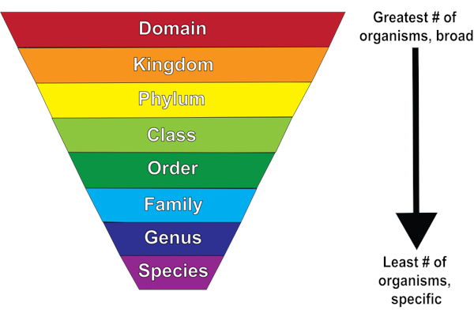
Humans belong to the species sapiens, the genus Homo, the family Hominidae, the order primates, the class of mammals, the phylum Chordata and the kingdom animalia.
In 1990, after the development of microscopes, a new taxon was introduced above kingdom, called the domain There are three domains – bacteria, archaea and eukaryota.

For example, consider the classification of the domestic cat:
Domain: Eukarya - the domain of eukaryotic organisms
Kingdom: Animalia - the animal kingdom
Phylum: Chordata - the members of the phylum chordata are animals with a backbone
Class: Mammalia - mammals
Order: Carnivora - carnivores eat animals only
Family: Felidae - the feline or cat family
Genus: Felis
Species: catus
The modern domestic cat is known as Felis catus.

Linnaeus also developed the binomial nomenclature system. This involves organisms being given a two-part name, a genus name and a species name.
For example, humans are called Homo sapiens. This means humans belong to the genus Homo, and the species sapiens.
Thermus aquaticus. Thermus is the genus name, while aquaticus is the species name. This bacterium is used in DNA profiling.
Yeast cells, are named Saccharomyces cerevisiae. Saccharomyces is the genus name, while cerevisiae. is the species name.
A Genus is a group of related species
This current system of classification is known as the three-domain system whereby
- Organisms are placed into one of three domains – bacteria, archea and eukrayota
- Organism are then placed into one of six kingdoms – bacteria, archea, protista, fungi, plantae and animalia
- Organisms are then assigned to a phylum, then a class, an order, a family, then given a genus and species name based on the binomial nomenclature system.
Also, scientists classified life based on the presence or absence of organelles bound by a membrane (such as the nucleus or mitochondria) - life can either be prokaryotic or eukaryotic.
Eukaryotic cells contain organelles bound by a membrane
Prokaryotic cells do not contain organelles bound by a membrane
The three domains of life
All organisms are grouped into one of three domains. These domains are based on genetic characteristics;
- Bacteria
- Archaea
- Eukaryota

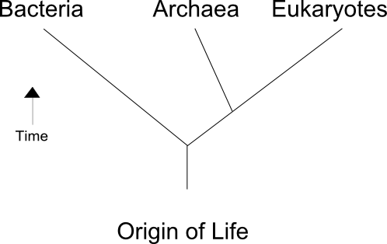

Domain Bacteria
Organisms in the domain bacteria have the following features in common
- Unicellular
- Do not contain organelles bound by a membrane (such as nucleus) - this means they are prokaryotic
- Contain a loop of DNA called a plasmid
- Reproduce asexually by binary fission
Note, all members of the domain bacteria, belong to the kingdom bacteria.

Domain Archaea
Organisms in the domain archaea contain similar characteristics to members of the domain bacteria. The word ‘archaea’ come from the words ‘ancient bacteria’.
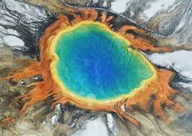
- Unicellular
- Do not contain organelles bound by a membrane (such as nucleus) - this means they are prokaryotic
- Many are extremophiles – they live in extreme environments such as high temperature, extremes of pH and high salt content
- The structure of their cell walls differs from that of the members of the domain bacteria
Note, all members of the domain archaea, belong to the kingdom archaea
Domain Eukaryota
Organisms in the domain Eukaryota have the following features in common
- Contain organelles bound by a membrane (such as nucleus) - this means they are eukaryotic
Note, members of the domain Eukaryota, can belong to one of four kingdoms – protista, fungi, plantae and animalia.

The six kingdoms of life
There are six kingdoms of life - bacteria, archea, protista, fungi, plantae and animalia
We have already discussed that all members of the domain bacteria, belong to the kingdom bacteria. Similarly, all members of the domain archaea belong to the kingdom archaea.
However, members of the domain Eukaryota, can belong to one of four kingdoms – fungi, protista, plantae or animalia. Remember, all organisms in these kingdoms, as they belong to the domain Eukaryota, are eukaryotic. The features of these four kingdoms are outlined
Kingdom in thedomain Eukaryota | Features of organisms in this kindgom | Examples of organisms in this kingdom
Protista | Most are unicellular, or simple multicellular organisms  Most are found in aquatic environments | Amoeba  Algae
Fungi | Some are unicellular while others are multicellular  Heterotrophic – due to no chlorophyll  Cell walls made from chitin  Reproduce asexually by producing spores | Mould  Yeast  Mushrooms
Plantae | Multicellular organisms  Autotrophic  Cell walls made from cellulose  Can reproduce asexually and sexually. | Trees  Grasses  Flowers
Animalia | Multicellular organisms  Heterotrophic – no chlorophyll present  No cell walls  Reproduce sexually only. | Humans  Insects  Fish  Worms

Phylogeny
Phylogeny is the classification of organisms based on their evolutionary development.
Evolutionary relationships are shown in phylogenetic trees.
A phylogenetic tree is a diagram that shows the evolutionary relationships between different species or organisms.
Phylogenetic trees work like a family tree, but instead of showing how people are related, it shows how species are connected through common ancestors.
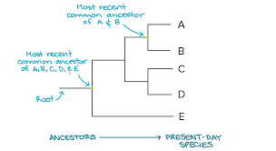

- Horizontal lines are called branches. Each branch represents a lineage (a group of organisms related through evolution).

- A node (where branches split) represents a common ancestor.

- The root is the most recent common ancestor of all organisms on the tree.

- The tips of the branches (A, B, C, D and E) are the current species or groups being compared.

- Organisms that share a more recent common ancestor are more closely related.

- Two species are more related if they have a more recent common ancestor and less related if they have a less recent common ancestor.

- The fewer the nodes between two species, the closer their evolutionary relationship.

- A longer branch indicates more genetic change or a longer period of evolutionary time.

Phylogenetic trees may be drawn in different formats

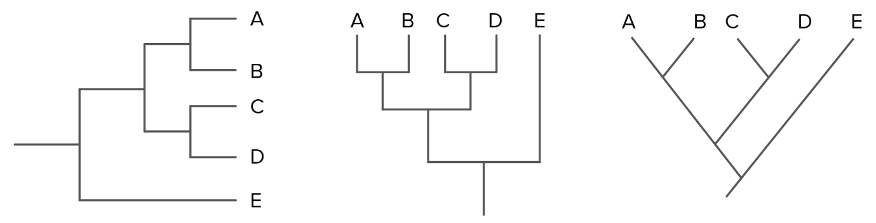

SAMPLE EXAM QUESTIONS
