Microscopy & Cell Structure
A microscope is needed to see animal and plant cells.
There are two types of microscopes; The Light Microscope & The Electron Microscope
The Light microscope sends a beam of light through the cell which is then focused on by two lenses – the eyepiece lens and the objective lens.
The Electron Microscope sends a beam of electrons through the cell and the beam is focused by electromagnets. The electron microscope has far greater resolution and magnification than the light microscope. There are two types of Electron Microscopes; The Transmission Electron Microscope (TEM) and the Scanning Electron Microscope (SEM).
There are two type of Electron Microscopes:
- The Transmission Electron Microscope (TEM), is used to view the internal structures of cells in detail.
- The Scanning Electron Microscope (SEM), is used to view the surface of cells. It often produces 3D images

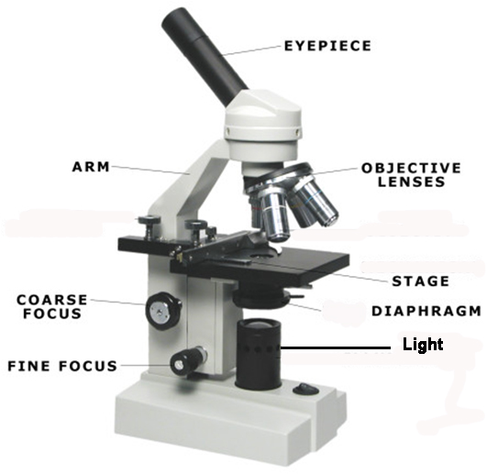
Part of the Light Microscope | Function
Eyepiece Lens | Magnifies the object
Stage | To place the slide on / support slide
Objective Lens | Magnifies the image
Diaphragm (like a shutter in a camera!) | Controls the amount of light reaching the object
Coarse focus wheel | For rough/approximate focusing
Fine focus wheel | To precisely focus the image
The total magnification of a microscope if found by multiplying the power of the two lens
Total Magnification = Objective Lens Power x Eyepiece Lens Power
The magnification, (M) actual size (A) of an image (I )or the size of the magnified image can be worked out using the MIA formula.

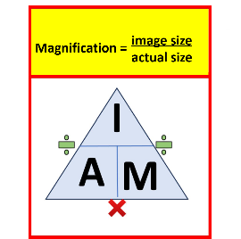
Magnification: The number of times bigger the image looks compared to the real object
Image: What you see when you look through the microscope; the image of the real object appears magnified or the drawing size.
Actual Size: The specimen you put under the microscope

Worked
Question:
You observe a cell under the microscope. The image you measure on the screen is 20 mm across. The actual size of the cell is 0.02 mm. What is the magnification?
Solution:
Magnification = 20 mm $÷$0.02 mm=1000 Answer: The magnification is ×1000.

Finding Image Size
You look at a leaf cell under a microscope with a magnification of ×400. The actual size of the cell is 0.05 mm. What is the image size?
Solution:
Image size = Magnification × Actual size
= 400 × 0.05
= 20 mm
Answer: The image size is 20 mm.

Finding Actual Size
An image of a root hair cell appears to be 30 mm long. The magnification used was ×600. What is the actual size of the cell?
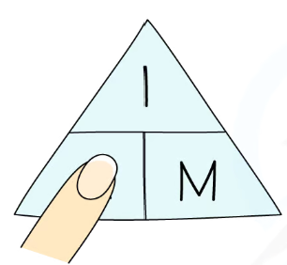
Solution:
Actual size = Image size $÷$ Magnification
= 30 $÷$ 600
= 0.05 mm

Cells contain a variety of internal structures called organelles
- The Light Microscope can view the cell membrane, cytoplasm, nucleus, cell wall, vacuole and chloroplast
- In addition to the organelles listed, the Electron Microscope can view the mitochondria and ribosomes.
Animal Cells
- Animal Cells contain the cell membrane, nucleus, ribosomes, cytoplasm and mitochondria
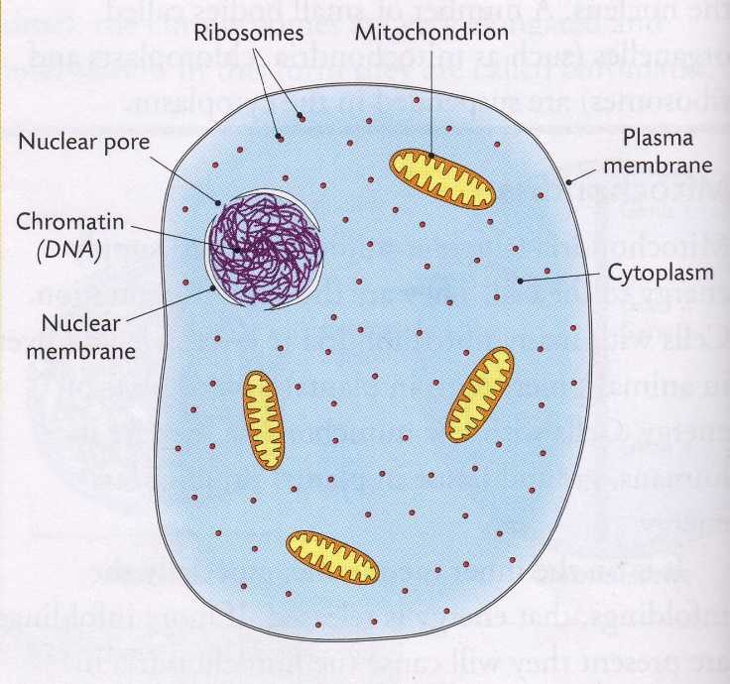
- Cytoplasm – a watery substance in which the cell organelles are suspended. This is where metabolic reactions occur in the cell.
- Nucleus – the control centre of the cell. It contains DNA of which chromosomes are made. Chromosomes contain the instructions for the manufacture of proteins in the cell. These proteins determine the function of the cell.
- Cell membrane – surrounds all cells. It gives support to the cell and controls what enters and leaves the cell.

The Cell Membrane

Cell Membranes are made of phospholipids and proteins

The Cell membrane is selectively permeable – this means is can control what enters and leaves the cell.
Pores present allow movement of molecules in/out of the cell
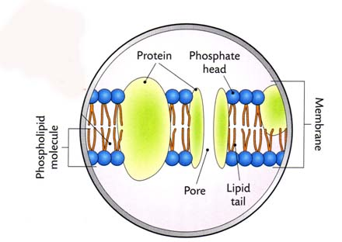

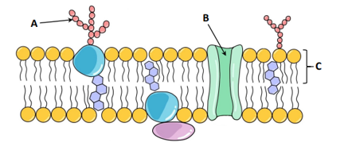

A = protein receptor B = channel protein C = phospholipid

Nucleus

The nucleus contains DNA (Deoxyribonucleic acid) which is organised into chromosomes.

The nucleus of somatic (non-sex cells) contains 46 chromosomes.

The nucleus of gametes (sex cells) contains 23 chromosomes.

When a cell is not dividing, the chromosomes are usually a thing thread-like form called chromatin.

The nucleus is surrounded by a double membrane with many pores, these pores allow substances to pass in and out of the nucleus.
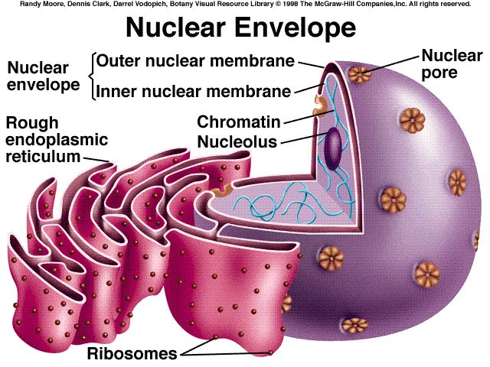
The Nuclear Pore allows for exchange of materials in and out of nucleus.
Nuclear pores facilitate the movement of molecules into and out of the nucleus.

The Nucleolus makes ribosomes and RNA
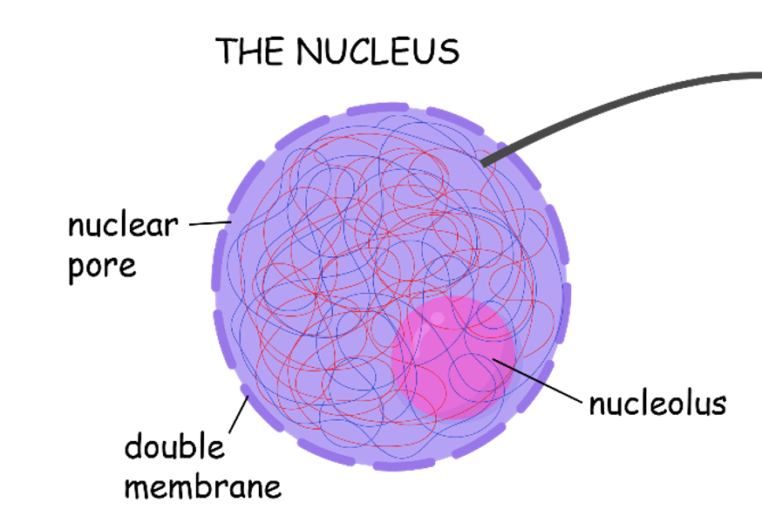

Mitochondria
The Mitochondria carries out aerobic respiration.
The mitochondria is surrounded by a double membrane.
The inner foldings of the mitochondria are called cristae. The more cristae present in a mitochondrion, the more energy it produces.
Mitochondria are double-membrane structures enclosing a semi-fluid matrix, in which aerobic respiration occurs, producing the energy (ATP) the cell needs.
- The inner membrane of a mitochondrion is highly twisted and forms cristae (folds).
- The outer membrane is smooth. Both the cristae and matrix contain the enzymes that allow for aerobic respiration.

Mitochondria contain DNA (non-nuclear DNA).
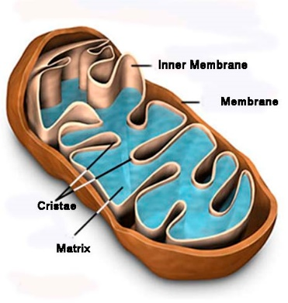

Ribosomes
The function of ribosomes are to make proteins. Proteins are made during Protein Synthesis in which amino acids are joined together

Endoplasmic Reticulum (HL)

The Endoplasmic Reticulum is an organelle made up of membranes that link to the nucleus's nuclear membrane. It is found in both animal and plant cells.
There are two kinds:

Rough Endoplasmic Reticulum (rRER) contains ribosomes and produces and transports proteins

Smooth Endoplasmic Reticulum (sER) synthesis, stores and transports lipids
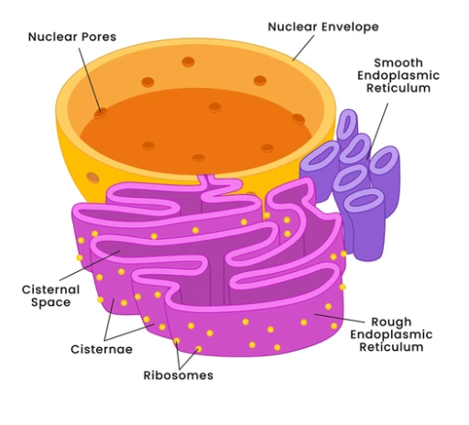

Golgi apparatus (HL)
Golgi apparatus processes and packages proteins for transport

The Golgi apparatus resembles the smooth endoplasmic reticulum in appearance. It processes the proteins in the rER, it modifies and packages them into vesicles, and releases them for transport, to various parts of inside the cell or for secretion outside the cell.

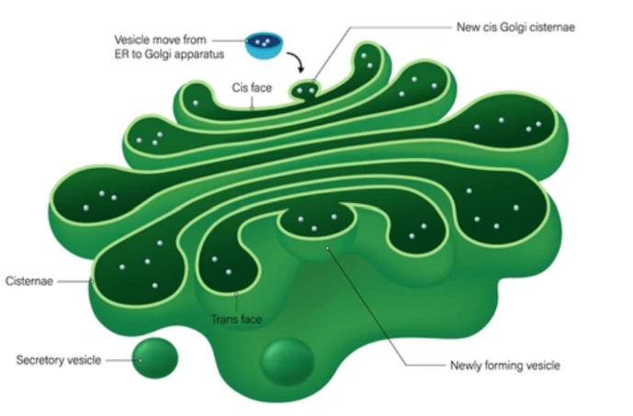

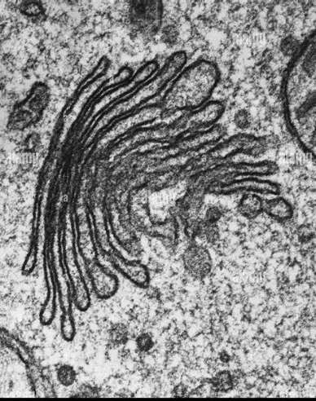

Plant Cells
In common with animals cells, plant cells contain a cell membrane, nucleus, cytoplasm, ribosome and mitochondria. In addition, they contain a cell wall, chloroplast and large vacuole.
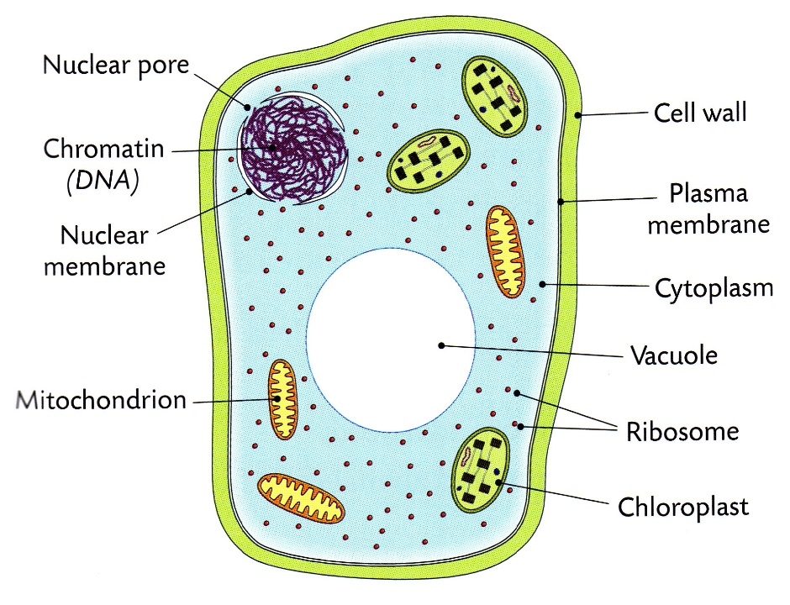
Chloroplasts (plant cells only)
Photosynthesis occurs in the chloroplasts
Chloroplasts contain the green pigment chlorophyll which traps sunlight energy for photosynthesis
Chloroplasts contain DNA

Cell Wall (plant cells only)
The cell wall gives shape and strength to plant cells
It is made from cellulose (polysaccharide)
The cell wall is fully permeable which means it allows all substances to pass in and out of it
Adjacent cell walls are held together by a cement-like substance called the middle lamella. The middle lamella is formed by the mineral calcium.

Large Vacuole (plant cells only)
- Vacuoles are membrane-bound sacs within the cytoplasm of a cell

- Vacuoles provide structural support, as well as serving functions such as storage, waste disposal, protection and growth

Eukaryotic and Prokaryotic Cells
- Organisms whose cell contain a nucleus and other membrane-bound organelles are called eukaryote. E.g. Plant and Animal Cells

- Organisms whose cells never contain (or lack) a nucleus and other membrane-bound organelles are called prokaryotes. E.g. Bacterial Cell

