The Characteristics of Life
Strand: Organisation of Life
Learning Outcome: 1.1.1

Review Questions
2.1
- What is an organism?
- Define the term ‘biodiversity’.
- Anabolism and catabolism are two types of metabolic processes. Which process involves the release of energy?
- Write down two examples of a catabolic reaction.
- Name the anabolic reaction which involves organism making their own food using light energy.
2.2
- What is meany by the term ‘continuity of life?
- Distinguish between a unicellular and a multicellular organism.
- Write down an example of (i) an animal organ (ii) a plant organ
- What term is used to describe a group of cells working together?
- Define the term ‘population’.
2.3
- Identify the ultimate source of energy for life on Earth.
- Distinguish between an autotroph and a heterotroph.
- Give two examples of autotrophic organisms.
- Is respiration an anabolic or a catabolic process? Justify your answer.
- Name the carbohydrate molecule which is broken down during respiration to release energy.
2.4
- How do multicellular organisms grow?
- What is meant by the term homeostasis?
- Why is homeostasis necessary?
- Write down two examples of conditions which must be kept constant in the human body.
- Define the term excretion.
- Identify three organs of excretion in humans and list the products they excrete.
- Name the pores in the leaf through which plants excrete oxygen gas during photosynthesis.
2.5
- Organisms respond to stimuli. Write down two stimuli that (a) animals (b) plants respond to.
- What is the benefit to organisms, of being able to response to changing conditions in their external environment?
- Distinguish between sexual and asexual reproduction.
- Comment on the genetic make-up of the offspring produced by asexual reproduction.
- What is meant by the term ‘heredity’?

2.6
One of the roles of the skin is temperature regulation. The data in Table 2.3 shows the number of sweat glands activated per cm² of skin at different external temperatures. Analyse the data in the table and answer the following questions.
Temperature (^{O}C) | Sweat glands activated per cm²
10 | 100
20 | 300
30 | 700
40 | 1000
Table 2.3
- At what external temperature is the most sweat gland activity observed?
- What conclusion can you draw from the results as shown in Table 2.3?
- Describe one possible danger of prolonged exposure to 40°C.
- Aside from the temperature regulation by the skin, write down another example of homeostasis in humans.

Revision Questions
2.
(a) Define the term “biodiversity”
(b) What is an organism?
2.8
Complete table 2.1 by ticking the box to classify each of the following features as ‘characteristics of life’
Feature | Tick (✔) if this feature is a ‘characteristic of life’
Excretion
Movement
Speech
Respiration
Metabolism
Agility
Growth
Table 2.1
2.9
A student carried out an experiment in the school laboratory. The student added glucose solution to yeast cells in a test tube. The student recorded the temperature of the mixture after ten minutes. The student noted an increase in the temperature of the contents of the test tube. (a) Suggest what characteristic of life is occurring in this experiment.
(b) Is this experiment an example of a catabolic or an anabolic reaction? Justify your answer.
(c) Suggest how the student could have made this investigation more accurate.
2.10
In relation to the production of life, describe how scientific ideas regarding this concept have been modified over time.
2.11
Draw an arrow to match each the characteristics of life in column A to their explanation in column B
Column A | Column B
Characteristic of Life | Explanation
Organisation | Maintaining constant internal conditions
Homeostasis | Making new individuals
Response | Chemical reactions in an organism
Heredity | The release of energy from glucose
Metabolism | A group of cells form a tissue
Respiration | Passing on genetic information from parent to offspring
Reproduction | The ability of organisms to react to stimuli
Table 2.2
2.12 Distinguish between each of the following pairs of terms by writing a sentence about each
(a) Sexual Reproduction and Asexual reproduction
(b) Autotrophic and Heterotrophic nutrition
(c) Homeostasis and Excretion
(d) Respiration and Response
(e) A tissue and an organ

2.13 The graph in the figure below shows how the heart rate, of a young adult, in beats per minute (bpm) varies with changing sound levels in decibels (dB) i.e. quiet noise and loud noise. Analyse the graph and answer questions (a) - (e)
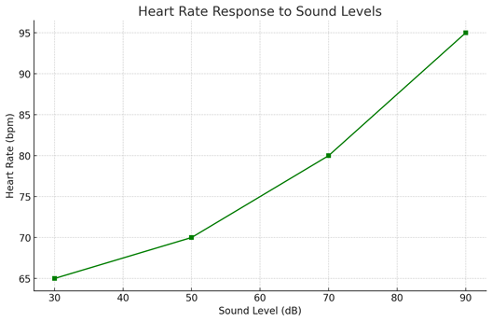
- Identify the heart rate of the young adult when the sound level is 65 decibels
- What is the relationship between sound level (dB) and heart rate (bpm).

- How does this data support the idea that organisms respond to stimuli?

- Identify the independent variable in this investigation.

- Identify the dependent variable in this investigation.

- Write down two factors which must be kept constant (controlled) in this investigation.
2.14
Draw a flow chart to show how organisms are organised from cells to populations

2.15
The illustration below shows the mitochondria
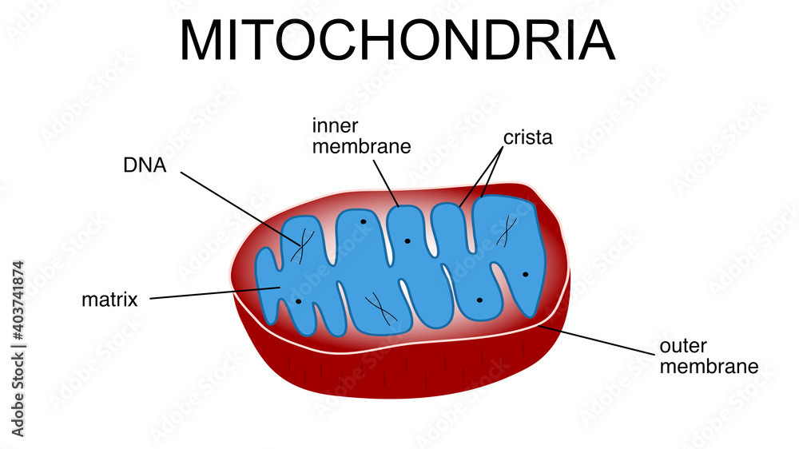
- Name the metabolic reaction which occurs in the mitochondria.
- In relation to the metabolic reaction mentioned in part (a), write down whether this reaction is anabolic or catabolic. Justify your answer.

- Both autotrophic and heterotrophic organisms carry out respiration.
Name two autotrophic organisms and two heterotrophic organisms
Autotrophic:
Heterotrophic:

2.16 Homeostasis involves the maintenance of an organism’s constant internal environment. An example of homeostasis is temperature regulation.
(a) Aside from temperature regulation, write down two other examples of homeostasis in organisms
The data in table 2.3 shows the body temperature of an 18-year-old woman while she is running over a 24 minute period.
Time (minutes) | Body Temperature (°C)
0 | 36.5
4 | 36.6
8 | 36.7
12 | 37.0
16 | 37.5
20 | 37.0
24 | 36.8
Table 2.3 Body Temperature regulation
(b) Draw a suitable graph to represent the data in table. Be sure to label both axes and scale the graph appropriately.
(c)Using the graph you have drawn, identify the range of time during which the woman’s body temperature is increasing.

(d) Describe how the data table 1.2 and the graph you have drawn support the existence of homeostasis in the body?
2.17
Fill in table 2.4 by writing down an example of each structure in humans
Structure | Example in humans
Cell
Tissue
Organ
Organ System
Organism
Table 2.4

