The Characteristics of Life
Strand: Organisation of Life
Learning Outcome: 1.1.1

Biodiversity is a term that describes the wide variety of life on the planet
An organism is a living thing.
Organisms have many features or characteristics in common such as;
- Metabolism
- Continuity of life
- Cellular basis
- Organisation
- Nutrition
- Respiration
- Growth
- Homeostasis
- Excretion
- Response
- Reproduction
- Heredity

1. Metabolism
Metabolism refers to the sum of all the chemical reactions that place in the body.

Term | Definition | Illustration
Anabolic Reactions (Anabolism) | These reactions use energy to convert smaller molecules into larger molecules such as during photosynthesis and protein synthesis.  Energy is used to create bonds which join molecules together during this type of reaction. | 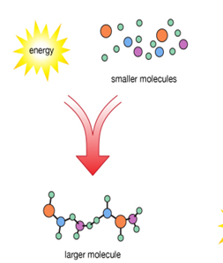
Catabolic Reactions (Catabolism) | These reactions release energy to convert molecules into smaller molecules such as respiration and digestion.  During this type of reaction, bonds are broken, which releases energy. | 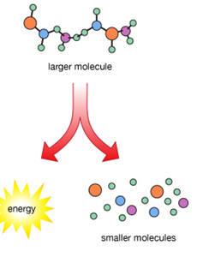

- Continuity of life
Continuity of life means that cells arise from cells of the same type and organisms arise from other organisms of the same type.

- Cellular Basis
All organisms are made of cells.
Unicellular organisms consist of only one cell
Multicellular organisms consist of many cells.

- Organisation
A tissue is a group of cells working together with a similar function.
An organ is a group of tissues working together with a similar function.
A system is a group of organs working together.
A population is a group of organisms of the same species.
Cell -> Tissue -> Organ -> System -> Individual -> Population

- Nutrition
Nutrition is the way organisms obtain and use food.
Autotrophs are organisms that make their own food
Heterotrophs are organisms that cannot make their own food

- Respiration
All organisms respire (carry out respiration) to fuel their metabolic reactions. Respiration is a catabolic process that occurs in cells. During respiration, a carbohydrate called glucose is broken down to release energy. Cells use this energy for other metabolic processes
Respiration is the release of energy from glucose.

- Growth
Growth involves organisms increasing in volume, mass and complexity over time.
- Homeostasis
In order for organisms to effectively carry out metabolic reactions, many factors need to be kept constant. These factors include
- Temperature
- pH
- Concentration of glucose
- Concentration of carbon dioxide
- Concentration of salt
Maintaining a constant internal environment is called homeostasis. Our body temperature needs to be 37 ^{O}C, our blood pH needs to be 7.4 and our cells need oxygen.
Homeostasis is the maintenance of a constant internal environment.

- Excretion
To ensure a constant internal environment, waste products from metabolic reactions must be removed. Excretion is the removal of waste products of metabolism.
For example, carbon dioxide is a waste product of the process of respiration, and it is excreted by the lungs
In plants, oxygen is produced as a waste product of photosynthesis, and it is excreted through the pores on the leaf called stomata
If these waste products build up in the body, they can become toxic.
Excretion is the removal of metabolic waste products.

- Response
Response is the ability of organisms to react to stimuli.
Most living organisms respond to stimuli by some form of movement. Plants increase the rate of photosynthesis in their cells by growing towards sunlight. Animals such as lizards, respond to very high temperatures by moving to the shade

- Reproduction
Reproduction is the formation of new organisms
There are two types of reproduction – sexual and asexual
Term | Definition
Sexual reproduction | - Occurs by fusing gametes (sex cells) such as the fusion of the sperm and egg in humans, and the fusion of the pollen and egg in plants.  - Involves two parents and thus produces variation, as the offspring produced contain genetic material from two different parents
Asexual reproduction | - Involves only one parent and is common in single-celled organisms such as bacteria.  - They reproduce simply by cell division producing offspring that are identical to the parent (no variation)

- Heredity.
Heredity is the passing on of genes from parents to offspring.

