Plant Structure
Plants are multicellular organisms capable of making their own food (autotrophic)
A flowering plant is divided into two sections; a shoot system and a root system
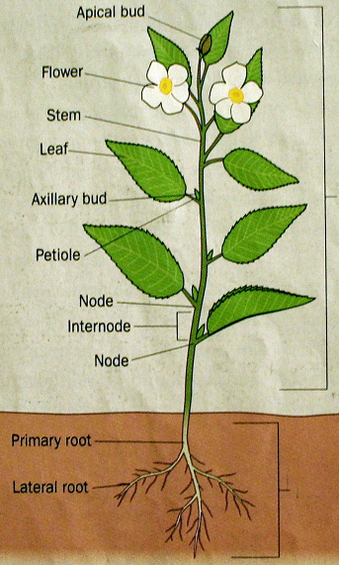
Under-ground root system
Over ground shoot system
There are two groups of flowering plants; Monocotyledons and Dicotyledons
A cotyledon is a food store (seed leaf) in seeds. Once a seed germinates and the true leaves develop, the cotyledons are no longer needed.
Monocots have one seed leaf in their seeds e.g. Grasses
Dicots have two seed leaves in their seeds e.g. Oak Tree
Roots
Functions of roots:
- Anchors the plant in the soil
- Absorbs water and minerals from the soil. The root hairs increase the surface area for absorption of water
- Stores food in some plants e.g. carrots and turnips
There are 3 types of Root Systems
- Tap Roots
Tap (Primary) Root consist of a main root that develops from the radicle (which is the initial root that emerged from the seed). Lateral (secondary) roots grow from the primary root. The tips of lateral roots have tiny root hairs.

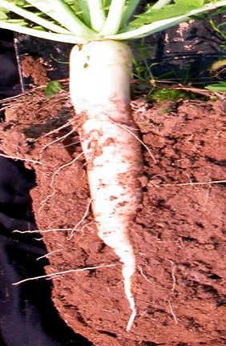

- Fibrous Roots
Fibrous roots consist of many roots all the same size. These roots emerge from the base of the stem.

These are roots that do not develop from the radicle but rather develop in strange locations in the plant e.g. Roots at the base of onions and the gripping roots of ivy.

- Adventitious Roots

The Zones in a Root
Zone of Protection
- The root cap protects the root tip as it grows through the soil
Zone of Cell Production/ Meristematic Zone
- A meristem is an area where cell division (mitosis) takes place in a plant. Cells in this zone are constantly dividing by mitosis to produce new cells for root growth.
Zone of Elongation
- When new cells are formed in the meristematic zone are formed they are very small – in this zone plant growth regulators (auxins) stimulate the cells to grow longer
Zone of Differentiation
- The cells formed from mitosis develop into different types of tissues
- Dermal Tissue – protects the plant
- Ground Tissue – found between the dermal and vascular tissues
- Vascular tissue – transports substances
Phloem Tissue (Vascular)
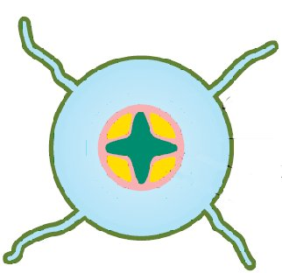
Xylem Tissue (Vascular)
Ground Tissue
Root Hair
Dermal Tissue

Stems
Stems may be herbaceous or woody.
A herbaceous plant is a small, seed-bearing plant with a green stem that lacks lignin.
Woody plants have a permanent hard layer of lignin (wood) inside the bark.
The tip of the stem has an apical bud – this causes the stem to grow at the growing tip. If the apical bud is removed, a low bushy plant will form.
The stem contains pores called lenticels which are needed for gas exchange.
A node is the part of the stem where new branches and leaves form
Internodes are areas between nodes where no branches form.
Functions of the Stem;
- Supports the aerial parts of the plant
- Transport food made in the leaves to the roots
- Transports water and minerals from the roots to the leaves and flowers
In Monocots, the vascular bundles are scattered ta random.
In Dicots, the vascular bundles are arranged in a ring (xylem towards the inside)
Leaves
Leaves are attached to stems at nodes
The pattern of veins on a leaf is called venation. Veins contain the vascular tissue.
Pores in the leaf called stomata allow for gas exchange.
Leaves are covered in a waxy cuticle to prevent water loss.
There are two types of venation in leaves
- Parallel venation – veins run along side each other – found in long narrow leaves – found in monocots
- Net (reticulate) venation – veins form a branching network – found in large broad leaves - found in dicots
Functions of leaves
- To carry out photosynthesis
- To exchange gases
- To allow water to pass out (transpiration)
Tissues in Flowering Plants
There are 4 main types of plant tissues
- Dermal Tissue
- Forms the outer protective layer in plants
- In the roots is covered in root hairs to absorb water
- In the leaves, it is covered with a waxy cuticle to prevent water loss

- Ground Tissue
- Makes up the majority of the plant – occupies area between dermal and vascular tissue
- Carries out functions such as photosynthesis, support and storage depending on its location in the plant

- Meristematic Tissue
- Meristematic tissue is found in the root and shoot tips and in all buds
- Meristematic tissue develops into each of the other 3 tissue types in plants
- A meristem is an area made of unspecialised cells that are dividing by mitosis
- Vascular Tissue
- This is transport tissue made up of Xylem and Phloem
- Xylem transports water and minerals from the roots up through the plant
- Phloem transports food around the plant from where the leaves to where it is needed
- In the stem of Monocots, vascular bundles are scattered
- In the stem of Dicots, vascular bundles form a ring-shape
Xylem
There are two types of xylem tissues; xylem vessels and xylem tracheids.
The living part of xylem dies before they reach maturity, so xylem is a dead tissue.
Xylem Vessels
- Long narrow tubes formed when cells join end to end
- The cells in xylem tissue are dead cells with think walls with lignin
- The vessels have pits in their side walls to allow water to pass from one vessel to another
Xylem Tracheid
- Narrow, long, tapered cells
- Walls are pitted to allow water to flow into the next tracheid
- Walls are supported by lignin
Phloem
Phloem tissue transports glucose around the plant
Phloem tissue is made of companion cells and sieve tubes
Phloem tissue is living tissue
Phloem tissue is found in the vascular bundles of roots, stems and leaves.
Phloem Sieve Tubes
- Long tubular structures which are joined end to end
- The end walls contain pores to allow transport of substances
- They do not contain a nucleus
- Their walls are made of cellulose
Phloem Companion Cells
- Each sieve tube has an accompanying companion cells on its outside
- Companion cells contain a nucleus which controls a sieve tube

Monocots and Dicots
 | Monocotyledons | Dicotyledons
Number of cotyledons | One | Two
Arrangement of vascular bundles in the stem | Scattered in the stem | In a ring pattern
Leaf venation | Parallel | Netted
Woody or herbaceous | Almost all are herbaceous | May be woody or herbaceous

