Study of an Ecosystem
A woodland, a pond, a seashore or a hedgerows are all examples of ecosystems.
Within each ecosystem, there are a number of different habitats in which communities of organisms live and interact.
Habitats in a woodland ecosystem include under a rock, the soil, around a tree stump and the shrub layer.
Experiment: To Investigate 3 Abiotic Factors in the ecosystem
- Soil Temperature
- Stick the soil thermometer in the ground
- Leave it for 5 minutes
- Remove the thermometer and read the temperature
- Wind speed
- Hold the anemometer so it faces the prevailing wind
- Read the wind speed from the anemometer
- Repeat in different parts of the ecosystem
- Light intensity
- Place the light meter in a well lit part of the ecosystem
- Read the light intensity from the light meter
- Repeat, with the light meter in a shaded area
- Compare the light intensities in each part of the ecosystem
Experiment: To use various pieces of apparatus to collect animals in an ecosystem
- A Pooter is used to suck up insects into the collecting jar
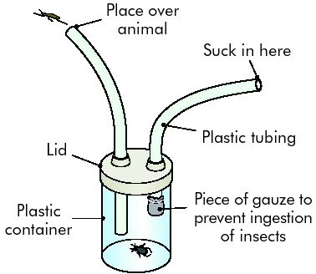
- A pitfall trap is used to collect small, crawling animals
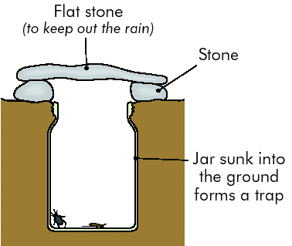

- A sweep net s swept in the motion of a figure of 8 through long grasses or hedges to collect insects
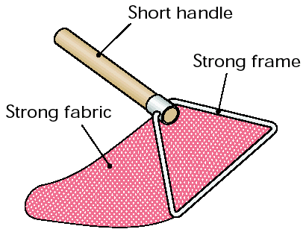
- A Beating tray is used to collect small animals from trees and shrubs
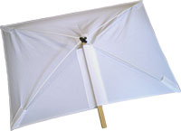
- A mammalian trap is used to catch small animals
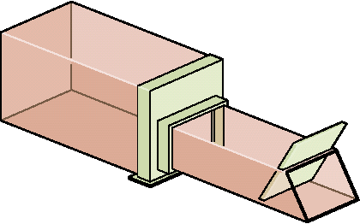
- A Tullgren funnel is used to collect animals from the soil by heating the soil on one side
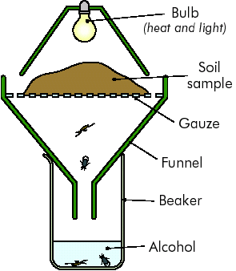
Estimating Organism Numbers
- A Qualitative study records the presence or absence of a species
- A Quantitative study records the number of each species that are present in a Habitat.
- A Quantitative study provides greater details than a qualitative study

Experiment: To carry out a Quantitative study of plants in a Habitat

A quadrat is used to carry out a quantitative study of plants in a Habitat
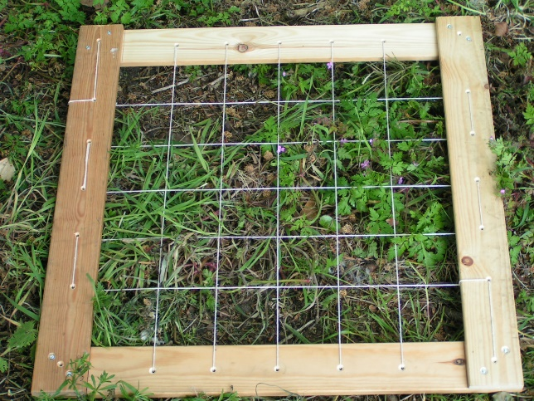

Method 1: Percentage Frequency – The chance of finding an organism in a habitat

- Throw a pencil over your shoulder
- Place a quadrat where the pencil lands
- Mark the plants present or absent
- Record the results in a table
Name | 1 | 2 | 3 | 4 | 5 | 6 | 7 | 8 | 9 | 10 | Total | %
Grass |  |  |  |  |  |  |  |  |  |  | 10 | 100
Dandelion |  |  |  |  | x | x |  |  |  |  | 8 | 80
Buttercup | x |  |  |  | x | x |  | x |  |  | 6 | 60
Daisy |  |  |  |  | x |  | x |  |  | x | 7 | 70
Clover |  | x | x |  |  | x |  |  |  |  | 7 | 70
Doc Leaf |  | x | x | x |  | x |  |  |  | x | 5 | 50

% frequency = (Number Present ÷ total quadrats thrown) x (100 ÷ 1)

Method 2: Line Transect – to see how vegetation changes across a boundary
- A line transect is a strong or rope marked off at regular intervals.
- The names of the plants or animals that touch the line are recorded
- Using a quadrat, the percentage frequency or percentage cover of the plants are recorded at each 1 m interval
- This non-random as it is decided where the line transect is placed
- This gives a picture of how the vegetation changes from one end of the line (i.e. in the woodland) to the other end (i.e. in the well-lit open area)
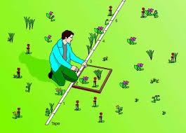

Method 3. Percentage Cover – the area of ground occupied by the aerial part of plants

The area of a quadrat covered by each species is calculated as a percentage of the total area of the quadrat. A quadrat with gridlines is used.

- Count the number of times each plant touches the top left of each small square
- This figure is expressed as a percentage of the total number of squares
(Number of touches ÷ number of squares) x (100 ÷ 1)
- This is repeated ten times
Experiment: To carry put a Quantitative Study of Animals in a Habitat
This method is used to estimate the number of animals in the habitat It involves capturing a number of animals of the same species, marking and releasing them unharmed.
The animals should be marked in such a way as not to endanger them. On a second visit a few days later, a similar number of animals are collected. Some of these will be marked. The total number of animals can be calculated from the formula:
Population size =
(Number marked on Day 1)X(Number caught on Day 2) ÷ (number marked on Day 2)
Sources of error in an ecosystem study
- Human Error – misidentification, miscalculation or mistakes in measuring and recording information

- Changing conditions – the results of an ecosystem study may not apply at all times of year as ecosystems are subject to natural and artificial change

- Sample size – a single habitat may not be an accurate representation of the entire ecosystem, the larger the number of habitats studied, the more accurately the results will reflect the overall ecosystem

