Energy in chemical reactions
1.What is an Exothermic reaction?
Answer: An exothermic reaction is one that gives out heat energy. A temperature rise is observed as heat energy is given out to the surroundings. (‘Ex’ means ‘out’ such as the words ‘exit’ or ‘extract’).
2.What is an Endothermic reaction?
Answer: An endothermic reaction is one that takes in heat energy. There is a drop in the temperature of the surroundings as heat energy is taken in. (‘Endo’ means ‘within’ such as ‘endoscope’).
- Outline the collision theory.
Answer: The collision theory is used to describe the energy changes that occur during chemical reactions.
The theory states that for products to be formed in a chemical reaction
- The reacting particles must collide with each other
- A certain minimum energy is reached in the collision called the activation energy

- What is an effective collision?
Answer: An effective collision is one that results in the formation of products

- What is activation energy?
Answer: When reacting particles move, they do so at different speeds. Some are moving slowly than others and therefore have lower amounts of energy. When particles with low energies collide, they simply bounce off each other without any products being formed. If particles with high enough energies collide, products are formed as an effective collision takes place. This minimum energy that colliding particles must have for an effective collision to occur is called the activation energy.

- Why do chemical reactions occur faster at higher temperatures?
Answer: At higher temperatures, there is an increased number of collisions since the moving particles have more energy. More of the collisions have the activation energy needed to form products as they have more heat energy.

- Why does particle size affect the rate of a chemical reaction?
Answer: The smaller the particles size, the more surface area is exposed. Therefore, there will me more collisions taking place. Since the number of collisions that take place is increased, the number of collisions that are effective will also increase.

- How does the concentration affect the rate of a reaction?
Answer: If the concentration of the reactants is increased, the molecules are crowded closer together. Therefore, the number of effective collisions will also be increased.

- What are energy profile diagrams?
Answer: Energy profile diagrams are graphs that show the change in energy of a chemical reaction with time.

Energy profile diagrams detail the size of the activation energy for a particular chemical reaction. (E_{A} = Activation energy. ΔH = energy released).

- Draw an energy profile diagram to represent an exothermic reaction

- Draw an energy profile diagram for an endothermic reaction

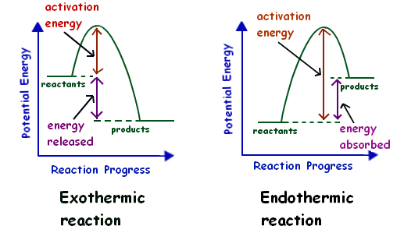

- How does a catalyst affect the rate of a chemical reaction?
Answer: A catalyst works by reducing the activation energy for a reaction allowing the reaction to proceed.

