Blood
Blood is a tissue made up of four parts; Plasma, Red Blood Cells, White Blood Cells and Platelets
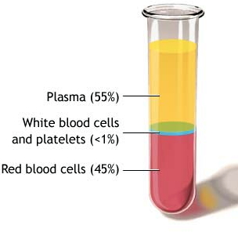
Plasma
- Golden coloured liquid
- 55% of blood tissue
- Made of 90% water, 7% proteins and 3% dissolved substances such as amino acids, glucose, carbon dioxide, oxygen, urea and heat.
Function of Plasma:
- Transport the dissolved substances around the body
- Regulate body temperature by carrying heat

Red Blood Cells
- Have a biconcave shape (for extra surface area for transporting oxygen)
- Are made in the bone marrow
- Have a nucleus when first made, but when they become mature, their nucleus dies
- Contain no mitochondria
- Very small and narrow so they can squeeze through capillaries
- Only live for 4 months as they cannot repair themselves
- Dead RBCs are broken down in the liver and the spleen
- RBCs determine the blood group of an individual
- Haemoglobin is a globular protein made of iron. Haemoglobin is found in red blood cells.
Function of Red Blood Cells;
Their function is to transport oxygen
In the lungs, oxygen diffuses into the red blood cells and combines with the haemoglobin to form oxyhaemoglobin.
Haemoglobin + Oxygen -> Oxyhaemoglobin
White Blood Cells
- Contain a nucleus and mitochondria (eukaryotic)
- Made in the bone marrow
- About twice the size of Red Blood Cells
- Less numerous in blood than Red Blood Cells
- Once made in the bone marrow, they mature in the spleen
- Their function is to fight infection
There are 2 main types of WBC;
- Lymphocytes
Lifespan of 3 months – 10 years
Have a large round nucleus
They fight disease by producing antibodies which attack pathogens

- Monocytes
Lifespan of 6-9 days
Have a kidney-shaped nucleus
Sometimes called macrophages
Engulf pathogens through phagocytosis

Platelets
- Tiny fragments of cells
- Made in the bone marrow
- Have no nucleus
Their function is to clot blood
- Blood clotting prevents the further loss of blood
- Blood clotting prevents the entry of pathogens into the body

Functions of Blood
- Transport – Plasma transports dissolved substances, heat and hormones. RBCs transport oxygen

- Defence – Monocytes engulf pathogens, Lymphocytes produce antibodies, platelets clot blood to prevent entry of pathogens.

Blood Grouping
The blood group of an individual depends on the presence or absence of the antigens A or B on the surface on their red blood cells.
Blood Group | O | A | B | AB
Surface Chemical | Neither A nor B | Antigen A | Antigen B | Antigens A and B

The immune system will not produce antibodies against its own cells but will produce antibodies against other antigens present on the surface of other cells.
Group AB can receive blood safely from every other blood type – universal recipient
Group O can donate blood safely to every other blood type – universal donor
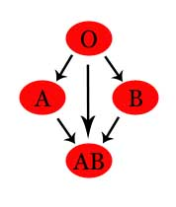
Rhesus Factor
Rhesus Chemical (Antigen D) is also used to classify individuals into different blood groups
Rhesus + (Rh+) means the antigen D is present on the Red Blood Cell
Rhesus – (Rh-) means the antigen D is not present on the Red Blood Cell
AB+ means the person has Antigen A and B, and also the Rhesus Factor (antigen D0
B – means the person has antigen B and does not have the rhesus factor
Importance of blood grouping;
- Blood transfusions – the incoming blood group must be matched to the blood of the recipient
- Pregnancy – if a rhesus negative mother is pregnant with her second rhesus positive baby she will need injections to ensure the pregnancy will continue

